


Boeing Autonomous

Final Report

Elise Chantegros, Budget Liaison
Selina Cozens, Steering CAD
Jacob Keeland, Brakes & Manufacturing
Marek Lemieux, Brakes CAD
Desirae Mangum, Fundraising Lead
Natasa Peric, Mechanical Engineering Team Lead
Lily Quintanar, Intra-group Communications


Fall 2025 - Spring 2026

Project Sponsor: Boeing
Sponsor Mentors: Donald Guzman, Connor Nolan, and Michael Vogelsang
Instructor: Professor David Willy
Group Number: F25toSp26_02

DISCLAIMER
This report was prepared by students as part of a university course requirement. While considerable effort has been put into the project, it is not the work of licensed engineers and has not undergone the extensive verification that is common in the profession. The information, data, conclusions, and content of this report should not be relied on or utilized without thorough, independent testing and verification. University faculty members may have been associated with this project as advisors, sponsors, or course instructors, but as such they are not responsible for the accuracy of results or conclusions.

EXECUTIVE SUMMARY
This report will discuss the progression and accomplishments of the Boeing Autonomous capstone project. The goal of the project is to develop an actuation and control system that can be retrofitted onto any existing vehicle. The vehicle of choice for this project was chosen to be the Coleman Powersports 196cc GK200 Go Kart. The project has been broken up into three main sub-teams: brakes, steering, and throttle. Additionally, there is an electrical sub-team that consistently worked with the mechanical sub-teams to create a program that can autonomously control the functions of the go-kart. This report will focus on the mechanical aspects for each of the three main sub-teams.
In the beginning of this project, the team was given a list of customer and general requirements provided by the clients', Boeing. From those requirements, each sub-team created the engineering requirements related to their functions and analyzed them using a House of Quality chart to determine wat requirements needed to be prioritized. Afterwards, benchmarking was conducted for each sub-team to help in determining what goals and standards should. A literature review consisting of multiple sources and mathematical modeling was conducted individually to analyze and predict reactions before prototyping. The concept development process was conducted for each sub-team to select a beginning idea to base their first prototype on. Once each concept was selected, prototyping moved forward, allowing each sub-team to identify and reiterate the downfalls in their design.
To follow the team's progress and future plans, outlined Gantt charts for both the fall and the upcoming spring semesters were created. The team worked through the first half of the Spring semester to complete the design and assembly of their mechanical components. Moreover, the team raised $3,473.16 along with the $5,000 sponsorship from Boeing, projecting an approximate budget total to be around $8400. Despite funds exceeding projected expenses, the team continued to fundraise for unexpected and emergency costs. To best organize the team’s expenses, a Bill of Materials (BoM) table was created for each sub-team to keep track of what parts/materials were used for the first prototype, second prototype, and the estimated amount of money each prototype might cost along with any added purchases based on any damages. Lastly, each sub-team's Failure Modes and Effects Analysis (FMEA) was factored into the BoM for each sub-team to provide the most accurate list of expenses.
Prototypes 1 and 2 were conducted. For all sub teams their main question for Prototype 1 was to determine how to mount their modifications onto the go kart. The brakes team focused on mounting their brake caliper and attaching their motor using a baseplate near the rear left wheel. The steering team 3D printed CAD models that were designed to hold a motor and the electrical components of the subsystem on the front rack of the go-kart. The throttle team mounted a stepper upside down on the overhanging rack opposite to the throttle level using brackets and a steel sheet. From these prototypes, the sub-teams used their results and analysis to influence Prototype 2. In their second iteration, brakes pivoted from the spool drive by wire brake system to a modified brake caliper arm system where the motor engages the brake directly. Steering changed their motor box to a mounting plate for better space conservation and incorporated the use of gears to best control the steering wheel. Throttle changed the location of their stepper motor, using the bottom chassis to mount their baseplate and employed the use of a Bowden cable to freely orient their mounting position relative to the throttle lever.
Through the defined requirements provided by the clients, performance metrics, requirement analysis using multiple methods, and detailed mathematical modeling, the team iterated their prototypes to reach a well-established design that can be manufactured within the confines of their resources. These efforts were made to ensure that the mechanical components of the autonomous' go-kart's braking, steering, and throttle subsystems would maintain a safe, responsive, and reliable operation that could meet both the clients' expectations and engineering standards.

TABLE OF CONTENTS
Contents
DISCLAIMER 1
EXECUTIVE SUMMARY 2
TABLE OF CONTENTS 3
1 BACKGROUND 2
1.1 Project Description 2
1.2 Deliverables 2
1.3 Success Metrics 3
2 REQUIREMENTS 4
2.1 Customer Requirements (CRs) 4
2.2 Engineering Requirements (ERs) 5
2.2.1 Brakes Engineering Requirements 5
2.2.2 Steering Engineering Requirements 6
2.2.3 Throttle Engineering Requirements 6
2.3 House of Quality (HoQ) 7
2.3.1 Brakes 7
2.3.2 Steering 8
2.3.3 Throttle 9
3 Research Within Your Design Space 10
3.1 Benchmarking 10
3.2 Literature Review 11
3.2.1 Elise Chantegros 11
3.2.2 Selina Cozens 13
3.2.3 Jacob Keeland 14
3.2.4 Marek Lemieux 16
3.2.5 Desirae Mangum 17
3.2.6 Natasa Peric 18
3.2.7 Lily Quintanar 20
3.3 Mathematical Modeling 21
4 Design Concepts 29
4.1 Functional Decomposition 29
4.2 Concept Generation 32
4.3 Selection Criteria 34
4.4 Concept Selection 35
5 Schedule and Budget 41
5.1 Schedule 41
5.2 Budget 44
5.3 Bill of Materials (BoM) 45
6 Design Standards 50
6.1 Design Standards 51
6.2 Design Standards Used 52
7 Design Validation and Initial Prototyping 53
7.1 Failure Modes and Effects Analysis (FMEA) 54
7.2 Initial Prototyping 56
7.3 Other Engineering Calculations 57
7.4 Future Testing Potential 59
8 Final Hardware 59
8.1 Final Physical Design 60
9 Final Testing Error! Bookmark not defined.
9.1 Top level testing summary table 66
9.2 Detailed Testing Plan 68
9.2.1 Brakes Test 1 68
9.2.2 Steering Test 1: Motor Controlled Steering Test 71
9.2.3 Steering Test 2: Time Test 1 (Steering Dynamics) 72
9.2.4 Steering Test 3: Time Test 2 (Override and Safety Response) 72
9.2.5 Steering Test 4: Steering Rotation Range and Stress Test 73
9.2.6 Throttle Test 1 74
10 Future work 76
11 CONCLUSIONS Error! Bookmark not defined.
12 REFERENCES 79
13 APPENDICES 86
13.1 Appendix A: Descriptive Title 86
13.2 Appendix B: Descriptive Title Error! Bookmark not defined.

BACKGROUND
This chapter of the report introduces the method of research and ideation that the team used to define and create the design of each sub-team. The main sections discussed include the project’s background, requirements, research efforts, design concepts, selections, and associated analyses. Each sub-team compiled their own research method and process to thoroughly discuss the parameters within the respective chapters.

Project Description
This project consisted of developing an actuation and control system that could be retrofitted onto an existing vehicle. For the duration of this project, the team chose to retrofit these systems onto a go-kart, as shown in Figure 1. The systems control the three major sub-teams of the go-kart, which include brakes, steering, and throttle. Each sub-team was designed to be controlled using electrical components, which include but are not limited to microcontrollers, drivers, and battery sources to power the electrical systems. The vehicle is projected to function autonomously with each component integrated into an open-source self-driving software. Its data relies on surrounding sensors and LiDAR that provide support to the go-kart’s system such as lane assistance and obstacle detection.
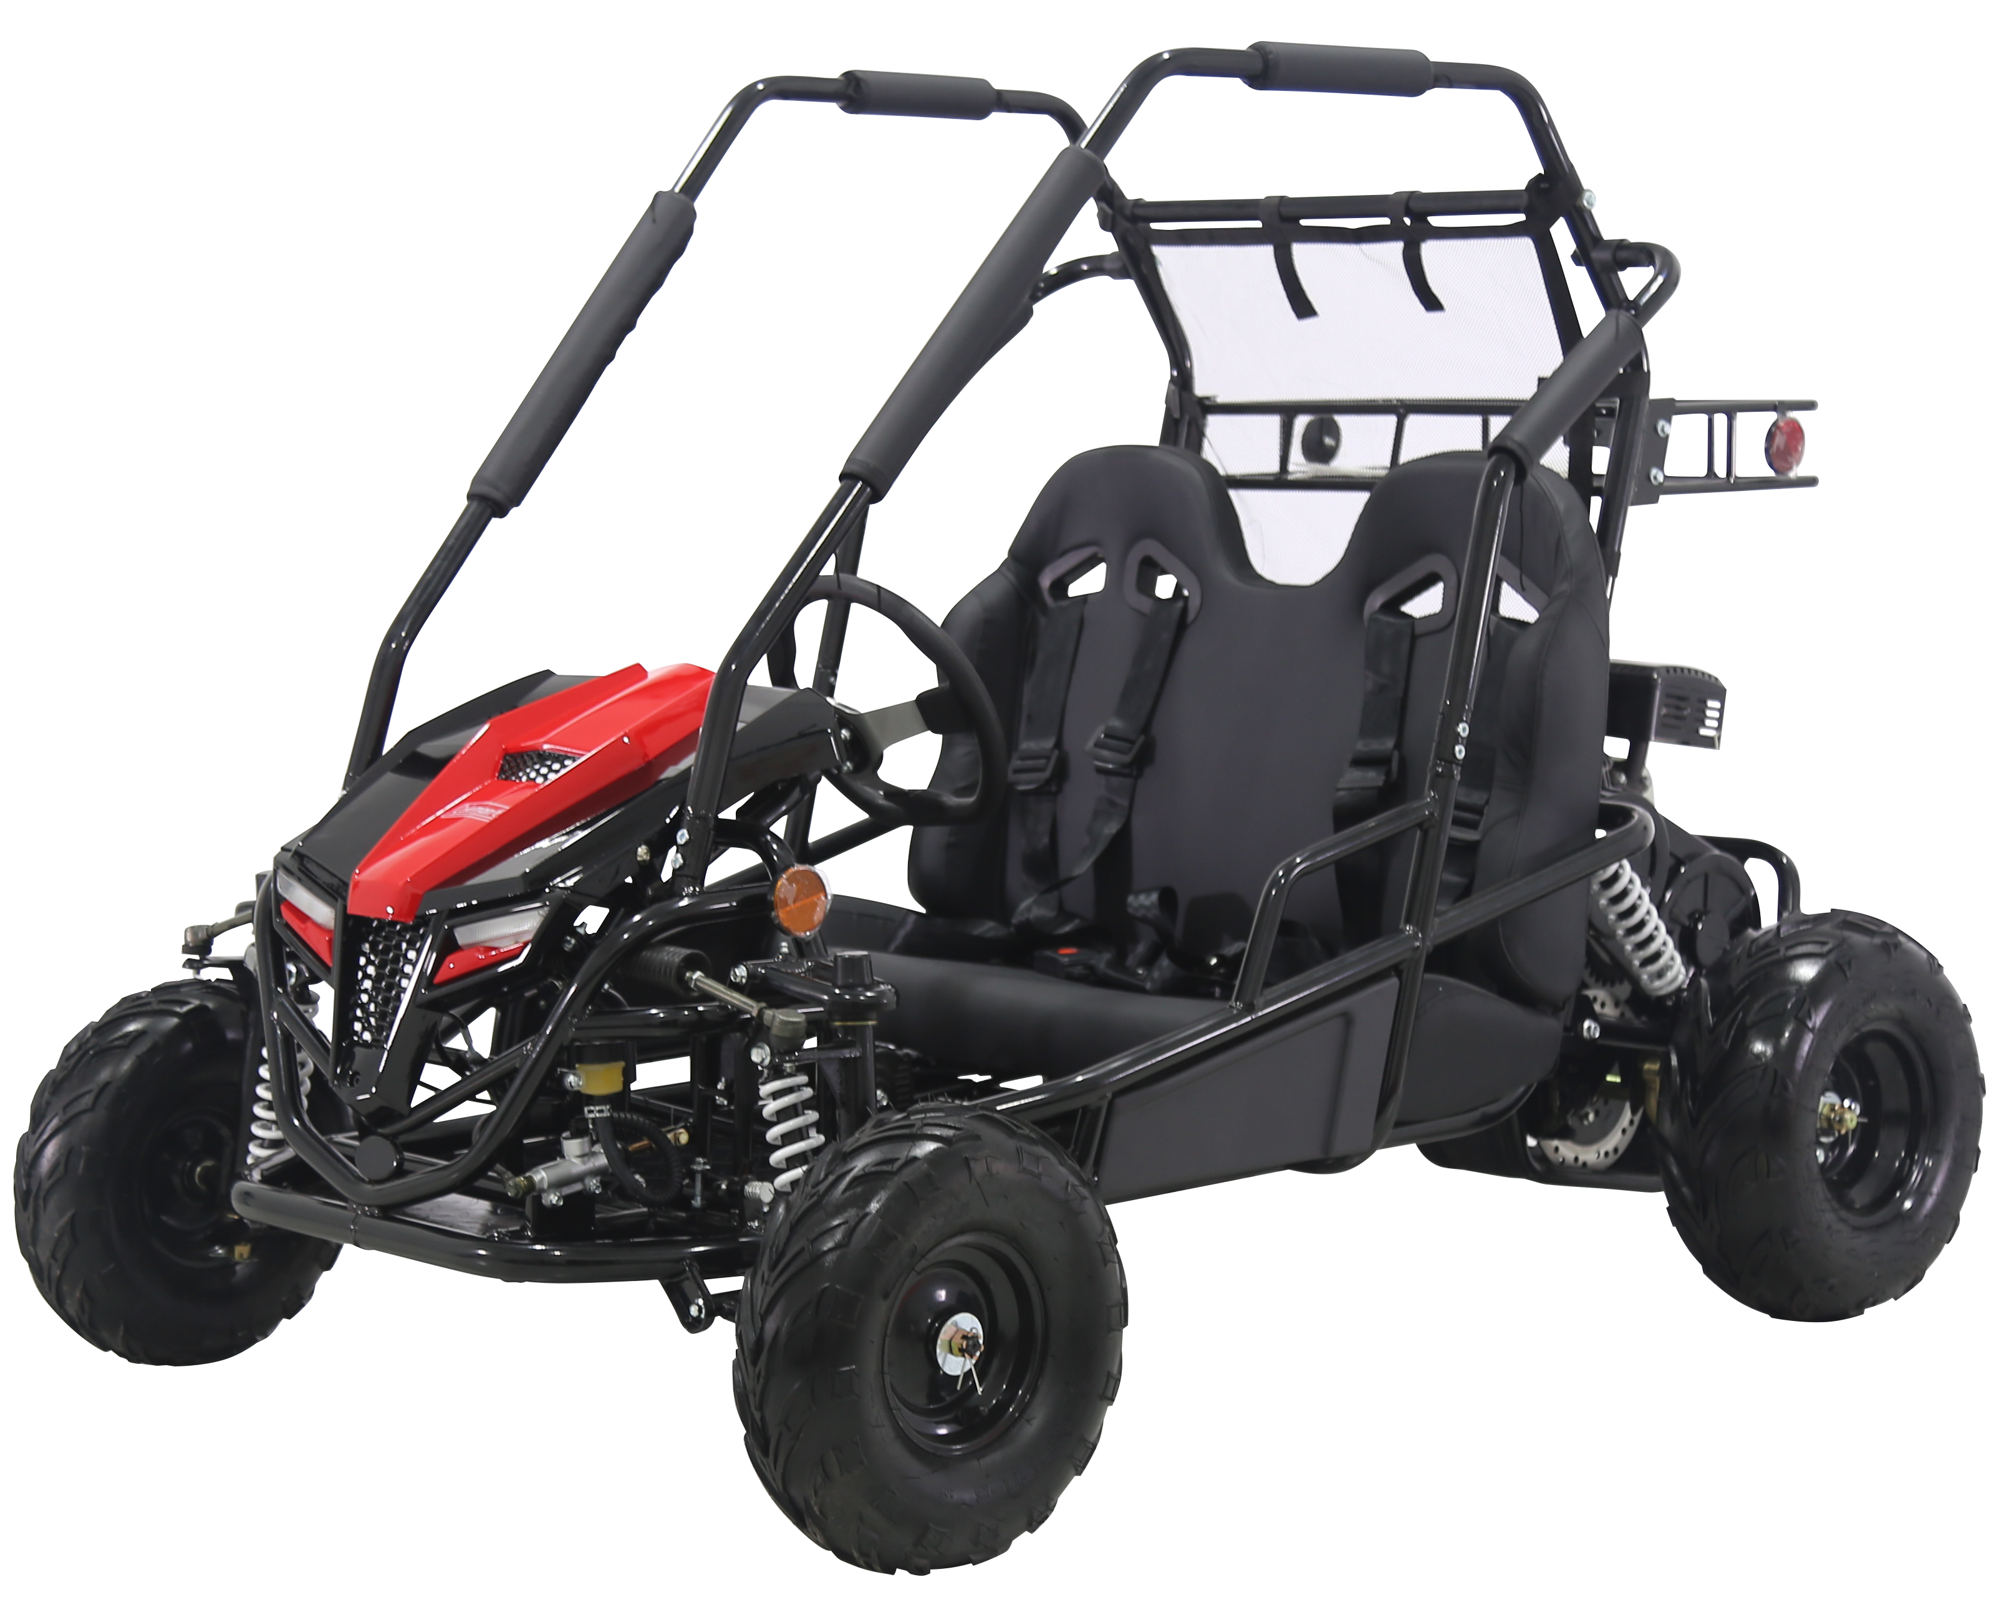
Figure 1:Selected Go-Kart

Deliverables
The deliverables of this project are largely centered around the presentations, prototypes, and final designs of the components on the autonomous vehicle. However, each deliverable varies based on the submission dates for the course compared to the client.
In the first semester, the course deliverables include the team charter, initial design report, conceptual design report, three presentations, final CAD, BoM, prototypes, and the team website. Along with these deliverables, peer evaluations, timecards, and meeting minutes were completed throughout the semester to keep track of the team’s progress. The team charter establishes guidelines for project etiquette so that all members may act accordingly, and the project can run as smoothly as possible. In the second semester, the team charter was updated to better fit the expectations and roles of each team member. Each report served to outline the progress that the team collectively made in the Fall. The presentations helped maintain the organization and demonstration of each completed deliverable to be shared with an audience. They also include individual research and analysis with the Literature Review and Mathematical Modeling sections, divided by team members. Meeting minutes and agendas are written up in a "Staff Meeting" document to keep meetings organized and to ensure all discussions are recorded for future reference. The final CAD and BoM deliverables act as a final design proposal and encompass all conceptual design work done throughout the last two semesters. The prototype and design iterations keep the instructor informed of progress with practical demonstrations, and the team website displays the team and the progress in the last year.
The client deliverables are similar to their respective course counterparts, as they ensure all relevant parties receive the same information and advise accordingly. The client deliverables have been based on reporting progress, by which the presentations, reports, prototype iterations, final designs, manufacturing, and the website demonstrate the team's achievements. Similar to the course guidelines, the presentation and reports showcase conceptual design and intellectual contributions, while the demonstrations are the actualizations of this work. The clients have also checked the team’s progress and results with the help of all deliverables.
This team is not affiliated with any competitions, meaning there are no additional deliverables for such a case.

Success Metrics
The success of this project largely centers on whether the vehicle can drive autonomously and respond to the control without any safety issues. In terms of the success matrix, the braking, steering, and throttle mechanisms as well as their interactions will be assessed along with the electrical components.
For all of the sub-components, response times will be measured for each mechanism as well as their corresponding time within the neural network. The ideal response time as well as the required figures for the project to be a success are defined in Engineering Requirements.
The brake system will work successfully once it is able to safely react according to its surroundings, whether that is coming to a complete stop or regulating the go-kart speed. It must also be able to transfer control to the user once manual override is enacted. Measurements for the required forces will be applied to regulate speed and ensure that the braking system employs those forces in the appropriate instances. The system responding to certain instances is dependent on the neural network detecting obstacles. The braking mechanisms will successfully respond to the neural network when the neural network can send out the right signal to the mechanisms, which can then transmit correct force respective to that signal.
For the steering system, the control device applied the right amount of torque to the wheel for the vehicle to navigate safely and respond to manual override. In terms of torque, the feedback from the encoders on the steering column and steering wheel to track the angle and were compared to calculation-based predictions to examine how the mechanical components will behave successfully. The design must also include a control unit attached to the steering column that includes a kill switch mechanism. To determine that the kill switch is successful, the user interference and the neural network must be easily accessed to remain in charge of the control device. The kill switch must be easy to access and be intuitive for the driver to utilize should they need it. It must also interact with the neural network in such a way that it halts autonomous operations and turns control over to the user. The kill switch metrics were tested practically in a safe environment once attached to the go kart and proved to be successful.
Like the steering systems, the throttle was deemed successful once it responded as expected to the control programming in a safe manner. It achieved a target speed decided by the neural network at a close-to constant acceleration to avoid jerking. The force enacted onto the system was determined once the neural network sent a signal and when the vehicle began to accelerate. Calculations for expected speed and acceleration were used given a certain force to compare the findings to the recorded measurements. The throttle was able to achieve maximum speed without exceeding it. The throttle also disengages once the kill switch is used or enough manual override force is enacted.

REQUIREMENTS
To ensure the success of the project, the requirements have been carefully chosen and established from both the clients' perspective and an engineering perspective. These requirements are an important factor because they provide the team with specific constraints, expectations, and goals for the completion of this project. In this section, the customer requirements (CR's) are listed in terms of the capstone, and the engineering requirements (ERs) are broken down into sub-teams. To aid in organization, each sub-team has a QFD (Quality Function Deployment) chart that identifies the most important engineering requirements that were prioritized throughout the past year.

Customer Requirements (CRs)
This section details the client-specified needs which include autonomous navigation, obstacle detection and avoidance, manual override, real-time state monitoring, safety features, and performance criteria such as speed limits and battery life. Below is a list of the customer requirements given by the clients at Boeing.
- CR1 - Autonomous Navigation
  - The buggy must steer, accelerate, and brake on a predefined path without any human interference.
- CR2 - Obstacle Detection
  - The buggy must be able to detect static and dynamic obstacles in its path to stop before collisions.
- CR3 - Manual Override
  - Each autonomous sub-team must have a manual mode that allows the driver to mechanically control the buggy, full disengaging the autonomous mode to avoid system interference.
- CR4 - Real-Time State Monitoring
  - The buggy must provide real-time feedback to a computer-based monitoring system that can determine errors and provide live-time data that can be monitored during travel time.
- CR5 - Emergency Stop Mechanism
  - There must be a physical emergency stop button that safely halts the vehicle mounted in an accessible area of the go-kart.
- CR6 - Fail-Safe Design
  - The system must be able to disengage all electrical components and stop safely in the event of any failure.
- CR7 - Battery Life for Continuous Operation
  - The buggy must operate autonomously for a minimum of 20 minutes on a single battery charge.
- CR8 - Support for Driver Assistance and Autonomous Modes
  - The system must support both manual and autonomous modes during every drive or operation.
- CR9 - Actuator Control for Subfunctions
  - The system must enable lane-keeping assist and other driver aids by controlling the buggy’s main subfunctions.
- CR10 - Integration with Open-Source Autonomous Platforms
  - The system must integrate with open-source self-driving software and sensor data to enable autonomous driving capabilities.
- CR11 - Prioritized Safety Features
  - The system must prioritize safety features like emergency stop, kill switch, and validated fail-safe mechanisms.
- CR12 - Closed-Course Testing with Controlled Parameters
  - The system must be tested on a closed course with defined performance parameters (e.g., speed, path accuracy, obstacle avoidance) to validate its functionality and reliability.
- CR13 - Comprehensive Documentation and Handover
  - The project must deliver a complete handover package within a comprehensive report including an operations manual, CAD models, Bill of Materials (BOM), software integration details, test reports, and a prototype demonstration of how to use the self-driving features.

Engineering Requirements (ERs)
This section summarizes quantifiable performance, safety, reliability, usability, scalability, and maintainability requirements provided by the client, along with additional engineering specifications defined to meet client expectations. The client has provided the following list of requirements to ensure successful completion of the go-kart’s autonomous construction.

General Engineering Requirements
The system's obstacle detection and avoidance algorithms shall have a response time of less than 500ms to ensure safe operation. The buggy's top autonomous speed shall be no more than 14 kph (9 mph). The system shall operate for a minimum of 20 minutes on a single battery charge during continuous autonomous operation.

Brakes Engineering Requirements
- ER1 - Manual Override Response Time
- ER2 - Actuation Response Time
- ER3 - Brake Disengage Time
- ER4 - Brake Disengage Time (dynamic)
- ER5 - Distance Traveled During Braking (dry)
- ER6 - Speed of Actuation
- ER7 - Ability to maintain user control
- ER8 - Braking in Rainy Conditions
- ER9 - Braking in Snowy Conditions
- ER10 - Number of times kart can brake before failure
- ER11 - Operation Time (continuous)
- ER12 - Intuitive Failsafe Testing
- ER13 - Maintainability of Components
- ER14 - Protection of Subsystem
- ER15 - Torque Contribution (from caliper tests)

Steering Engineering Requirements
- ER1 - Manual override response time (<500ms)
- ER2 - Actuation response time (<1000ms)
- ER3 - Time to achieve angle (500ms)
- ER4 - Time to start turn (300ms)
- ER5 - Rate of steering (100°/s)
- ER6 - Right Turning Radius (6m)
- ER7 - Left Turning Radius (6m)
- ER8 - Max Rotation Range (45°)
- ER9 - Left wheel angle (45°)
- ER10 - Right wheel angle (45°)

Throttle Engineering Requirements
- ER1 – Maximum Speed
- ER2 – Throttle Lever Force
- ER3 – Manual Override Response Time
- ER4 – Actuation Response Time
- ER5 – Failsafe Response Time
- ER6 – Electrical Pedal Force Range
- ER7 – Throttle Cable Velocity
- ER8 – Spool RPM at Maximum Throttle
- ER9 – Required Force to Pull Throttle Cable

House of Quality (HoQ)
The House of Quality (HoQ) is one of the matrices of the Quality Function Deployment. The HoQ is utilized to maximize efficient planning that considers the clients' needs and requirements, the team's understanding of its clients, and the technical engineering requirements for the project. Boeing Autonomous has created a HoQ for each sub-team for focused decision-making.

Brakes
The House of Quality (HoQ) presented for the autonomous go-kart's braking subsystem serves as a critical tool to align the customer requirements with the technical specifications, ensuring a robust and effective design process. The team has meticulously defined customer needs, such as reliable braking performance, rapid response times, and safe operation under varying conditions, as outlined in the customer requirements document (e.g., for the emergency stop mechanism and for fast response to obstacles). These needs are mapped against technical requirements such as braking force, actuation time, and power consumption derived from the System Requirements Specification and project kickoff details. The HoQ, with its weighted relationships and prioritized targets (e.g., braking within 500ms as per SRS 3-1), allows the team to identify key areas of focus, such as optimizing brake actuator responsiveness and ensuring durability. By integrating customer feedback, like the emphasis on safety from the Canvas project file, and balancing trade-offs (e.g., power consumption vs. performance), the group aims to deliver a braking system that not only meets but exceeds expectations.
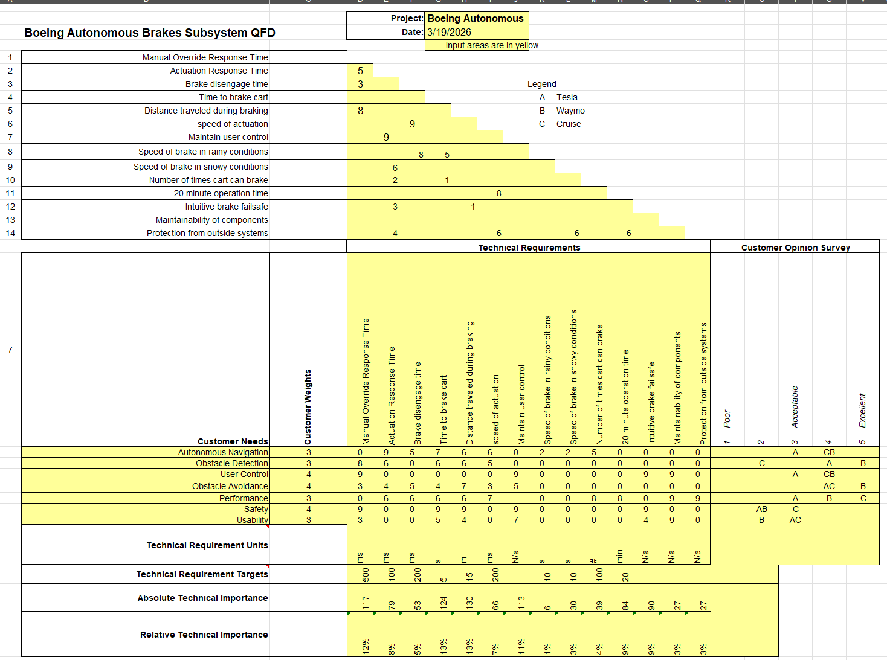
Figure 2: Brakes QFD

Steering
The QFD for steering displays the customers’ needs and weights, that were derived from a list of functional and nonfunctional requirements given by the clients. For the customer needs, the steering sub team will be focused on autonomous navigation, obstacle detection, user control, obstacle avoidance, performance, safety, and usability. The customers’ needs were compared with the three companies of our choice for benchmarking, Tesla, Waymo, and Cruise. The technical requirements are manual override response time, actuation response time, time to achieve angle, time to start turn, rate of steering, right turning radius, left turning radius, max rotation range, left wheel angle, right wheel angle. As depicted in Figure 3 below, response time was determined to be the most important technical requirement based on the weighed customer needs.
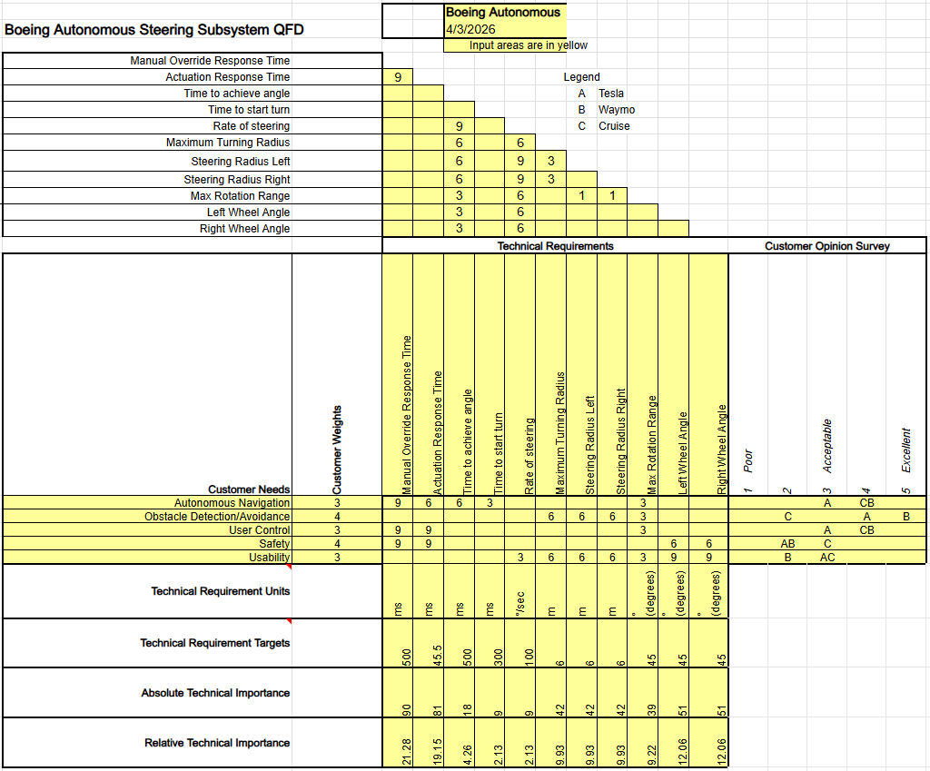
Figure 3: Steering QFD

Throttle
The QFD in Figure 4 for the throttle subsystem followed similar criteria to the brakes and steering subsystems. However, the engineering requirements have been updated regarding the technical requirements based on the most updated parameters to define the success of the throttle mechanism. Because the safety of the throttle subsystem largely depends on the electric pedal and mechanical failsafe in the throttle lever, the technical values were evaluated to the most accurate extent, demonstrating the importance of each technical parameter. The technical requirements include the go-kart’s speed range, the spring force range, the response time for the manual override, actuation, and failsafe. The electrical pedal force, throttle cable velocity, spool rpm and required force on the throttle cable were also in the engineering requirements. These were compared to the listed customer requirements, which included autonomous navigation, obstacle detection/avoidance, user control, performance, safety, and usability. The customer surveys from Tesla, Waymo, and Cruise helped compare these needs. Through the QFD process, the electric force range and the failsafe response time were the most relevant criteria for the design and manufacturing of the throttle mechanism. The sub-team concluded that the electric pedal force range had the most significant impact on the go-kart’s safety and efficiency.
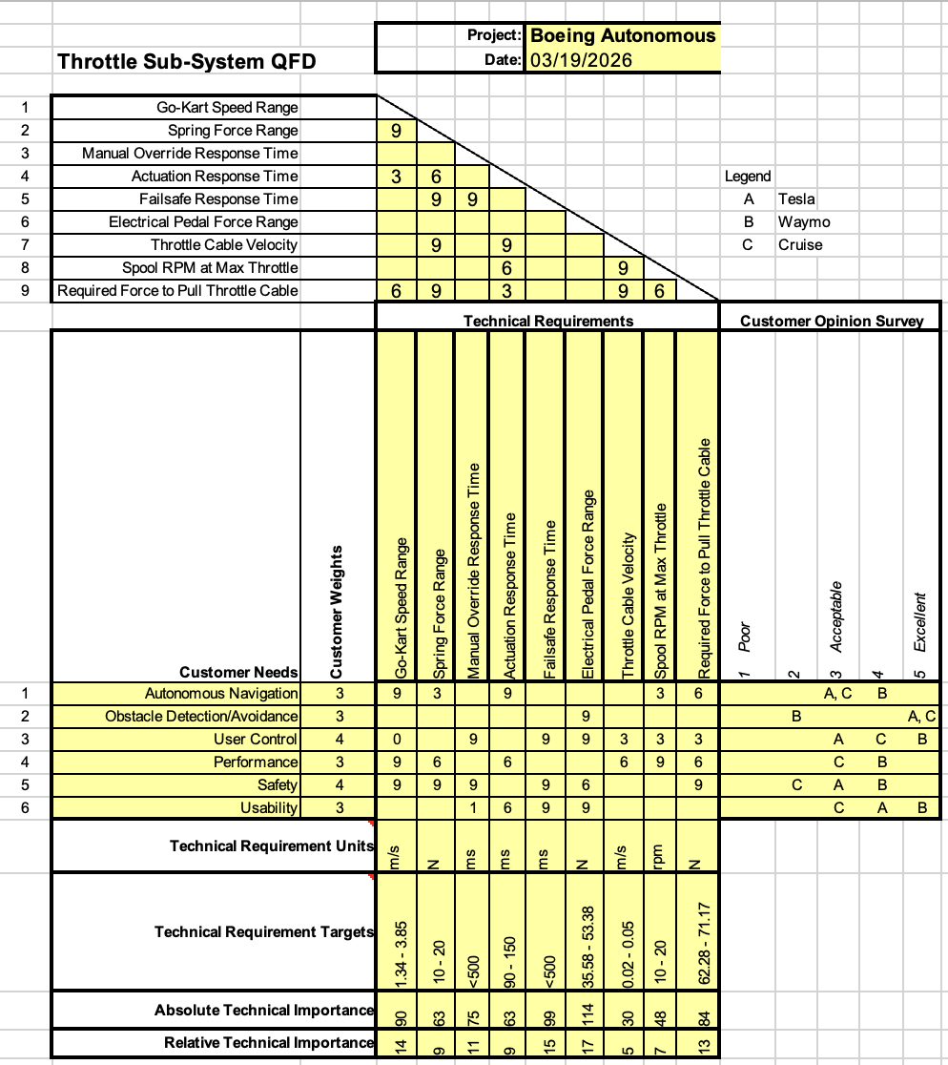
Figure 4: Throttle QFD

Research Within Your Design Space
In this project, the effort of the team is represented in understanding and analyzing existing technologies, relevant literature and patents, and mathematical analyses that have informed the development, design, and manufacturing of each sub-function. Subsystem-level benchmarking was conducted to identify targets and design insights for the project. Afterwards, an extensive literature review was conducted, individually summarizing multiple sources that have provided insight and guidance. Finally, mathematical modeling was used to solve important inquiries that could affect the design and enabled the team to predict performance, optimize designs, and ensure compatibility across the project.

Benchmarking
To form an idea of the current state of the field of automated vehicles, the top autonomation companies, Tesla, Waymo, and Cruise, were thoroughly evaluated. Each company highlights important areas of consideration, such as whether the vehicle should steer using lidar or cameras, or both. Waymo has gained traction for the issues with training a lidar system. Tesla uses highly specified cameras, in which they compare their system to human eyes [1], while Waymo and Cruise use LiDAR control systems [2] [3]. Nonetheless, these differences still allow both companies to produce the best results. LiDAR cameras have strong depth perception, being able to detect within 30cm-3mm. However, this clarity does not remain as accurate for objects at a distance greater than 200m. Cameras can detect objects within 1.2 megapixels, but the disadvantage is a lack of accurate depth perception and computation power. Using these companies as benchmarks has allowed the team to consider recurring challenges within the design space.

Literature Review
Listed below is an annotated bibliography of all the references used by each team member in this project. This list serves as a top-level summary of how each source was helpful to the completion of this project, as well as what specific content was most significant. Moreover, engineering standards were also used as crucial parameters to fill in specific constraints for the autonomous system of the go-kart that were not outlined in the customer or engineering requirements. Those standards are outlined at the end of this literature review.

Elise Chantegros
A Hybrid Model for Vehicle Acceleration Predictions [4]
This paper uses real driving data, clusters different acceleration patterns, and then applies deep learning to more accurately predict a vehicle’s short-term acceleration. For our project, this idea is relevant because better acceleration prediction can help the controller choose safer, smoother throttle commands instead of just reacting in real time.
Design and Implementation of a Fault-Tolerant Drive-by-Wire System [5]
This thesis develops a fault-tolerant drive-by-wire system that uses redundancy, failure detection, and safe-state responses to maintain control of steering, braking, and throttle even when components fail. It demonstrates how distributed control, hardware monitoring, and safety-oriented structures improve the reliability of electronic vehicle systems. This relates to our project because it involves design principles such as redundancy, component monitoring, and fail-safe behavior, which are important when adding autonomous features to any vehicle system, including throttle control.
Electronic Throttle Control – A Dependable Case Study [6]
This paper evaluates the safety and reliability of electronic throttle control systems by modeling faults, redundancy, and ECU monitoring strategies to prevent unsafe events like unintended acceleration. The authors compare multiple ETC architectures and show how added checks and redundancy greatly improve safety with minimal extra cost. This relates to our project because it highlights proven safety practices, like sensor redundancy, plausibility checks, and fail-safe modes, that can inform how we design a safer autonomous throttle system.
Model Predictive Path Following Control for Autonomous Cars Considering a Measurable Disturbance: Implementation, Testing, and Verification [7]
This paper presents a model-predicative path-following controller for autonomous cars that accounts for road boundaries, vehicle shape, and disturbances from changing road conditions. To make the controller fast enough for real-time use, the authors replace traditional solvers with a differential evolution-based optimization method and experimentally verify that it performs reliably on an autonomous test vehicle. This relates to our project because it highlights how predictive control and real time optimization can improve autonomous steering and navigation.
Accurate and Smooth Speed Control for an Autonomous Vehicle [8]
This paper presents a preview-based control algorithm for automated vehicles that uses future road slopes and target speed information to improve speed tracking. Compared to a standard PID controller, it achieves smoother throttle and braking, lowers tracking errors, and improves ride comfort. This method is relevant to our project because it demonstrates how incorporating predictive information into control systems can improve performance and vehicle response. Implementing a similar approach could help optimize our throttle control for a more precise and efficient operation.
Throttle Control of Engine by Using PMDC Motor and Drive [9]
This paper discusses the design and control of an electronic throttle control (ETC) system using a permanent magnet DC (PMDC) motor, which allows precise regulation of the engine airflow through feedback and pulse-width modulation (PWM). It highlights how the system achieves fast and accurate throttle responses using PID and nonlinear control strategies, despite nonlinearities and friction. In our go kart, this system can automatically manage the throttle position to control speed and acceleration safely and efficiently.
Diagnosis of Automotive Electronic Throttle Control Systems [10]
This article discusses how drive-by-wire (DBW) systems replace traditional mechanical linkages with electronic controls, which allow the driver's inputs, such as throttle, brake, and steering, to be managed through sensors and actuators. It demonstrates that Electronic Throttle Control (ETC) is a key subsystem of DBW, where the accelerator pedal sends signals to the ECU, which then adjusts the throttle actuator electronically. This setup allows for smoother and more precise throttle modulation without having mechanical cables. This paper relates to our project as integrating ETC provides for the computer to control acceleration through electronic signals instead of manual input autonomously.
Drive-by-wire Conversion for Autonomous Vehicle [11]
This article discusses drive-by-wire (DBW) technology, which replaces mechanical linkages with electronic systems such as throttle-by-wire, brake-by-wire, and steering-by-wire. DBW has benefits such as reduced weight and improved precision, however, it faces challenges with software reliability and sensor failure. This technology is relevant to our project as it enables autonomous control of the throttle and pedals through software commands.
Digital Twin System for Automotive Safety with Integration of a Safety Controller [12]
This thesis presents the development of a Digital Twin System for autonomous vehicle applications, integrating real and virtual environments to test and validate control systems in real time. It focuses on the modeling and simulation of vehicle dynamics, actuator control, and electronic subsystems such as throttle, brake, and steering within a hardware-in-the-loop framework. By enabling safe and efficient testing without requiring physical prototypes, the Digital Twin System supports the design and refinement of autonomous driving functions. This is relevant to our project because it demonstrates how throttle and other drive-by-wire systems can be virtually modeled and controlled to optimize autonomous performance and system integration.
Autonomous Braking and Throttle System: A Deep Reinforcement Learning Approach for Naturalistic Driving [13]
This paper represents a Deep Reinforcement Learning approach using the Deep Deterministic Policy Gradient algorithm to create an autonomous braking and throttle system that mimics human driving. The system was tested in simulations to smoothly adjust throttle and brake inputs for collision avoidance and natural vehicle control. This is relevant to our throttle subsystem because it demonstrates how learning-based control can enable smooth, adaptive throttle response for autonomous operation.

Selina Cozens
Reinventing the Wheel: Transforming Steering Wheel Systems for Autonomous Vehicles [14]
This article conducts a study on two different types of steering wheels: robotic and LED. These steering wheels were programed to warn the driver of upcoming hazards. The robotic steering wheel warned the driver mechanically while the LED steering wheel warned the driver physically. The robotic steering wheel was found to be more effective at getting the driver’s attention. This study may be utilized as a potential safety modification for the project.
Nonlinear Steering Wheel Angle Control Using Self-Aligning Torque with Torque and Angle Sensors for Electrical Power Steering of Lateral Control System in Autonomous Vehicles [15]
Most modern-day cars use electric power steering (EPS). However, for the EPS to work properly, the self-aligning torque is seen as a disturbance and is rejected. However, this study proposes an idea to utilize this self-aligning torque through a nonlinear control of the steering wheel angle. This study can be useful for the design of this project's DIY EPS kit.
Electric Power Steering Automation for Autonomous Driving [16]
This paper discusses a fuzzy based control system that can be applied to mass produced electric power steering systems that can mimic human behavior. The control system of choice for the study was the Citroën C3 Pluriel. Some experiments were conducted on a private test circuit which was found to obtain human-like behavior in all mannerisms. This study can help the steering sub team with programing the EPS.
Predictive Active Steering Control for Autonomous Vehicle Systems [17]
In this paper, a study is performed using a model predictive control (MPC) to control the steering wheel for autonomous vehicles. The MPC is used to calculate the steering angle required to navigate through icy or slippery roads. There are two approaches this test takes, a nonlinear vehicle model and a successive online linearization of the vehicle model. The study can be useful for the programming of the steering sub team's EPS since Flagstaff is a snowy city.
Automatic Steering System [18]
This paper discusses the creation of a “pre-notification” that can be attached to both automatic and manual vehicles to reduce the chances of car accidents and further advance the creation of autonomous vehicles. This safety modification consists of having the motor of the EPS connected to an electrical control unit (ECU) and moving with the steering shaft in both manual and automatic steering modes. This study can be useful when it comes to the design of the DIY EPS kit.
Real Time Ackerman Steering Angle Control for Self-Driving Car Autonomous Navigation [19]
The Ackerman Steering Angle is a well-known formula that can predict the angles that a vehicle can make based off of its dimensions. This study proposes an idea for autonomous steering to use this formula with sensors that are used for lanes lines detection. The use of sensors and the Ackerman Steering Angle is very similar to the draft idea the sub team has for the DIY EPS kit. This study can be useful for implementing the Ackerman Steering Angle formula into the controlling unit.
Simulation of the Effect of Turning Steering Wheel Intensity on the Vehicle Stability [20]
This article discusses a mathematical model that has been developed to show the effect of the drivers’ steering wheel turning intensity on the vehicle’s stability. This study experiments with the effect of steering wheel intensity on the stability of the vehicle. This source was used to ensure the autonos steering doesn’t interfere with the stability of the go kart.
Investigation on 3D Printing Parameters of PLA Polymers for Gear Applications [21]
Fused Deposition Modeling (FDM) enables low-cost complex part fabrication with a wide range of materials making it a popular option across industries. This study experiments with how various FDM parameters such as temperature, layer height, print speed, and infill pattern affect the mechanical and tribological (wear and friction) behavior of PLA for gear applications. This study will aid the steering sub team by providing more insight for the realities of using 3D printed PLA for prototyping a helical gear train.
Feasibility Investigation of Gears Manufactured by Fused Filament Fabrication [22]
This paper experimented with the production and tests of plastic gears made by fused filament fabrication (FFF). Different 3D printers of high and low quality along with multiple materials were used to print the gears. The study found that the quality and accuracy of the geometry from the printing process was not responsible for the failure of the gears. Instead, for PLA specifically, the gears failed due to the tooth root heating up and affecting the material properties. This study will help the steering sub-team prevent 3D printed prototype gears from overheating and failing.
Surface durability of 3D-printed polymer gears [23]
This study investigates the feasibility of using 3D-printed gears in unlubricated mechanisms. Many types of filaments were tested, and factors were analyzed such as sliding speed, material hardness, surface finish, geometry, and microstructure influence wear. The study found that PLA demonstrated better abrasive-wear resistance than ABS, but ABS had superior overall structural integrity. The findings in this study can influence the type of material that can be used for prototyping the steering prototype helical gear train and can provide guidance for evaluating performance and wear and tear behavior.

Jacob Keeland
Clamping Force Control of Electromechanical Brake Actuator Considering Contact Point [24]
This analysis studies clamping force control in EMB actuators using motor torque, current, and friction lining contact points with the brake disc. Comparing the control strategies and response times found in the study to group testing data could provide information on actuator reliability, force accuracy, and how motor-caliper integration affects autonomous braking performance.
EMB System Design and Clamping Force Tracking Control Using LADRC [25]
The article studies a new EMB mechanism layout with a feedforward second-order linear active disturbance rejection controller for caliper clamping force. Importantly, the article shows improved response speed and anti-interference compared to traditional PID. In the future of this project, special modeling considerations will be needed for the braking system based on controller tuning, motor dynamics, and integration with the DC 550 motor and mechanical caliper.
Clamping-Force Estimation for Electro-Mechanical Brake Using Kalman Filter [26]
The troubles outlined in this study concern accurate clamping force estimation in sensor-less EMB systems using motor current, angle, and torque-balance equations. Though sensor cost is reduced, nonlinear disturbances and friction could impact force accuracy during testing cycles. Another use of this article is applying the motor torque equations to calculate force output from the DC 550 motor to the mechanical caliper.
Design and Optimization of a Novel Electronic Mechanical Brake Actuator Based on Cam [27]
This paper analyses a novel EMB actuator using negative radius roller cam mechanism for clamping with motor drive. These designs can be used with other sources for modeling to predict maximum clamping forces and efficiency that can be achieved without losing braking effectiveness in autonomous systems. With the data measured, comparisons can be made between traditional calipers and the motor-driven mechanical caliper system being developed.
Review on the Development, Control Method and Application Prospect of Brake-by-Wire Actuator [28]
This article explains the development, structures, and control methods of brake-by-wire actuators including motor-driven EMB designs with gear and screw mechanisms. Using the models and torque transmission formulas in this article will be a very rough estimate of the go-kart’s braking response with the DC 550 motor. Further use of modifying these equations could yield more precise estimates with further testing and prototype updates.
Clamping Force Control Strategy of Electro-Mechanical Brake System Using VUF-PID Controller [29]
This article is a detailed look at variable universe adaptive fuzzy PID control for EMB clamping force with planetary gear and ball screw in the caliper. Several related formulas for torque output, friction modeling, and dynamic response are particularly helpful in analysis of the DC motor-driven mechanical caliper subsystem.
Electro-Mechanical Brake System Architectural Design and Analysis Based on Functional Safety [30]
This analysis studies EMB architectures with servo motors, transmission, and wheel-end calipers for intelligent vehicles. Comparing the safety levels (ASIL) and redundancy designs found in the study to those gathered through group testing could provide information on critical events such as actuator failures and how motor-caliper integration supports autonomous braking.
Review of Brake-by-Wire Technology for Low-Speed and Autonomous Vehicles [31]
The article studies BBW structures including EMB variants with motor plus caliper actuation, control strategies, and performance gaps in low-speed autonomous applications. Importantly, the article discusses response time, fault tolerance, and integration challenges. In the future of this project, special modeling considerations will be needed for the braking system based on sensor fusion and motor control for the DC 550 motor plus mechanical caliper design.
A Review of Electro-Mechanical Brake (EMB) System: Structure, Control and Application [32]
This paper focuses on EMB system structures, force-amplifying mechanisms, sensor-less clamping force estimation, and applications in intelligent vehicles using motor-driven calipers. There are plenty of usable formulas and control algorithms found within the report that will make future analysis more accurate for safety and reliability assessment of the prototype.
High-Quality Clamping Force Control for Electro-Mechanical Brake Considering Nonlinear Disturbances [33]
This article is a focused look at dynamic modeling and control of EMB executive mechanisms with motor-driven caliper actuation for improved braking performance. Several related formulas for torque-to-force conversion and disturbance rejection are particularly helpful in analysis and benchmarking against best-in-class systems.

Marek Lemieux
Vehicle Braking, Stability and Control [34]
This analysis studies the braking systems and tires of a vehicle set to brake in a straight line compared to a control which drives without using brakes. Comparing the measurements found in the study to those gathered through group testing could provide information on critical events such as rollovers, accidents, and how steering affects the braking system.
The Effect of Tire Break-In on Force and Moment Properties [35]
The article studies the interactions between the tires of a braking vehicle and the road beneath it. Importantly, the article notes that there is no possible way to have a single governing equation to study the effects of braking tires on the surface. In the future of this project, special modeling considerations will be needed for the braking system based on the curvature of the road, the road consistency, the weather conditions, and any considerable outside factors.
Analysis of heat conduction in a disk brake system [36]
The troubles outlined in this study concern the possibility of brake fluid vaporization caused by frequent or long distanced disk braking. Though this should not be of concern for short term applications, the consistent use over the proceeding testing cycles could have a significant impact on brake fluid, impacting results. Another use of this article is using the force applied to the disk to calculate energy loss from the system.
On the Distribution of Braking Forces in Road Braking [37]
Using road regulations from Finland this paper studies the effects of braking forces on a vehicle’s axels. This can be used with other sources for modeling to predict the maximum turning forces applied to the vehicle while braking that can be accomplished without losing brake effectiveness.
Acceleration-Deceleration Behavior of Various Vehicle Types [38]
This paper analyses the behaviors of drivers of different sized vehicles when approaching or leaving a stop light. These statistics can be used to influence where stop lights are placed, but they also include determination of sight and statistics for human drivers. With the data measured, comparisons can be made between human drivers and the autonomous system being developed.
Autonomous Vehicles Testing and Operating in the State of Arizona [39]
These are the current Arizona laws of autonomous vehicles operating on roads and streets. In this stage, it is almost certain the vehicle will not be testing on public roads, but it is still good to have every case covered in case further testing is needed.
Braking distance [40]
This article explains braking distance history, uses, and simple formulas. Using the simple models in this article will be a very rough estimate of the karts braking distance. Further use of modifying these equations could yield more precise estimates in future testing.
Acceleration [41]
This article explains acceleration history, uses, and simple formulas. Using the simple models in this article will be a very rough estimate yielding the vehicles' deceleration from maximum speed. Further use of modifying these equations could yield more precise estimates with further testing.
Design and analysis of a brake caliper [42]
This paper focuses on analyzing a typical brake caliper and the forces applied using some very interesting finite analysis. There are plenty of usable formulas and constants found within the report that will make future analysis more accurate.
Motor Torque Calculations for Electric Vehicle [43]
This article is a much more generalized look at the torque found within electric vehicles in several states. Several related formulas and a table of rolling resistance coefficients are particularly helpful in analysis.

Desirae Mangum
Steering System and Method for Autonomous Vehicles [44]
This resource is a European patent specification for an autonomous steering mechanism, including methods for operation. This document will allow us to generate a well-rounded idea of what we need to design moving forward. The description of how it works provides a deeper understanding and insight into what we are designing to be able to do.
Intelligent Electric Power Steering: Artificial Intelligence Integration Enhances Vehicle Safety Performance [45]
This article focuses on electric power steering systems and how they have developed over the years. Discussing the safety parameters surrounding power steering systems and the challenges that occur when AI is implemented into the automotive field. Using this knowledge to not only understand how these systems work, but also how we can use them to our advantage while designing our own system.
Analysis and Robust Control Design of Steering System for Autonomous Vehicles [46]
This resource provided an analysis of the steering systems for autonomous vehicles with a robust control design. Showing both the simulation and the methods applied to perform the required calculations. This article provided a unique perspective on the results produced, allowing a deeper understanding of autonomous vehicles and what knowledge is needed to be successful.
Simulation Studies – Path Tracking of an Autonomous Electric Vehicle (AEV) by Using Fuzzy Information of Speed and Steering Angle [47]
This article discusses the issues that will arise when you are turning a vehicle autonomous, more specifically, electric vehicles. Knowing potential issues will allow us to plan to avoid these issues or design to solve these problems. This knowledge will allow us to stay ahead of the problems and stay on our timeline to have a successful project.
Model Predictive Control-Based Path Tracking with Four-Wheel Independent Steering, Driving, and Braking Autonomous Vehicles on Low Friction Road [48]
This report focuses on a similar vehicle setup to what we will be working on, and the controlling aspects to consider. Providing insight into how to create a predictive control system based on path tracking, touching base on the braking system to ensure that all safety components are being taken into consideration. The takeaway from this source is that a model predictive control system requires multiple trials to ensure that all systems are properly executed.
Development of Steering Control System for Autonomous Vehicle [49]
This report is a similar study to that of what we will be producing by the end of this project, focusing on the steering of autonomous vehicles. Providing a background of steering technology and an example method of integrating an autonomous system into existing systems. Using this article to have an idea of the direction of the project, gaining ideas for calculations and potential results.
What is the Role of Steering Angle Sensor in Autonomous Driving? [50]
This YouTube video provides a brief explanation of the roles of the steering angle for the sensor when implementing an automated system. First, explaining what exactly the steering angle is and how it can be found, and then explaining the importance of the angle when using sensors. This information was used to develop a further understanding of the aspects involved in designing an autonomous steering system.
Mechanical Engineering Design [51]
This textbook provided the know to analyze the stress acting within the gear system used to turn the steering column. As this textbook focuses on the analysis of various parts of engineering calculations related to design including factors of safety. This source proved to be useful for assembly of the gear system throughout the project.
Machinery’s handbook [52]
This source is a textbook that provides deeper explanations of designing various mechanical components. This source was used to help justify a 2.5:1 gear ration to show was it could be more beneficial for the team’s design. With various components within the book this source will continue to be useful as the team runs into mechanical errors and issues.
Spur Gear Design in SolidWorks [53]
This video comes from YouTube and allows an understanding of creating size varying helical gears. This source was used to show how gear can easily be changed when equations are used for the dimensions. With this new skill iterations of gears will be easier to produce within SolidWorks, allowing for more time to focus on mechanical issues within prototyping.

Natasa Peric
A Recommended New Approach on Motorization Ratio Calculations of Stepper Motors [54]
This article defines the different stepper motors that are used in a variety of fields based on their torque and cycle ratios. Because they can be used in a variety of environments such as aeronautical and automotive fields, the article highlights the significance of accurately calculated torque ratios in stepper motors. It also emphasizes the impact of different torques in a mechanism, which has proven to be useful for calculating the net torque in the stepper motor used by the throttle sub team.
3D Printing of Automobile Power Transmission System Using Tough PLA [55]
This paper explains the benefits and possible risks that arise with the use of PLA material in 3D printed components used in the automotive industry. This article is important to the throttle sub team's approach in 3D printing the spool attached to the motor stepper, as it can be a possible risk over time based on regular use. This paper, thus, highlights the importance of using the correct plastic material to ensure that 3D printed objects can be used for automotive based components.
Past and Future Practical Solutions for Torsional Vibration Damping in Vehicle Industry [56]
This article explains the alternative routes available in overcoming the torsional vibration when a vehicle is in motion through damping mechanisms. It introduces torsional resonance due to the vibrations in an engine that can lead to possible damages and issues within a vehicle. Hence, this article highlights possible risks the added actuation systems may undergo after long periods of drive time when the vehicle is being used.
AUTOSAR-enabled throttle position sensor testing and analysis using MATLAB [57]
This article describes the way MATLAB can be employed to determine and test the parameters of sensors used for a throttle body. It offers an innovative approach to discovering the most effective methods that sensors can be added to a throttle mechanism through an effective simulation. This feature will be important in exploring once sensors are chosen for the throttle components and how they can be accurately monitored through MATLAB.
Multi-Parametric Analysis of a Mimicked Accelerating Pedal (Via DC Motor) of an Electric Vehicle [58]
This paper details the use and abilities of throttle pedal when it is controlled by a DC motor for an electric vehicle. Because it employs a DC motor for its mode of control, the paper offers important details to actuating the pedal, such as the different torque and distances crucial to the implementation and calculations that will allow the pedal to be controlled. This information is important because the throttle mechanism has a very similar approach to actuating the throttle body to make it autonomous.
Safety of 3D Printing in Automotive Industries [59]
This document defines how 3D printed components can be safely added into the creation and improvement of automotive-based machines. It explains the benefits and risks of using different materials such as Nylon 6 compared to traditional materials like aluminum. This evaluation will help the throttle team in deciding what material will be best for the spool design on the motor in the iteration process.
Development of an Emergency Control Algorithm for a Fail-Safe System in Automated Driving Vehicles [60]
This article explains the various options that can be used as a failsafe mechanism for a self-driving vehicle. It outlines the current mechanisms and software systems that are actively used for autonomous vehicles, which can be applicable the fail-safe design built for the throttle sub-system. The NHSTA has proposed several ideas for a fail-safe to be used in autonomous driving, in which the paper offers another approach that may be more universal to the actuation fail-safe for the go-kart. This article, hence, serves as a helpful source in catching the possible risks that must be considered when designing an effective failsafe that must always be employable, especially during operation.
Power Consumption on Arduino Boards [61]
This paper defines how power consumption fluctuates for Arduino-based products and what devices they are compatible with. The throttle body plans to use an Arduino microcontroller, such as a Nano or Raspberry Pi, in which the power consumption will be significant to the control over the throttle's mechanism. Hence, this paper is important in defining what parameters must be considered for the power source in the throttle's actuation system.
Autonomous car following: A learning-based approach [62]
This source outlines a method of autonomous driving on the highway and the different options that exist for the concept and what seems to be the most effective notion. It also details the different ideas there are for transmitting feedback, using reliable safety-related calculations, and determining the proper metrics to make the vehicle act as closely as possible to human-like driving. This document was sourced to gain a better perspective on how others have taken on the challenge to make an autonomous vehicle and what factors others have taken into consideration during both the ideation and constructive process.
Safety goals and functional safety requirements for actuation systems of automated vehicles [63]
This paper offers the specifications to define the safety standards and concepts made for autonomous driving. It highlights the details specifically on the actuation system for steering, brakes, and drives, and thoroughly describes how the wheels and vehicle should follow. This paper is used to better define the safety standards required for the go-kart and how those standards should align with the needs and requirements of the client.
Exploiting over-actuation for improved active safety of autonomous electric vehicles [64]
This article explains the significance of having an over-actuated system especially for the safety and enhancement of autonomous vehicles. Having an over-actuated system will allow for better-regulated controls over the vehicle’s mechanical and electrical components, using redundant inputs for a stronger connection between all the mechanisms added to the g-kart. This article is incorporated to offer the team a better-defined perspective on how safety can be enhanced for the go-kart’s throttle to limit the possibilities or failure or the need to use the manual override option.
Drive-By-Wire Development Process Based on ROS for an Autonomous Electric Vehicle [65]
This article offers a reliable method to incorporating a robot operated system (ROS) to an already existing drive-by-wire throttle mechanism, which is very similar to the throttle sub-team’s approach for autonomous throttle control. The article offers diagrams in relation to the different LiDAR and camera systems that can interact with the electric controls of the throttle for a passenger to enable and disable the self-driving option. This article is highly important in finalizing the method desired by the sub-team to achieve the most straightforward approach for an autonomous throttle mechanism.

Lily Quintanar
Research on the Application of Multi-Sensor Fusion in Autonomous Driving [66]
This source explores the implementation of LiDAR, millimeter wave radar, ultrasonic radar, and cameras in autonomous vehicles. It both compares their performance on an individual level and describes the decision logic when used together. This source was important in contributing to the development of our sensor system.
LiDAR-Based Obstacle Avoidance with Autonomous Vehicles: A Comprehensive Review [67]
This source explores the efficacy of the use of LiDAR in autonomous vehicles by itself and with other sensor types. The authors specifically apply this research to electric power steering (EPS) models using an artificial neural network. This source is relevant to the project because we will be utilizing LiDAR sensors, EPS, and a neural network.
Nonlinear Hybrid Impedance Control for Steering Control of Rack-Mounted Electric Power Steering in Autonomous Vehicles [68]
This source proposes a hybrid impedance control system to create a smoother transfer of control of the wheel from the automated system to a driver. This source, while insightful, focuses on a rack-mounted steering system, which we have ultimately decided against.
Autonomous Driving by Using Convolutional Neural Network [69]
This source explains the relationship between three front-mounted cameras, a convolutional neural network (CNN), and the steering wheel. It describes the testing process for obtaining an accurate wheel angle from data collected by the cameras. This source is relevant to our case because it explains a possible way to train a neural network.
Neural Network-Aided Fast Iterative Model Predictive Control for Autonomous Vehicle Motion Control [70]
This source proposes a data-physics system utilizing a long short-term memory neural network to capture data from and predict non-linear aspects of a vehicle, such as road friction variances. This source is incredibly detailed and will be useful when building our convolutional neural network.
Reinforced Curriculum Learning for Autonomous Driving in Carla [71]
The authors of this paper seek to create and utilize a reinforcement learning (RL) system for autonomous vehicles. They test their code in CARLA, a simulator for testing autonomous driving systems. The code ended up having a few issues including low speed and some collisions, however it will be helpful while we train our RL.
Fault Diagnosis Strategy of Autonomous Steering System for Intelligent Vehicle Based on State Estimation [72]
This source utilizes rack displacement as a state feedback signal into its steering system to determine whether the system is working properly or not. This will be useful later when testing and seeking to reduce error.
Training of a Convolutional Neural Network and Its Object Recognition Ability Depending on Illumination and Contrast of Images [73]
This paper concludes that a qualitative data set is necessary to train a neural network for object recognition. This reduces errors with variances in light sources and contrast.
An Improved Neural Network Algorithm for Intelligent Object Recognition [74]
The research of this paper aims to allow for a neural network to recognize objects that may be out of frame or askew. This helps in building the neural network’s ability to recognize any object and act accordingly.
Advancing Object Detection: A Narrative Review of Evolving Techniques and Their Navigation Applications [75]
This source outlines current algorithms for dynamic object detection and their current and future applications in autonomous navigation. This is important to meet Boeing’s object detection requirements.

Mathematical Modeling
The following summary contains a list of standards, codes, and regulations that the team used to assess the road requirements and proper safety protocol while modifying the go-kart. These rules were significant in ensuring that the changes made to the go-kart would keep a passenger safe at all times and that no modifications can potentially cause harm to the passenger or the individuals around them.

Brakes - Jacob Keeland and Marek Lemieux
- Native Braking System Analysis (Jacob Keeland)
This analysis evaluates the native hydraulic braking system to establish baseline performance prior to autonomous modifications. The results enable comparison between pedal-generated clamping force and brake torque and those produced by the autonomous system, ensuring passenger safety during all testing.

- Assumptions:
- Pedal force input produces consistent master cylinder pressure.
- Friction and leverage remain constant during short-term testing.

- Variables:
- Input pedal force (F_{i}) = 63.04 N
- Master cylinder diameter (D_{r}) = 0.0159 m
- Coefficient of friction (μ) = 0.35
- Rotor radius (r_{rotor}) = 0.092 m
- Minimum required clamping force (Fᵢ) = 1015 N
- Equations:
  - Clamping force from pedal input [76]
Fₚ = Fᵢ (Lₚ / Dᵣ)
Pₛ = Fₚ / (π D² / 4) = 318Kpa
  - Brake torque from clamping force [77]
T = 2 μ F_{clamp} (r_{rotor})= 50.7Nm (continuous) 118 Nm (peak)
- Conclusion:
The native braking system can generate sufficient clamping force and brake torque under the given pedal input. These results establish a reliable baseline for comparison with the autonomous braking system and confirm that the system meets the minimum clamping force requirement for safe deceleration.

- Autonomous Braking System Analysis (Jacob Keeland)
This analysis evaluates the autonomous braking system using the Docyke 350 motor and a modified mechanical caliper with a direct-drive ramp mechanism. The calculations validate that the motor produces sufficient clamping force for safe autonomous operation and support design improvements from prior iterations.

- Assumptions:
- Motor torque is efficiently transferred through the lever arm or ramp.
- Ramp efficiency and friction remain stable over repeated cycles.

- Variables:
- Motor continuous torque (τ_{motor}) = 14.7 N·m
- Motor peak torque (τ_{max}) = 34.3 N·m
- Effective lever arm (L_{eff}) = 0.00933 m (original lever design)
- Effective lever arm (L_{eff}) = 0.00763 m (ramp design)
- Rotor radius (r_{rotor}) = 0.092 m
- Coefficient of friction (μ) = 0.35
- Ramp angle (θ) = 60°
- Ramp efficiency (η) = 0.92
- Minimum required clamping force = 1015 N
- Equations:
  - Clamping force from motor torque
F_{clamp} = τ_{motor} / L_{eff}= 3676 N
  - Total clamping force with ramp mechanism
F_{total} = 2 × (τ_{max} / L_{eff}) × tan(θ) × η= 14628N
- Conclusion:
The autonomous braking system using the Docyke 550 motor and ramp mechanism produces sufficient clamping force to meet or exceed the 1015 N requirement for safe braking. This validates the design’s feasibility for autonomous operation and confirms significant performance margin over the native system.

- Brake Stopping Distance Analysis (Marek Lemieux)
Space for brake testing is a crucial part of testing setup and as such brakes are needed to estimate the stopping time and distance traveled to create a crash free environment during dynamic brake testing. The results gathered from this analysis can also be compared to those gathered from the test to compare calculated values to real world values.

- Assumptions:
- Decreasing acceleration is constant or comparable to variable acceleration
- Neglect air resistance and weight

- Variables:
- Maximum autonomous speed ( $v$) = 2.2352 m/s
- Brake efficiency ($μ$) = .7
- Acceleration due to Gravity ($g$) = 9.81$\frac{m}{s^{2}}$
- Reaction time of vehicle ($t$) = 0.5 s
- Acceleration of vehicle ($a$) = 6.87$\frac{m}{s^{2}}$
- Time to bring vehicle to complete stop ($T$)
- Equations:
  - Time needed to stop [78]
$T=t+\frac{∆v}{a}=0.826s$
  - Constant slowing acceleration [78]
$a=μg=6.87\frac{m}{s^{2}}$
  - Distance traveled [78]
$D=vt+\frac{v^{2}}{2a}=2.21m$
- Conclusion:
Given the speed and distance at which the kart will travel it should be relatively fine to test in an area of equal or greater than 20m.

- Static Brake Test Results (Marek Lemieux)
These calculations simply help the team process the data gathered by the static brake test. Since the test was performed on jacks there was a necessity to find how fast the tires were spinning to fit the client’s maximum speed requirement.
- Assumptions
  - The speed of the tire rotation before just actuation is acceptable
  - Neglect human error
  - Velocity is constant over the stopping time
- Variables
- Time for wheel rotation (s) $t_{w}=0.37 s$
- Wheel circumference (m) $L=1.28$ m
- Wheel stopping time (s) $t_{s}=0.83 s$
- Equations:
- Calculated Velocity (m/s) [79]
$$V=\frac{L}{t_{s}}=3.46\frac{m}{s}=7.7mph$$
- Conclusion:
Since the karts speed will be roughly 5mph at maximum it is promising to see that the autonomous brake system can stop at almost 8mph in less than a second.

Steering – Selina Cozens, Desirae Mangum, and Lily Quintanar
- Set Screw Shear Stress Analysis (Selina Cozens)
The steering sub-team is looking to purchase steel gears containing shafts with set screws for their assembly. Given the variables and constraints, further analysis is conducted to determine if the provided set screws with Loctite blue applied could withstand the required force to move the wheel as shown below.

  - Assumptions:
    - Loctite Blue is assumed to prevent any loosening of the screw-pin
    - Ignore threads
    - Set screws will be the same material as the gears
    - Steel material is 1018 CD
  - Variables:
    - Steel Material Properties [80]
      - Yield Strength ($S_{y}$) = 370 MPa [80]
    - F = 73.4 N
    - $A_{p}$ = 7.07 mm^2
    - $A_{g}$ = 19.63 mm^2
- Equations:
  - Allowable Shear Stress [80]:
$$\begin{aligned}τ_{allow}=\frac{S_{y}}{\sqrt{3}}\end{aligned}$$
- Shear Stress [80]:
$$\begin{aligned}τ=\frac{F}{A}\end{aligned}$$
- Factor of Safety (FoS) [80]:
$$\begin{aligned}FoS=\frac{τ_{allow}}{τ}\end{aligned}$$

- Conclusion:
For both set screws, the allowable shear stress is 213.62 MPa. For the pinion and gear set screws, their calculated shear stress is 10.38 MPa and 3.74 MPa, respectively. Since both shear stresses are less than the allowable shear stress, mathematically, if the set screws were steel, they would work. This calculation would validate the purchase of the set screws.
When calculating the factor of safety, the pinion and gear values for the set screws are 20.58 and 57.12. Both values are over 1, clarifying that material strength is not the limiting factor. Although the set screws are safe in shear, there may be other failure modes such as slip at the shaft interference or loosening under vibration, which are expected to govern the design. More calculations will be made in the future to consider these external factors.

- Gear System Stress Analysis (Desirae Mangum)
The steering sub-team is looking to purchase steel spur gears for their assembly. Given the variables and constraints, further analysis is conducted to determine the factor of safety for the material of the purchased gears and if the gears could withstand the required force to move the wheel, as shown below.

- Assumptions:
  - Material is 45 Carbon Steel
  - All forces are concentrated at the midpoint of the tooth
  - Reliability Factor ($Y_{Z}$) = 1.00
  - Temperature Factor ($Y_{θ}$) = 1.0
- Variables:
  - Steel Material Properties [81]
  - F = 73.4 N
  - $N_{g}$= 50T
  - $N_{p}$= 20T
  - $d_{g}$= 78mm
  - $d_{p}$= 33mm
  - $b_{g}$= 12mm
  - $b_{p}$= 10mm
  - $m_{tg}$ = 1.56mm
  - $m_{tp}$ = 1.65mm
  - K Values [80]:
$K_{o}$ = 1.00 $K_{v}$ = 1.20 $K_{s}$ = 1.00
$K_{H}$ =1.196 $K_{B}$ = 0.668 $K_{B}$ = 0.085
  - $Y_{Jg}$ = 0.30 [81]
  - $Y_{Jp}$ = 0.33 [81]
  - $Z_{E}$ = 8.169 $\sqrt{N/{mm}^{2}}$
  - $Z_{R}$ = 1 [81]
  - $d_{wl}$ = 33mm
  - $Z_{I}$ = 0.098 [81]
  - $S_{t}$ = 379.2 $N/{mm}^{2}$ [81]
  - $Y_{N}$ = 1.017 [81]
  - $S_{c}$ = 1241.056 $N/{mm}^{2}$ [81]
  - $Z_{N}$ = 1 [81]
  - $Z_{W}$ = 1 [81]
- Equations [81]:
  - Bending Stress:
$$σ=W^{t}K_{o}K_{v}K_{s}\frac{1}{bm_{t}}\frac{K_{H}K_{B}}{Y_{J}}$$
  - Contact Stress:
$$σ_{c}=Z_{E}\sqrt{W^{t}K_{o}K_{v}K_{s}\frac{K_{H}}{d_{wl}b}\frac{Z_{R}}{Z_{I}}}$$
  - Safety factor for bending:
$$S_{F}=\frac{{S_{t}Y_{N}}/{(Y_{θ}Y_{Z})}}{σ}$$
  - Safety factor for Contact:
$$S_{H}=\frac{{S_{C}Z_{N}Z_{W}}/{{(Y}_{θ}Y_{Z})}}{σ_{C}}$$

  - Allowable Bending Stress:
$$σ_{all}=\frac{S_{t}}{S_{F}}\frac{Y_{N}}{{Y_{θ}Y}_{Z}}$$
  - Allowable Contact Stress:
$$σ_{all,c}=\frac{S_{c}}{S_{H}}\frac{Z_{N}Z_{W}}{Y_{θ}Y_{Z}}$$
  - Factor of Safety (FoS):
$FoS=\frac{σ_{all}}{σ}$

- Conclusion:
For the pinion and gear, the allowable bending stress is 1.644 $N/{mm}^{2}$and 12.53 $N/{mm}^{2}$, respectively. For the pinion and gear, their calculated bending stress is 1.644 $N/{mm}^{2}$and 12.53 $N/{mm}^{2}$, respectively. For the pinion and gear, the allowable contact stress is 14.743 $N/{mm}^{2}$and 13.458 $N/{mm}^{2}$, respectively. For the pinion and gear, their calculated contact stress is 14.743 $N/{mm}^{2}$and 13.458 $N/{mm}^{2}$, respectively. Since both are equal to the allowable bending and contact stresses, mathematically, the gears’ material will work. This calculation would validate the purchase of the gears.

- Gear Ratio Calculation (Lily Quintanar)
To purchase the correct gears, the steering sub-team must know the gear ratio necessary for the system to properly work. Having the correct gear ratio means that the torque needed to operate the steering wheel will be applied when the servo motor and gears are in use.
- Assumptions:
  - Ideal gears
  - The force is applied at pitch radius
  - There are no dynamic effects
- Variables
  - $r_{pinion}$=0.0165 m
  - $r_{gear}$= 0.034 m
  - F=73.4 N
  - $θ$= 90$°$
- Equations
  - Input Torque
$$\begin{aligned}τ_{in}=Ϝ*r_{pinion}\sin\left(θ\right)\end{aligned}$$
  - Output Torque
$$\begin{aligned}τ_{out}=Ϝ*r_{gear}\sin\left(θ\right)\end{aligned}$$
  - Gear Ratio
$$\begin{aligned}Gear Ratio=\frac{τ_{out}}{τ_{in}}\end{aligned}$$
- Conclusion
With an input torque of 1.211 Nm and an output torque of 2.863 Nm, the gear ratio needed is 2.36:1. The gears that the sub-team is looking to purchase have a ratio of 2.5:1, which is more than required. This means that these gears will be ideal for the system.

Throttle Sub-Assembly – Elise Chantegros and Natasa Peric
- Calculation – Elise Chantegros
The goal of this mathematical model is to determine the range of the pedal force needed using the NEMA 23 stepper motor to reach full throttle.
- Variables:
  - $F_{pedal}=19.06 N$
  - $r_{spool}=0.01 m$
  - $d_{pedal}=0.0635 m$
  - $d_{cable}=0.039 m$
  - $τ_{stepper}=1.2 Nm$
  - $F_{cable}=2 kg=9 N$ [82]
- Equations:82
  - $τ_{pedal}=F_{pedal}∙d_{pedal}$
  - $τ_{cable}=F_{cable}∙r_{spool}$
  - $F_{scale,max}=\frac{τ_{stepper,dynamic}}{r_{motor}}∙\frac{d_{cable}}{d_{pedal}}$ [83]
- Results and Conclusions:
The stepper motor can sustain between 20-30N of force on the pedal to reach full throttle

- Calculation – Natasa Peric
This mathematical analysis answers the question of how fast the velocity of the throttle cable is based on its displacement and the stepper motor’s response time. This calculation is crucial in determining what value the ran the velocity must be to accurately overcome the stepper motor’s torque.
- Variables:
    - $θ=22.7°$
    - $r_{spool}=0.02 m$
    - $l_{spool}=15.1E^{-5}kg∙m^{2}$
    - $l_{stepper}=5.3E^{-5}kg∙m^{2}$
    - $d_{cable}=0.0314 m$
    - $T_{stepper}=1.25 Nm$
    - $T_{spring}=0.03924 Nm$
    - $T_{friction}=0.05 Nm$ [84]
  - Equations:
    - $s=θ∙d_{cable}$ [85]
    - $I_{total}=I_{spool}+I_{stepper}$
    - $T_{net}=T_{stepper}-T_{spring}-T_{friction}$
    - $t_{cable}=\sqrt{\frac{2∙s∙I_{total}}{r_{spool}∙T_{net}}}$
    - $v_{cable}=\frac{d_{cable}}{t_{cable}}$
  - Results and Conclusion:
The cable’s velocity will be approximately 0.46-0.66 m/s for a 23-33 ms timeframe. This velocity will help determine the response time range for the electrical input to accurately take feedback from the control system and direct it to the throttle response system. Moving forward, the sub-team must determine the viable RPM that can be controlled by the driver.

Design Concepts

Functional Decomposition
The team is dedicated to designing and building a fully functional autonomous go-kart by incorporating an integrated and thorough strategy for the braking, steering, and throttle subsystems. The braking system prioritizes safety and rapid response, fulfilling key customer requirements such as a dependable emergency stop mechanism, a response time of 500 milliseconds, and consistent performance. The steering subsystem focuses on achieving precise navigation, potentially incorporating advanced features like robotic feedback for improved safety, while the throttle subsystem ensures controlled acceleration and seamless integration with both autonomous and driver-assisted modes. A functional decomposition chart delineates these subsystems into core functions sensing, decision-making, actuation, and monitoring, providing a structured framework for the design process. This comprehensive methodology, reinforced by the House of Quality, bridges customer expectations with technical execution, positioning the go-kart for successful and reliable closed-course demonstrations as stipulated.
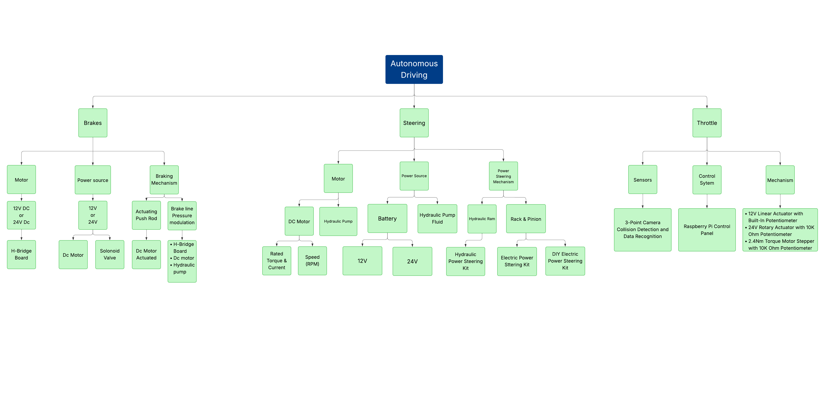
Figure 5: Top Level Functional Decomposition

Brakes
Functional decomposition organizes the autonomous braking system into key subsystems motor, power source, and braking mechanism allowing the project to break a complex system into manageable parts, support parallel development, apply performance calculations at the correct level (such as motor torque to clamping force), and identify critical interfaces for safety and reliability, ultimately ensuring the system is effectively designed, validated, and integrated.
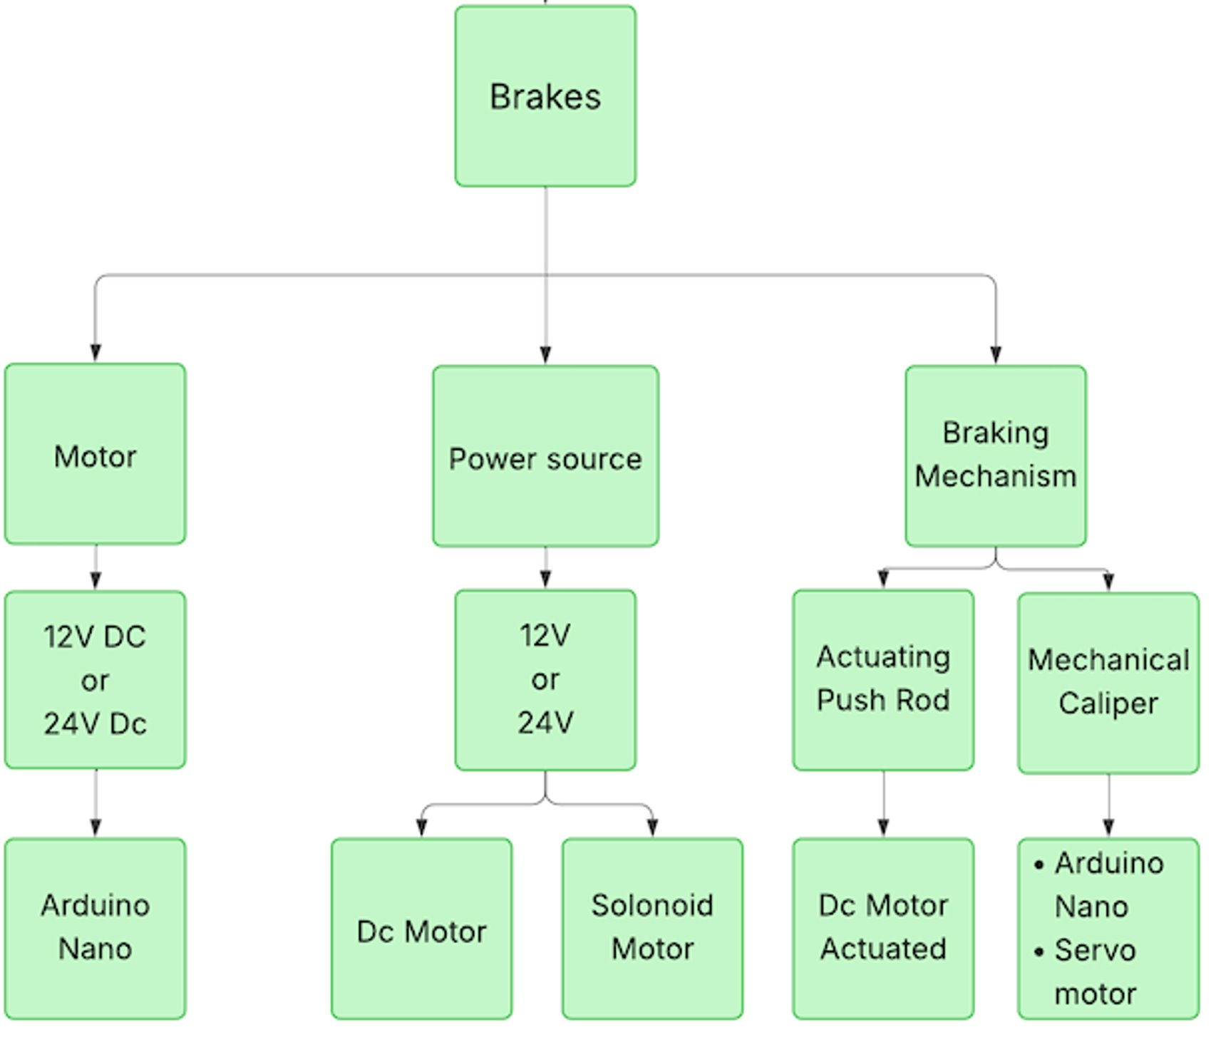
Figure 6: Brakes Functional Decomposition

Steering
The functional decomposition chart outlines Steering System Operation with sub-functions tailored to autonomous navigation. Sensing Environment includes detecting path deviations and obstacles, using sensor data to maintain accurate tracking. Decision-Making and Control processes this input to adjust steering angles, potentially incorporating robotic feedback mechanisms for enhanced driver alerts. Actuation of Steering engages actuators to execute turns, ensuring smooth lane-keeping, while Monitoring and Feedback provides real-time adjustments and failure detection. This structure is vital as it ensures precise navigation, aligns with the project’s autonomous goals, and supports integration with other subsystems, minimizing errors during complex maneuvers.
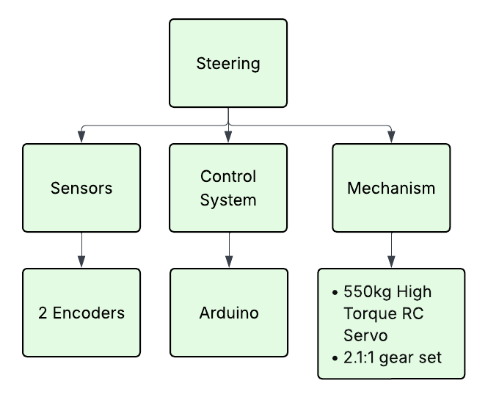
Figure 7: Steering Functional Decomposition

Throttle
The throttle subsystem’s functional decomposition focuses on throttle system operation, which is divided into three important sub-functions. Sensors include environmental sensing, through which the system observes speed and terrain to guide throttle adjustment for controlled acceleration. The control system incorporates a Raspberry-Pi microcontroller necessary to transmit information between each electrical component within the mechanism. The mechanism itself largely relies on correct decision-Making and controls for autonomous or driver-assisted modes, optimizing power delivery. The actuation itself activates the throttle mechanism to ensure a quick response, while the monitoring and feedback oversee performance and identify issues. This breakdown is vital as it facilitates smooth mode changes, integrates with braking and steering systems, and guarantees the go-kart meets performance goals during demonstrations, thereby boosting overall reliability.

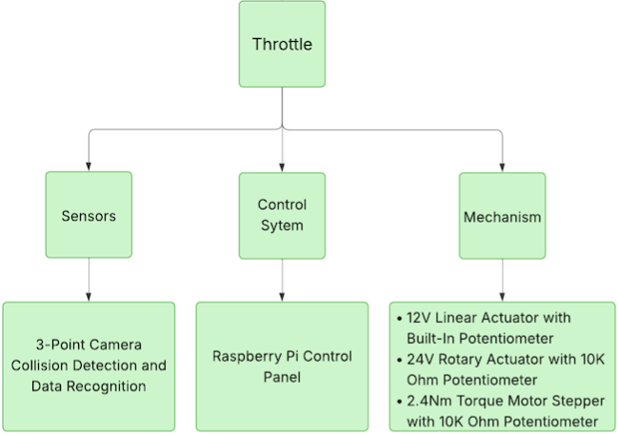
Figure 8: Throttle Functional Decomposition

Concept Generation
To develop an effective system, the concept generation process is divided among the three sub-teams, brakes, steering, and throttle. Using the established customer and engineering requirements as a foundation, each sub-team conducted research, gathered input from mentors and clients, and explored a range of possible design solutions for the sub-team. The goal was to compare and evaluate concepts based on performance, cost, safety, and feasibility before picking the best options. The following sections outline the concept generation process and evaluations done by each sub-team, highlighting the advantages and disadvantages of each design.

Brakes
Three main concepts were developed for the autonomous braking system, evolving from an initial mechanical arm sketch actuated by a motor shaft. Concept 1 uses a simple push-rod mechanism driven by a 24V DC motor to directly actuate the brake pedal, offering simplicity, low electronics needs, and intuitive fail-safe operation, but with drawbacks in size and cost. Concepts 2 and 3 represent iterations of a similar hydraulic booster design, integrating a 24V DC motor with an on/off solenoid (manual in Concept 2, electric in Concept 3) and H-Board or Arduino Nano control to boost brake line pressure for automated actuation and strong performance, though they involve more components and binary control. Concept 4 employs a servo motor with Arduino Nano control to directly drive brake calipers, delivering high torque, minimal failure points, and no interference with the mainline system, but requiring precise calibration. All concepts operate on 24V power and target a 500ms response time, 10-hour reliability, dual-mode capability, and braking force matching or exceeding the mainline system, with early low-reliability ideas filtered out.

Table 1: Brakes Morphological Matrix
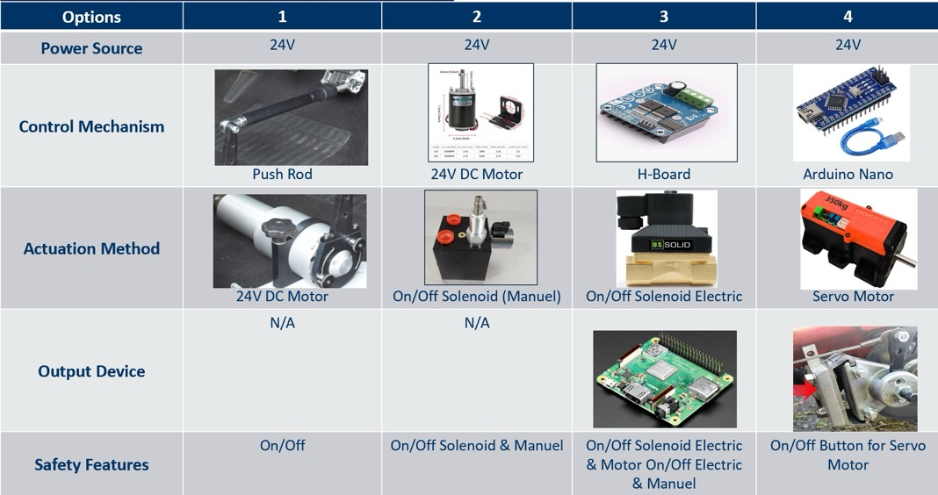

Steering
Generating designs for the steering system, the sub team gathered ideas based on client and mentor suggestions into a morphological matrix as shown in Table 2. Looking into purchasing a power steering conversion kit, the team considered both electronic and hydraulic power kits. After determining the various costs, the steering sub team researched a DIY electric power steering (EPS) system that could be customized and was more affordable. The advantage of the EPS is that it has fewer components involved, but it is more expensive than the other options. The hydraulic power steering (HPS) allows precise control; however, the system is flammable while the others are not. Finally, the DIY EPS system is customizable and cost effective. However, this system is more time-consuming to complete.

Table 2: Steering Morphological Matrix
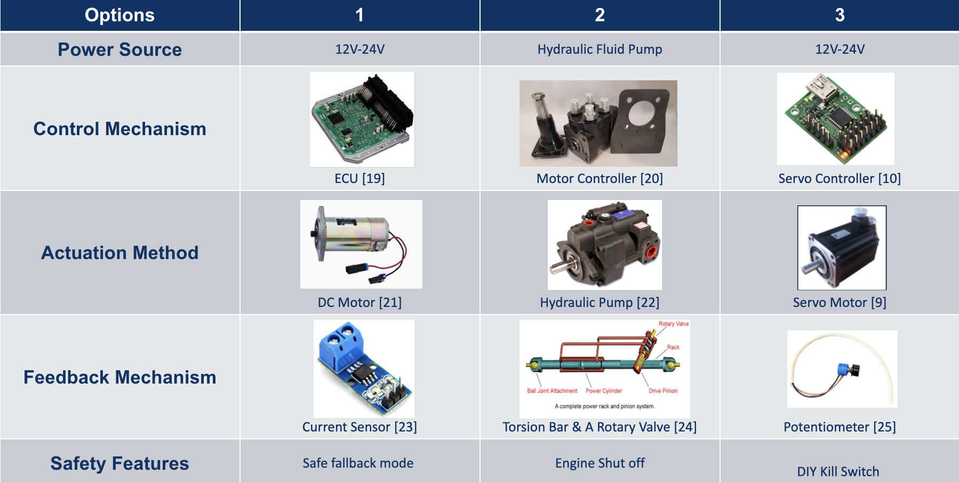

Throttle
For the throttle control system, the sub team generated concepts based on the customer and engineering requirements and created a morphological matrix to decide on three designs. The three main options are a rotary servo with a potentiometer (Figure 16), a linear actuator (Figure 17), and a stepper motor with a potentiometer (Figure 18). The rotary servo offered high accuracy, efficiency, and rapid acceleration, but it was the most expensive option and required a more complex controller. The stepper motor was a low-cost and reliable alternative based on its high torque and accuracy abilities. While the linear actuator has a built-in potentiometer and a simpler design, the stepper motor ultimately offered a more straightforward solution for the team to retrofit an actuation system onto the existing throttle mechanism. Because the motor has a shaft, 3D printed components will be more easily added to the overall design compared to the enclosed structure of the linear actuator, which would make it easier for the team members to alter based on new iterations of the overall design.

Table 3: Throttle Morphological Matrix
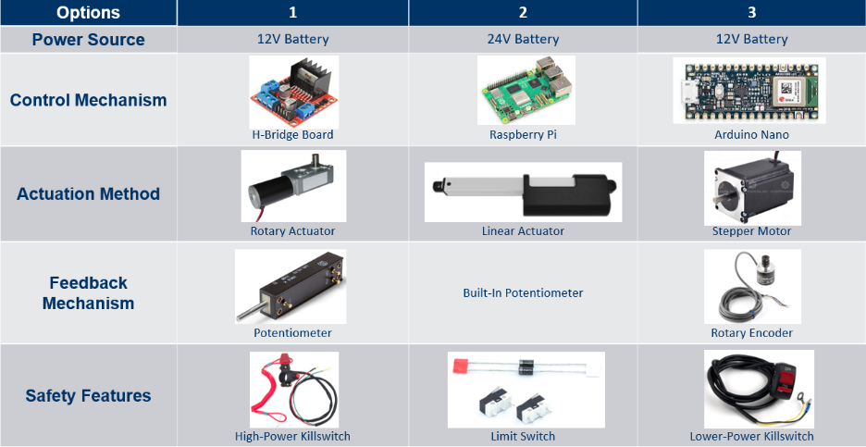

Selection Criteria
For concept selection, each sub-team developed selection criteria based on the customer and engineering requirements to ensure that all the proposed concepts met project expectations. These criteria were chosen to be measurable and directly related to the system's performance and integration. Factors such as weight, cost, complexity of integration, efficiency, safety, and user interaction were analyzed using specifications and design considerations. Evaluating these parameters allowed the team to compare the advantages and disadvantages of each concept and determine which design best satisfied the overall project goals and system compatibility.

Brakes
Choosing between each design simple. A linear actuator would interfere with the user’s ability to operate the vehicle without autonomous mode whereas with a system integrated directly into the brakes it is much easier to leave the normal operation methods of the vehicle intact at the cost of being quite invasive. Another benefit of choosing a parallel brake line is that it will be much quicker to act as there is simply less movement needed to achieve the same actuation of the brakes. Then between choosing a solenoid-based brake line or a secondary brake caliper is much more difficult. The solenoid-based brake line would function much closer to how brakes usually work in cars but due to the price and amperage of hydraulic pumps the team decided that a secondary brake caliper was the necessary choice. Following this the team tried a pull by wire design but due to the extra force placed by the spool’s radius, there was another pivot to a direct modified brake lever arm system.

Steering
When choosing between power steering kits, customizability, mass weight, complexity of integration, cost, maneuverability, and user interference were analyzed. Customizability is important because the part will need to be altered for it to be properly integrated into the go kart. The weight of the system is important because it can affect the movement of the vehicle. The complexity of integration can affect the amount of time and effort that will go into utilizing the system. Cost is considered because staying within budget is a top priority. The maneuverability of the kit ensures that it can respond best to electrical components. User interference determines how well the user will be able to use the system

Throttle
When choosing between the listed throttle actuation concepts, specifications on accuracy, efficiency, integration complexity, and cost were heavily considered. Accuracy and integration complexity were the most important to ensure a precise throttle response that can be easily altered. Efficiency impacts overall system performance and power usage, and integration complexity affects the time and effort required for implementation. Cost is a key factor to stay within budget, and self-locking capability ensures the throttle holds position without continuous power. Based on these criteria, the stepper motor was selected as the best choice to begin the actuation design for the throttle mechanism.

Concept Selection
To identify the best design for each subsystem, the team used Pugh charts and decision matrices. Each sub-team compared its proposed concepts against a defined set of selection criteria derived from the customer and engineering requirements. Weighted factors were applied to reflect the importance of each criterion to ensure that both technical performance and practical implementation were considered. The Pugh charts provided a qualitative comparison between concepts, while the decision matrices quantified results to support a final decision. The highest-scoring concepts from each sub-team were then modeled in SolidWorks, shown in the following figures.

Brakes
The criteria used for the brake sub team concept selection are speed, reliability, cost, user interference, ease of installation, and electrical integration. Speed, reliability, and user interference are of the utmost importance for this project since they are critical to the success of the sub-system. Speed will determine how quickly the vehicle can begin breaking, which could be the difference between a collision or a complete stop. Reliability is also important since during operation the team would not be able to safely work on the vehicle and avoiding system failures will be crucial in determining the success of the project. It also considers the number of failure points that are involved with the design since the less possible means of failure the better for the vehicle. User interference is one of the biggest challenges to overcome for creating autonomy in the budget provided and it is one of the clients’ criteria needed for success. It is also apparent that the more control users have over the vehicle the safer it is for instances of failed autonomy. Cost, ease of installation, and electrical integration are still important factors which also drive the selection process. Ultimately the design chosen was the secondary mechanical caliper since it would be the fastest, most reliable, and most user friendly. This is at the cost of price and ease of installation so considerations must be made for the time needed to work on prototyping.
Table 4: Brakes Specifications Chart
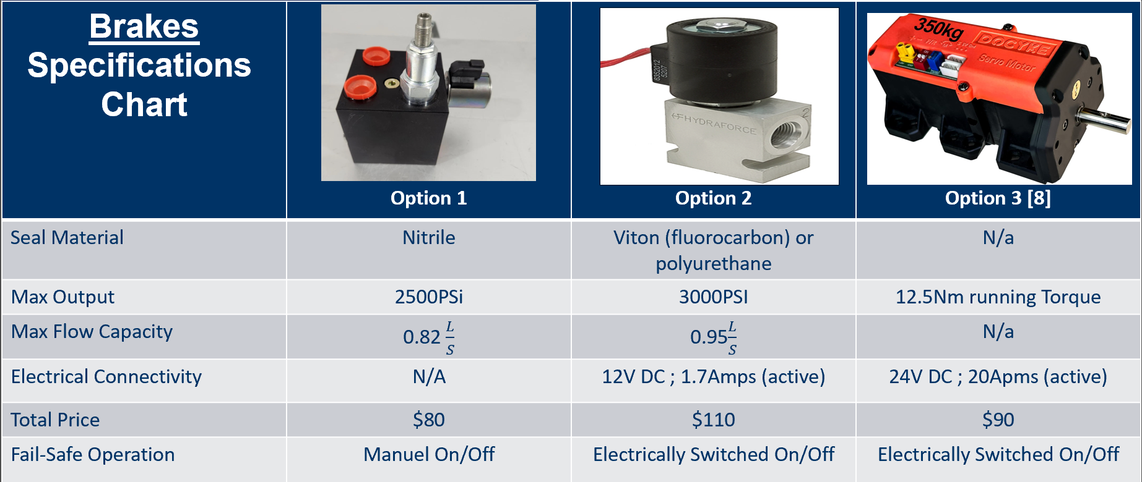

Table 5: Brakes Option Comparison
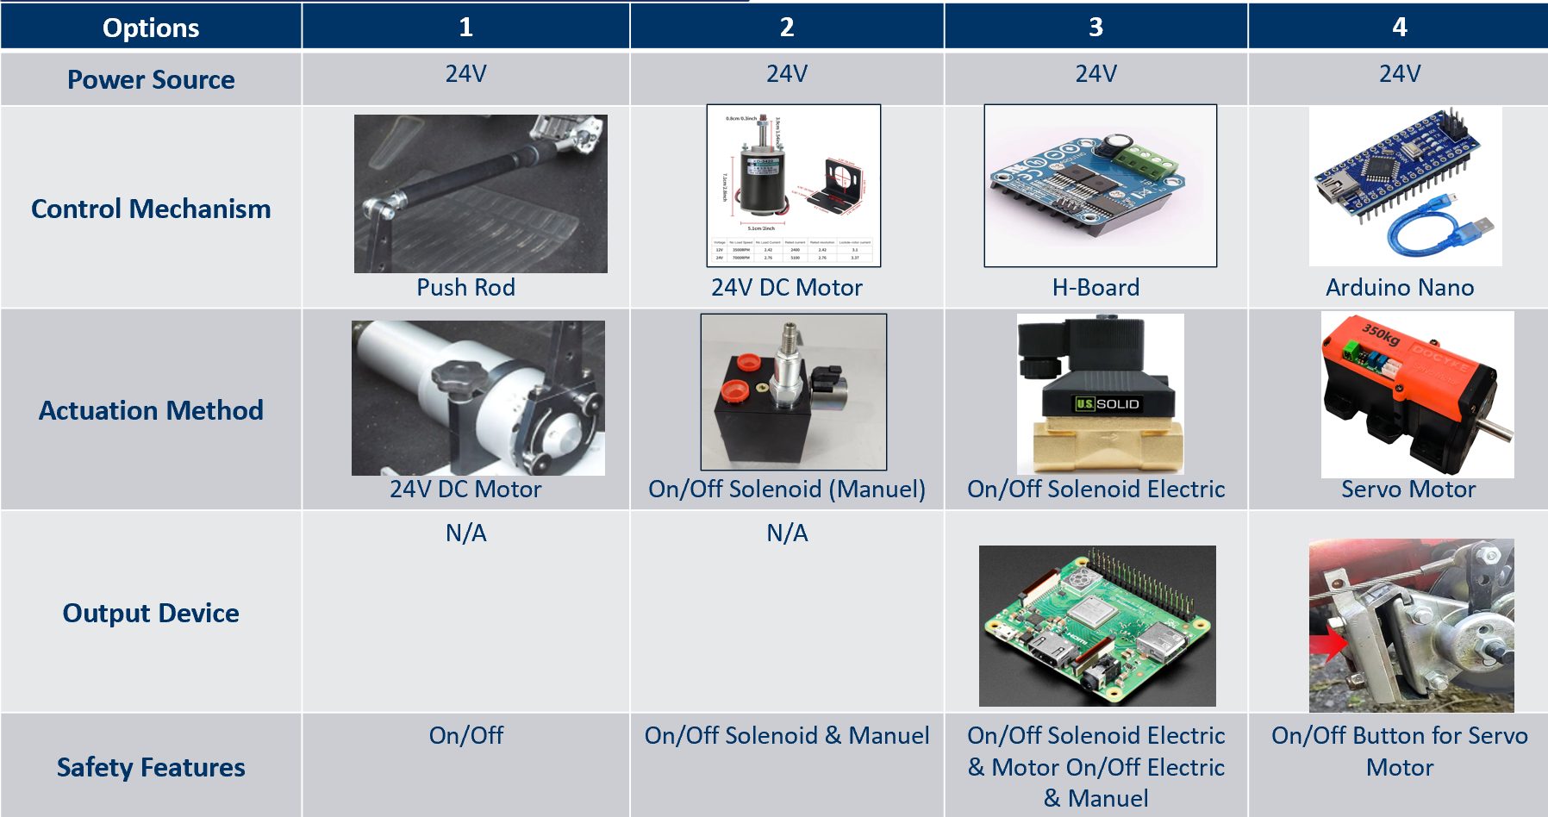
Table 6: Brakes Pugh Chart
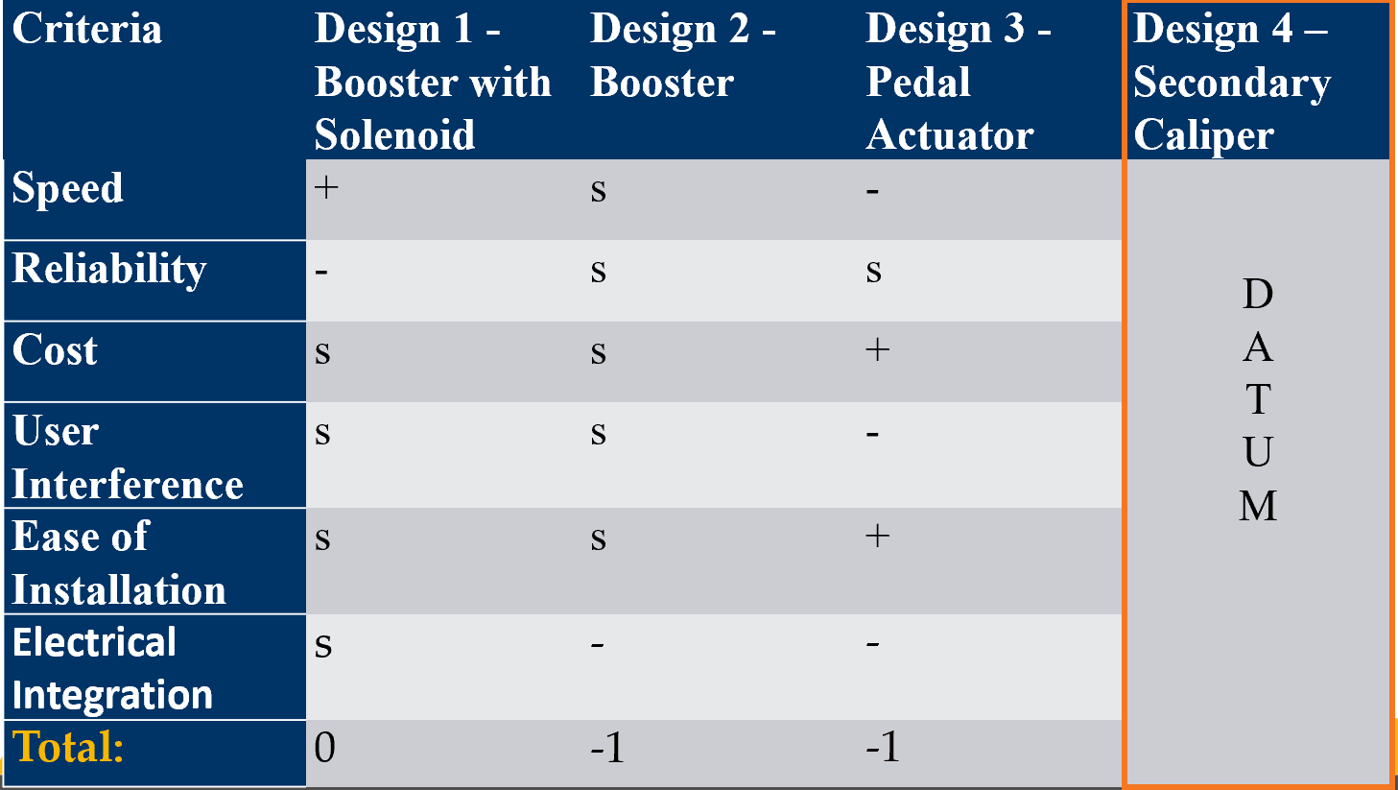

Table 7: Brakes Decision Matrix
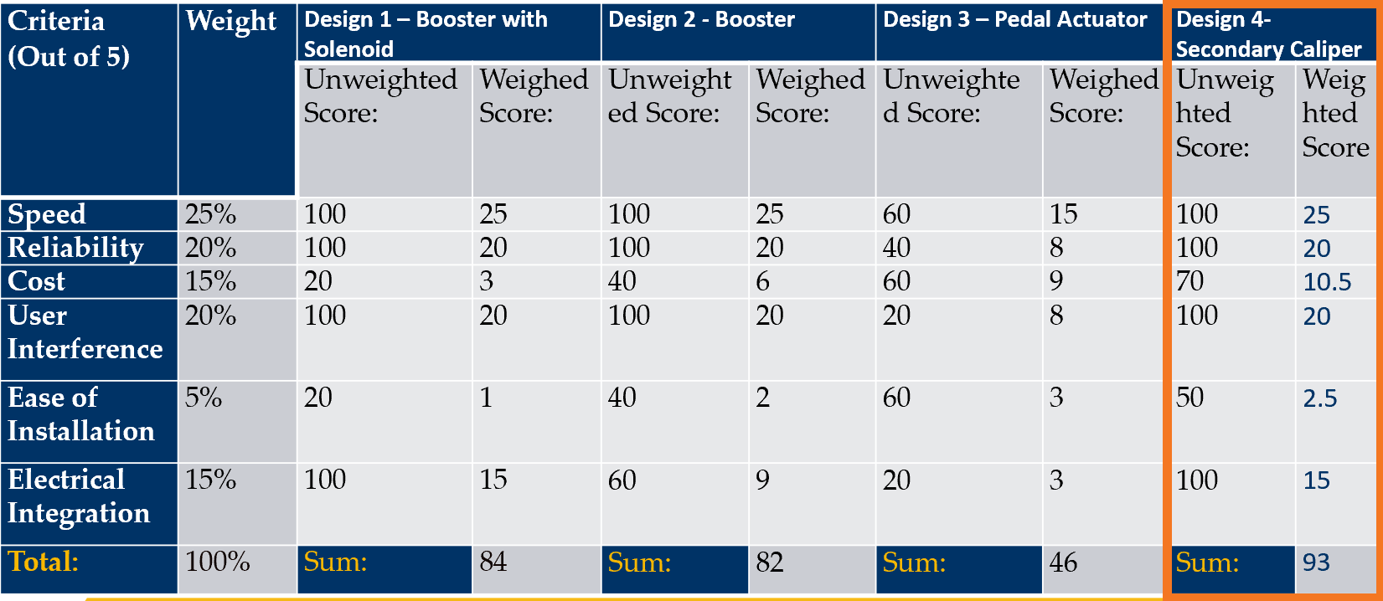

Steering
In the Pugh Chart and the Decision Matrix, complexity of integration and maneuverability were rated 10% in the decision matrix because it would be easier to work around if the selected design were to score low. The rest were equally rated at 20% because they are harder to work around and all just as important. The electric power steering kit was chosen as datum in the Pugh chart because it would be the ideal system to work with. However, the DIY kit scored higher in comparison because of its lower cost and customizability. The scores for these criteria were why the DIY kit scored the highest in the decision matrix as well.

Table 8: Steering Specifications Chart
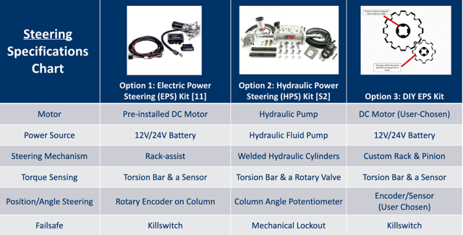

Table 9: Steering Option Comparison
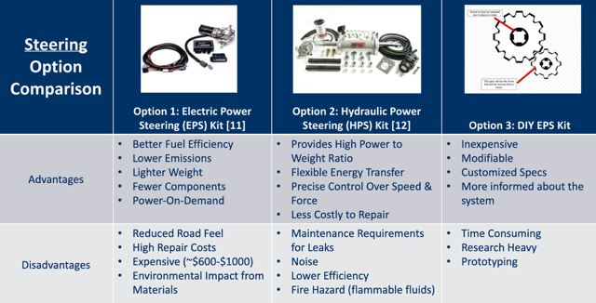

Table 10: Steering Pugh Chart
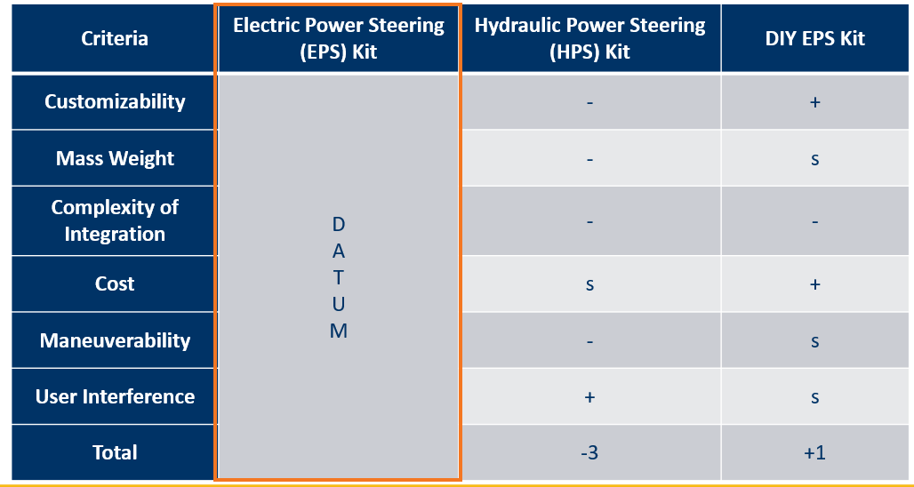
Table 11: Steering Decision Matrix
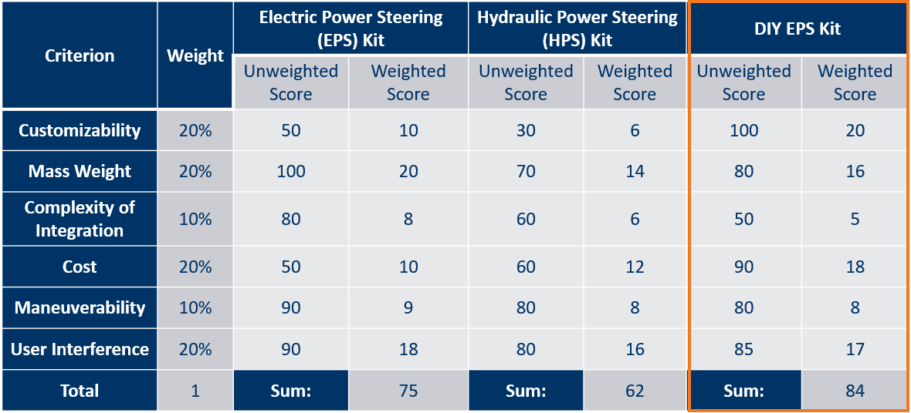

Throttle
The following tables depict the Pugh Chart and Decision Matrix designated for the throttle subsystem that was used to determine the proper item selection based on the sub-team's designated criteria. The lowest weighted items for throttle in the Pugh Chart and Decision Matrix were efficiency and power consumption at 10% due to the throttle's nature of requiring a substantial amount of power to allow the go-kart to move. The highest weighted criteria were reliability and response time at 25% because safety was considered the most significant factor when determining the throttle mechanism. In comparing the different actuation options, the stepper motor paired with a potentiometer displayed the most promising results based on the highest weighted criteria. It is cost-effective and offers a stable response time while providing enough power for the throttle actuation system to work safely.

Table 12: Throttle Option Comparison
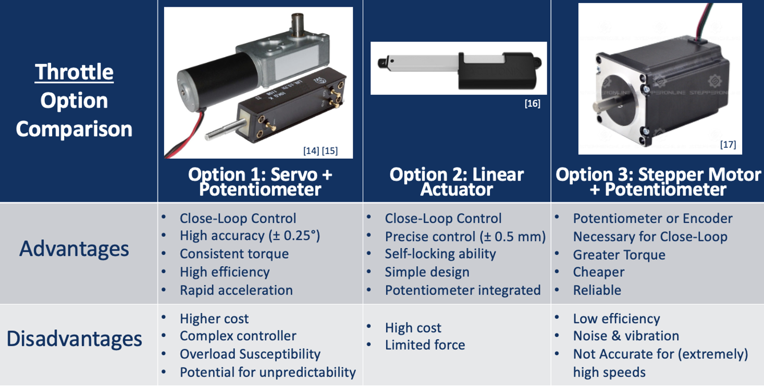

Table 13: Throttle Specification Sheet
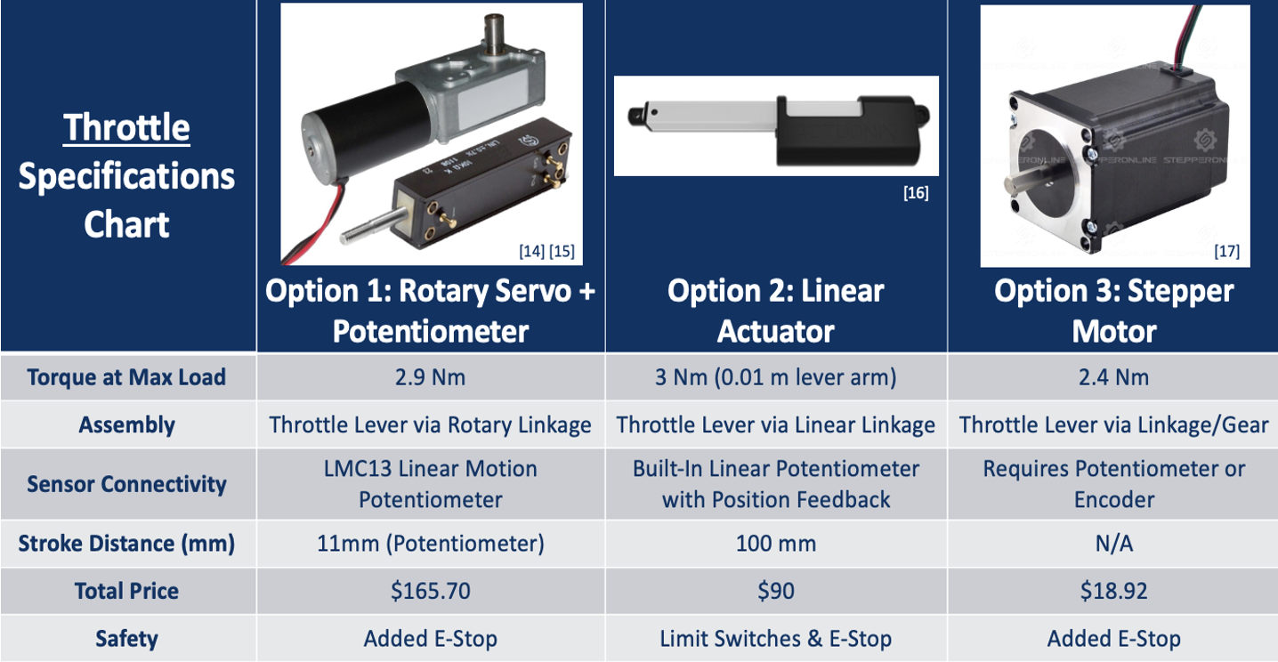

Table 14: Throttle Decision Matrix
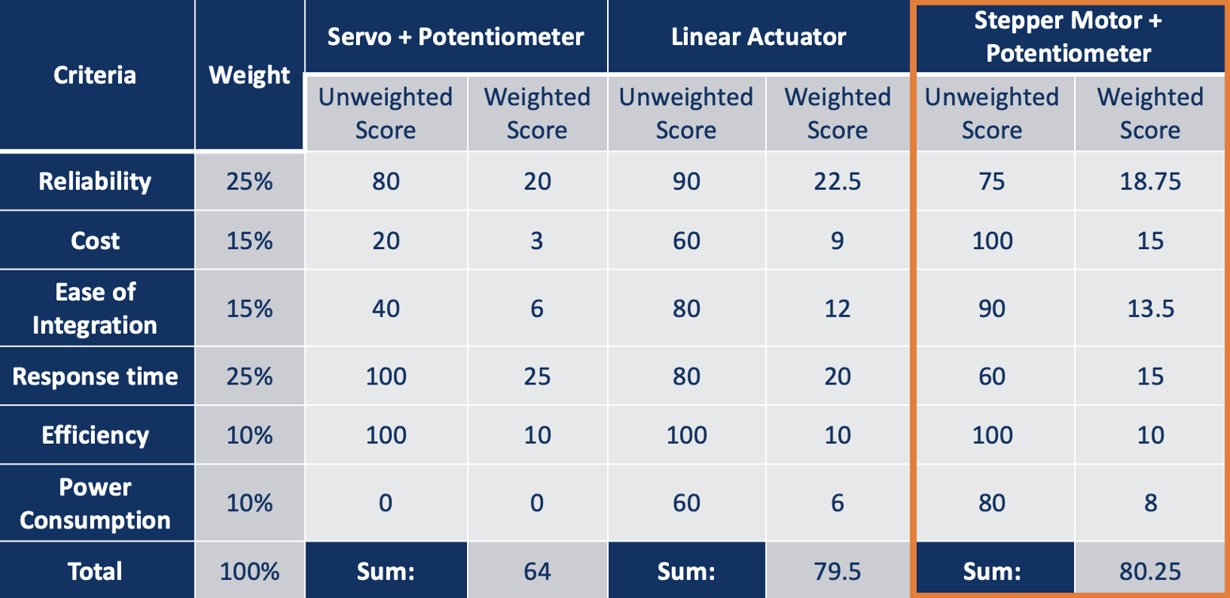

Table 15: Throttle Pugh Chart
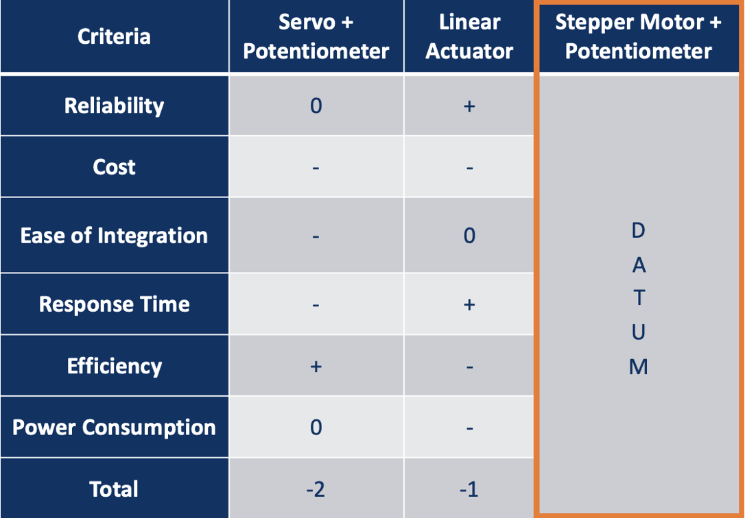

Schedule and Budget
This section outlines the important logistical components that will aid in the support of the success of the capstone project, including scheduling, budgeting, and material preparation. First, a detailed Gantt chart for this current semester and a draft for the upcoming semester, along with a work breakdown-schedule and a description of each task, will be discussed. Next, the overall project budget will be summarized, going in depth about covering prototyping costs, electrical costs, travel, and any anticipated miscellaneous costs. Finally, a comprehensive Bill of Materials (BoM) will discuss each sub-team’s current item specifications, unit costs, and total costs.

Schedule
The team's schedules for the fall and spring semesters are shown below in figures 23 and 24, respectively, within Gantt charts. The main assignments for the fall semester include presentations, reports, and prototypes. These assignments focused on progress made throughout the semester and allowed for answers to questions within the sub-teams. Each round of these assessments was followed by a peer evaluation to determine whether each group member was contributing evenly or not. Within the sub-teams, there were specific topics that required research, with each team having an initial and final design with iteration in between.

Brakes
Brake sub-team focused on staying far ahead of the deadlines in case issues came up. For semester one this was mostly design-based choices, measurements, and prototyping. Ultimately this led to the sub-team completing class objectives and leaving the finer details for second semester. In the second semester the brake team was highly involved having to pivot multiple times for designs often just before class requirements. This high-tension lead to a much more detailed plan to finish the project. Most of the time used during second semester was spent on finalizing the design and testing as soon as possible. Unfortunately, due to part failures and scheduling this ended with the sub-team being far behind schedule.

Table 16: Semester 1 Gantt Chart Brakes
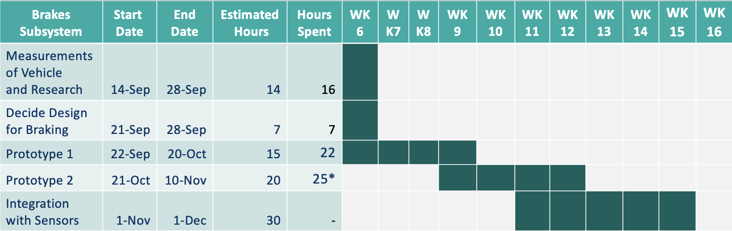

Table 17: Semester 2 Gantt Chart Brakes
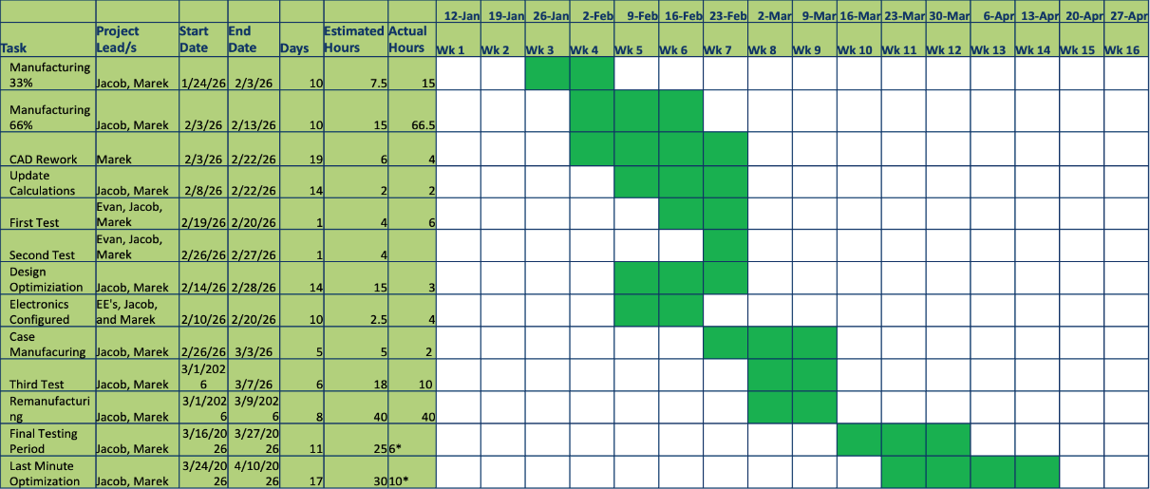

Steering
The steering sub team delegated task based on time availability and skills. Working as a team to achieve goals by setting deadlines. Throughout both semesters the team was able to meet our deadlines in line with the due date. The goal of these deadlines was to complete progress on the project in a timely manner. In the first semester, the team focused most on ideation, research, and the prototypes to bring their ideas to life from CAD models. In the second semester, the team spent reiterating their prototypes and redesigning their last prototype. Then, optimization and protection of components was heavily focused on. Moreover, the team collaborated with the electrical sub-team to see which modifications had to be made to best accommodate the sensors and wires that stemmed from the electrical components.

Table 18: Semester 1 Gantt Chart Steering
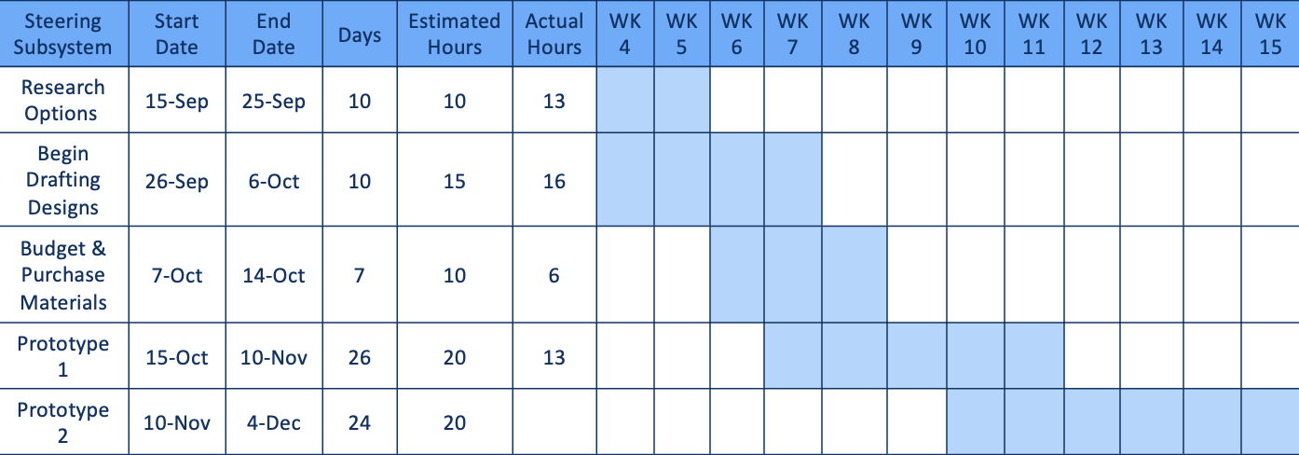

Table 19: Semester 2 Gantt Chart Steering
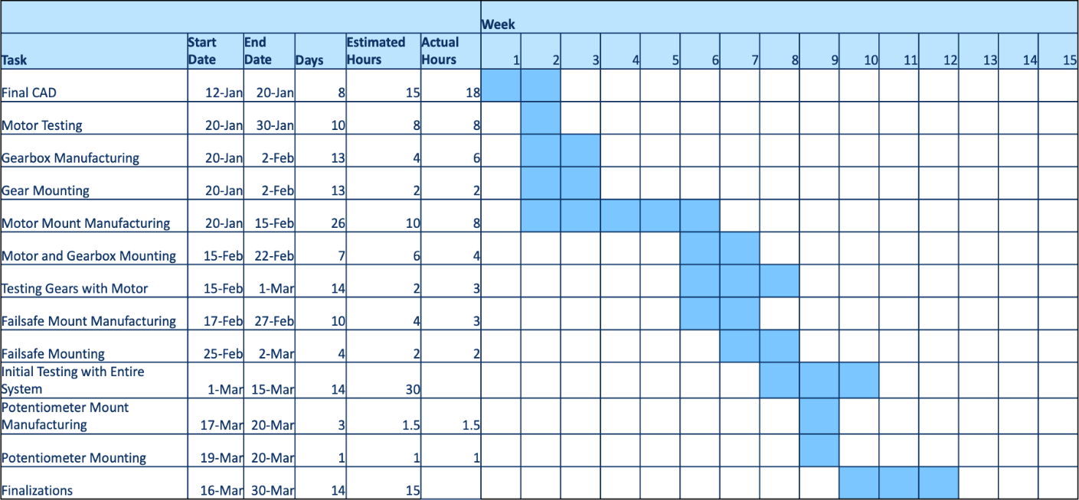

Throttle
The following Gantt charts demonstrate the entire progression of the throttle sub-team across two semesters. In the first semester, the team focused most on ideation, research, and the prototypes to bring their ideas to life from CAD models. In the second semester, the team spent reiterating their prototypes and redesigning their last prototype. Then, optimization and protection of components was heavily focused on. Moreover, the team collaborated with the electrical sub-team to see which modifications had to be made to best accommodate the sensors and wires that stemmed from the electrical components.

Table 20: Semester 1 Gantt Chart Throttle
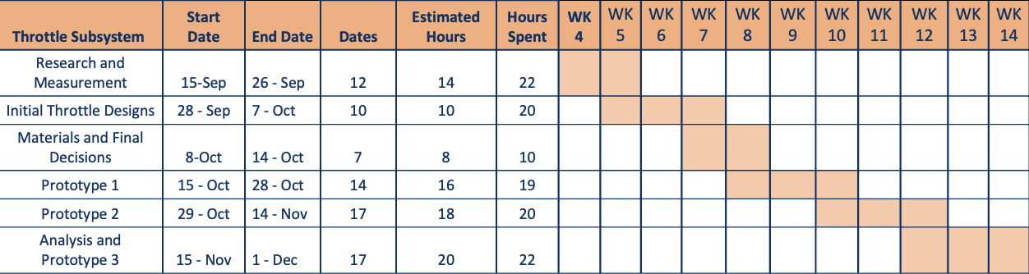

Table 21: Semester 2 Gantt Chart Throttle
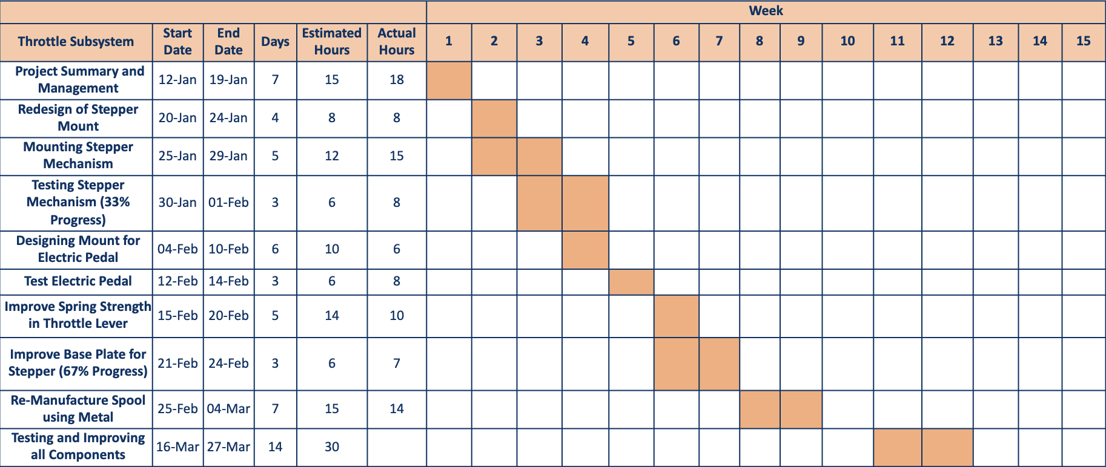

Budget
To date, the team has raised a total of $8,473.16 in funding, consisting of $3,473.16 from donations and fundraising efforts and a $5,000 sponsorship from Boeing. As of the completion of the project, total expenditures amount to $5,780.90, leaving a remaining balance of $2,692.26.
Project expenses were distributed across several categories. Major cost included $2,154.75 in miscellaneous expenses, which covered the initial go-kart purchase and other general project needs, as well as $1,612.65 for electrical components, representing the most significant portion of the final design costs. Additional expenditures included $670 for travel, $106.84 for tools, and subsystem costs such as brakes ($127.46 prototype, $188.16 final), steering ($147.83 prototype, $320.14 final), throttle ($142.78 prototype, $262.27 final), and electrical prototyping ($48.02)
The team initially estimated a total project budget of $7,900, allocating funds across major subsystems and operational costs. The final total expenditure of $5,789.90 came in significantly under budget, demonstrating effective financial planning, cost control, and efficient resource allocation throughout the project.
Overall, the team maintained a strong financial position from start to finish. The surplus funds provide a buffer for any remaining post-project expenses. Continued fundraising efforts through the project contributed to this flexibility and ensured that financial limitations did not hinder design iterations or system performance. The project was successfully completed within budget while meeting all major design and operation objectives.

Table 22: Budget Expenses Table
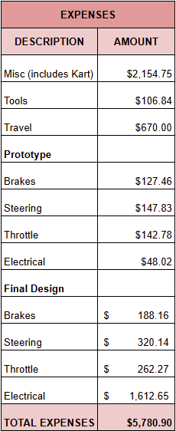

Bill of Materials (BoM)

Brakes
The bill of materials (BOM) consists of all the materials necessary to build at least one unit of the entire subsystem. This includes manufactured parts such as the modified lever arm, caliper mount, base plate, and pipe bracket dampeners. With a glance one might notice there is no motor included and that is because the team felt it necessary to have a separate electrical BOM.

Table 23: Brakes Bill of Materials
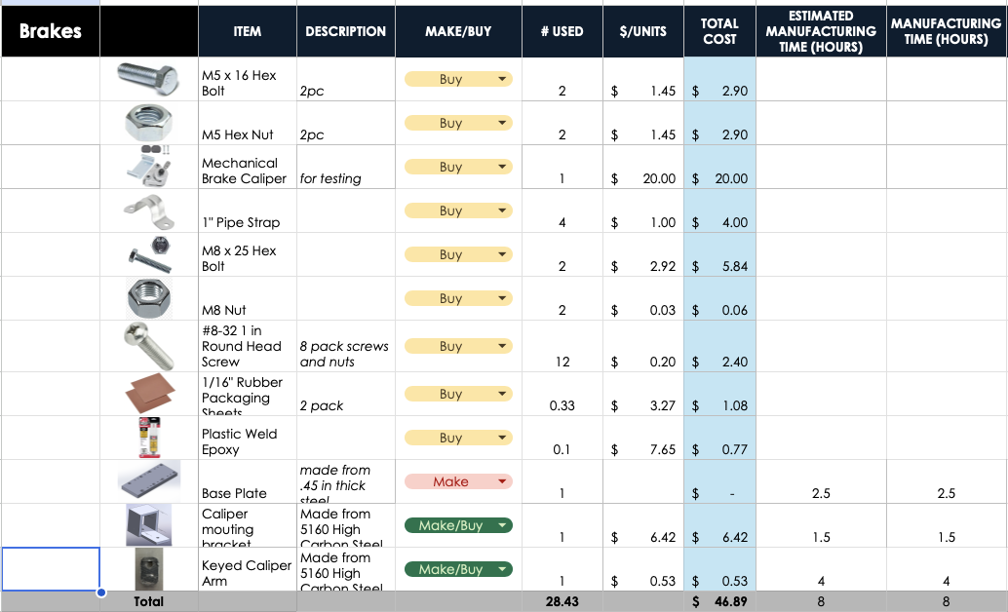

Steering
The BOM consists of all the material necessary to build one full unit of the entire subsystem at a total of $176.45 per unit. This includes manufactured parts such are the motor and encoders mounts, and gearbox. The motor used to control the steering system is included in the electrical system.
Table 24: Steering Bill of Materials
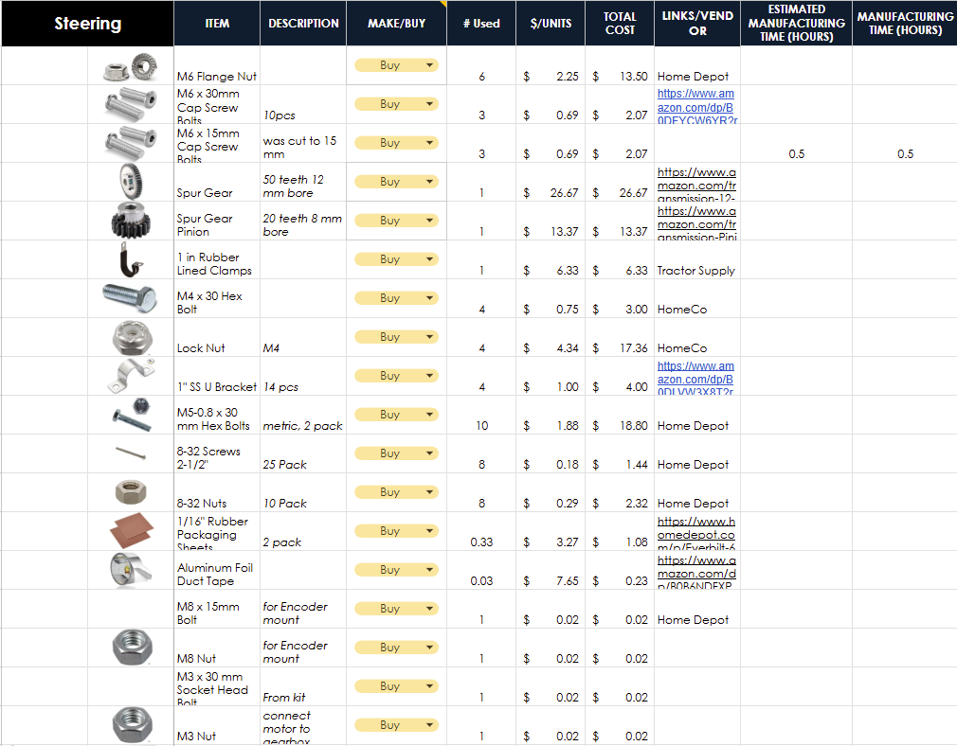
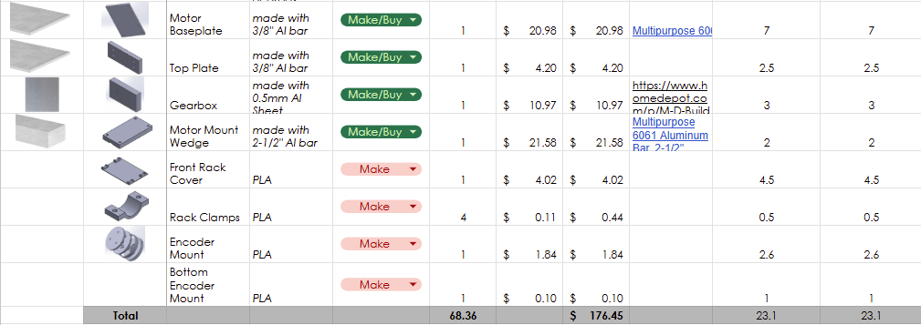

Throttle
The following contains a list of all the materials that were used to create and manufacture the final design of the throttle subsystem. With a total of approximately $98, the throttle mechanism stuck to four main components: a base plate, a Bowden cable, a CNC-based spool, a custom welded L-bracket, and a custom welded Bowden cable mount.

Table 25: Throttle Bill of Materials
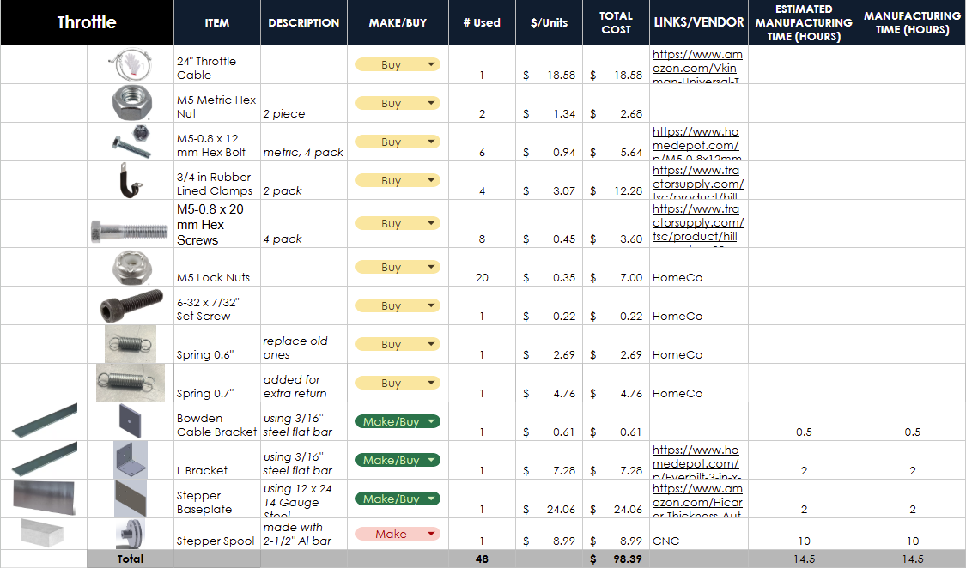

Electrical
The electrical BOM includes all the wiring, sensors, controllers, communications, casing, and sub-team specific devices. Most of these components are somewhat cost inefficient for a single unit of production such as the multiple colors of electrical tape but they also help categorize the different wire systems. Another note is that the electrical sub-system has the highest total cost compared to the other three. This is understandable though as they include expensive motors and devices like raspberry pies.
Table 26: Electrical Bill of Materials
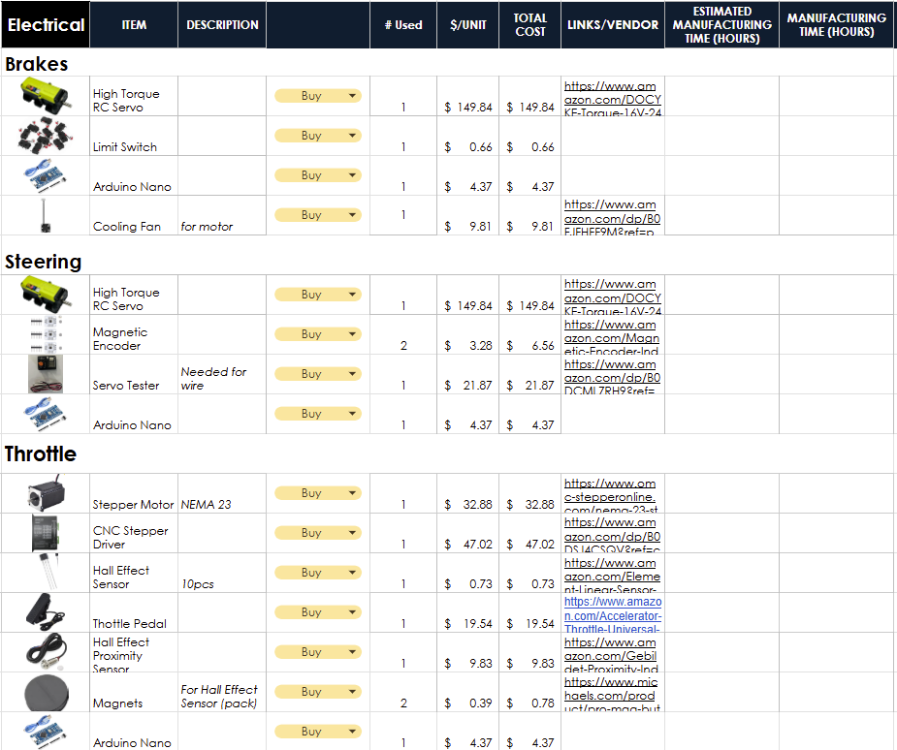
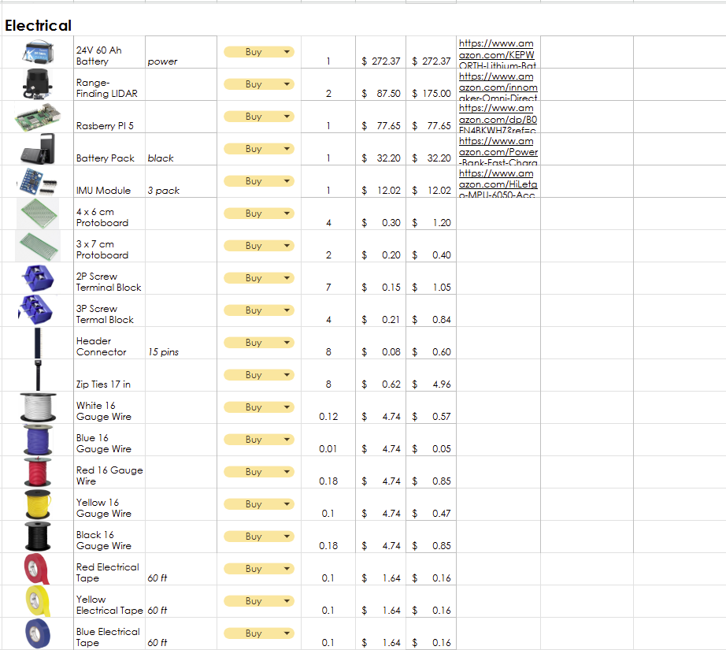
Table 27: Electrical Bill of Materials Continued
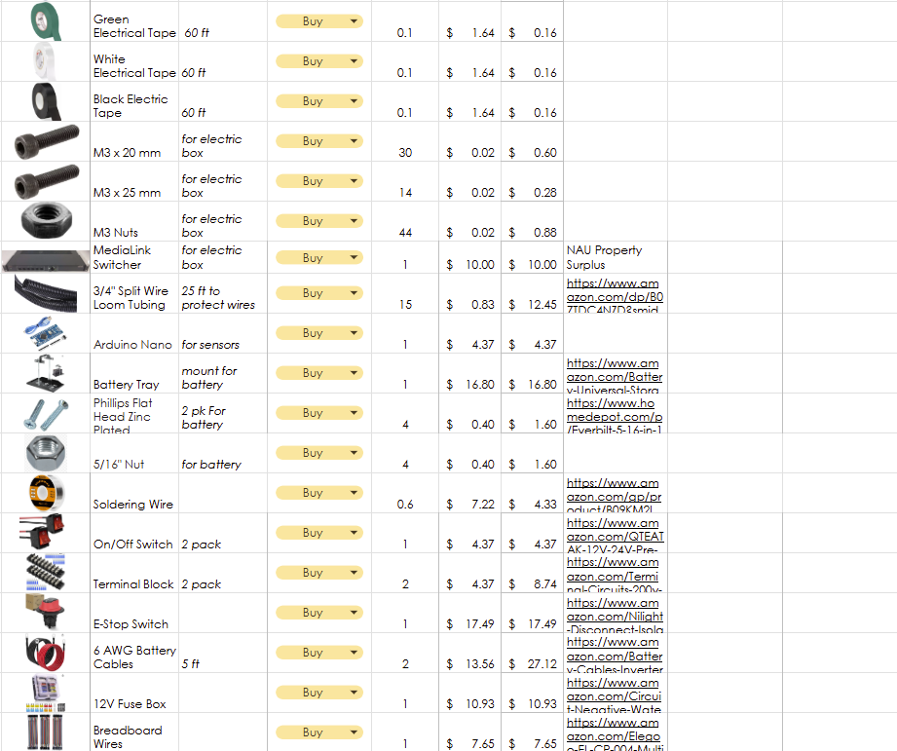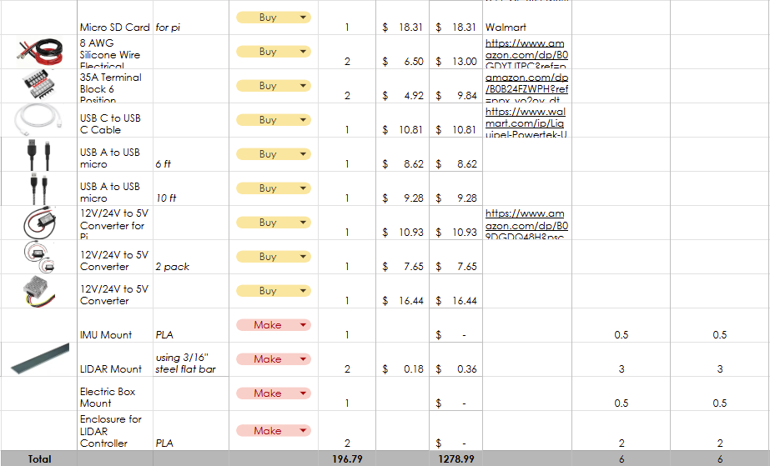

Design Standards
Design standards are important for making sure that the subsystems are safe, compliant with regulations, and optimized. They make the project more efficient by employing simpler working methods, reducing costs, and preventing errors. These guidelines help facilitate faster development times.

Design Standards

Brakes
- SAE International papers and Formula SAE Rules (e.g., 2023-01-5168 and 2024 Formula SAE Rulebook, Section T.3 Brakes) [86]
Provide guidelines for go-kart and formula-style vehicle braking systems, including requirements for hydraulic disc brakes, actuation on all wheels where applicable, stopping performance, and dual independent circuits for safety. Used as a reference for baseline braking force and system reliability in small vehicles.
- ISO 22733-1:2021 and ISO 22733-2:2023 (Road vehicles; Test methods for autonomous emergency braking systems) [87]:
Define performance testing for autonomous braking (AEBS), including response characteristics and collision avoidance scenarios. Relevant for evaluating the 500 ms target response time and automated actuation in Concepts 2-4.
- ISO 26262 (Functional Safety of Road Vehicles) [88]
Covers safety requirements for electrical/electronic systems in vehicles, including hazard analysis, risk assessment, and fail-safe design for autonomous functions. Applied to ensure redundancy and fail-safe operation in the servo and solenoid-based designs.
- General go-kart braking design references (e.g., hydraulic disc brake selection papers):
Common practices for master cylinder sizing, caliper force, and pressure ratings (typically 2000-3000 PSI range) to achieve adequate deceleration while maintaining low weight and cost.

Steering
- Steering Wheel Systems (393.209) [89]
According to the “The Motor Carrier Safety Planner” in section 5.1.12 Steering Wheel Systems (393.209) steering wheels must be attached to the automotive securely and properly without any spokes cracked or missing. For power steering systems, all components must be in operating condition. No parts shall be broken or loose; belts shall be in good condition. There should also be no leaks, and the system should have sufficient fluid in the reservoir. These standards will aid the steering sub team by making sure that the steering wheel and its power steering component are safe according to these standards.
- Automated Vehicles for Safety [90]
This source is from the Department of Transportation, referring to the regulations and safety requirements for autonomous vehicles. Providing a timeline of regulations as they become enforceable, such as antilock brakes or lane-keeping assistance. Along with examples of the different levels of automation at work and the technologies involved. This source was used to understand the safety behind autonomous driving, and a bonus description of the varying levels of automated vehicles.
- Dimensioning and Tolerancing: Engineering Product Definition and Related Documentation Practices [91]
This manual is the authoritative standard for Geometric Dimensioning and Tolerancing in the US and provides rules for designing engineering drawing specifications. This standard establishes rules, definitions, requirements, defaults, and recommended practices for creating and interpreting engineering drawings.

Throttle
- NHISA Rulemakings Related to Automated Driving System-Equipped Vehicles NHTSA Rulemakings Related to Automated Driving System- Equipped Vehicles [92]
This document is administered by the National Highway Traffic Safety Administration, and it offers the most recent set of laws and regulations on autonomous vehicles being on public roads. It also involves information from the Federal Motor Vehicle Safety Standards that companies must follow for safe autonomous vehicles (i.e., speed, response, and detection abilities). Hence, this document emphasizes the safety laws and regulations that apply for the go-kart to be considered safe and autonomous by federal safety standards.
- Organization of machine learning based product development as per ISO 26262 and ISO/PAS 21448 [93]
This article outlines the ISO standards for machine-learning based algorithms used based on new technology that can apply for electric vehicles. The article offers a list of technical specifications and processing systems that are related to ISO standards to define and limit hazards that can arise in complex technology. It is sourced as an instructive guide for the methods of controls considered to be implemented in the construction of the go-kart's autonomous abilities, as well as where the possible downfalls lie.

Design Standards Used

Brakes
The project applied the researched standards to ensure safe, reliable autonomous braking with a target 500 ms response time, 10-hour operational reliability, and braking force equal to or greater than the mainline system while supporting dual-mode operation.
- In drawings and component selection
  - The mechanical arm/push-rod interface (Concept 1), hydraulic booster elements (Concepts 2 and 3), and servo motor direct caliper actuation (Concept 4) were dimensioned and tolerance per ASME Y14.5-2018 to ensure proper fit, mounting baseplate alignment, and torque transfer without interference with the main hydraulic system.

- Through calculations
  - Braking force, torque (12.5 Nm for the servo motor), pressure ratings (2500-3000 PSI), and response time targets were calculated to verify performance, drawing on NHTSA Automated Vehicles for Safety guidelines for autonomous actuation reliability and safety.

- Elsewhere
  - Fail-safe features (manual/electric on/off switching and solenoid redundancy) across Options 1-4 were implemented following NHTSA safety principles to default to a safe state and maintain manual braking capability. Component security and operating condition requirements were considered in line with 49 CFR 393.209 principles for secure, non-loose mechanical and power elements.

Steering
The steering sub team utilized the Steering Wheel Systems (393.209) [89], to ensure that sections (a), (c), and (e) are met.
(a) The steering wheel shall be secured and must not have any spokes cracked through or missing
(c) The steering column must be securely fastened
(e) All components of the power system must be in operating condition. No parts shall be loose or broken. Belts shall not be frayed, cracked or slipping. The system shall not leak. The power steering system shall have sufficient fluid in the reservoir.
Automated Vehicles for Safety [90] was referenced to ensure that the autonomous steering met the NHTSA standards.
From the Dimensioning and Tolerancing: Engineering Product Definition and Related Documentation Practices [91], sections 3 (Definitions), 4 (Fundamental Rules, Tolerancing Defaults, and Dimensioning Practices), 5 (Tolerancing, Interpretation of Limits, Limits of Size, and Material Condition Modifiers), and 6 (Symbology) for generating the engineering drawings.

Throttle
- The throttle sub-team utilized the ASME Y14.100 – Y14.5 [90] standard to conduct, design, and approve all drawings related to the manufacturing of the sub-system and its associated components.
- Using the ISO 26262 and ISO/PAS 21448 standards [86], the throttle sub-team used the assumed frictional coefficient to make the proper assumptions for its influence on the calculations conducted for the throttle subsystem.
- The throttle sub-team utilized the NHTSA document RIN2127-AM00 [91] to incorporate crash avoidance testing into its system. The document ensures that the autonomous throttle has a mechanical failsafe that avoids crashes by cutting any power to the throttle lever.

Design Validation and Initial Prototyping
To present the team’s ongoing validation and analysis efforts, this section will begin with a detailed Failure Modes and Effects Analysis (FMEA) that identifies critical potential failures, associated risks, and design strategies to mitigate them. This FMEA section will be split by sub-team and will focus on the items chosen for each sub-function’s prototypes. Afterwards, initial prototyping will be discussed by breaking the section up into sub-teams. This portion of the section aims to clarify what question was trying to be answered, what the answer was, and how it informed the design. A summary of all engineering calculations performed since the concept selection phase is also provided to document any progress that has taken place mathematically. Finally, the section concludes with an overview of some potential testing procedures that could be completed in the future, broken up by sub-team.

Failure Modes and Effects Analysis (FMEA)
This section defines the Failure Modes and Effects Analysis used by each sub-team to define the potential failures related to each subsystem. Along with these failures is an evaluation of how often, when, and how these failures can occur. Using this information, each sub team has determined what are the best ways to mitigate these critical failures from happening, explaining the trade-off analysis that is involved within the safety confines of each subsystem.

Brakes
The brakes FMEA analyzed the various failure points of the sub-system focused primarily on every part major involved. Results showed that the most often, severe, and subtle part failure was the lever arm. Seeing as the modified lever arm is a relatively small part with some of the highest importance it also makes it the most dangerous. Since it can strip/wear with use and it’s difficult to check requiring removing the system to replace, if one is not careful it could be disastrous. Luckily the emergency main brake line is still perfectly active in the event of any part failure. Refer to the full FMEA analysis below for further information.
Table 28: Brakes FMEA
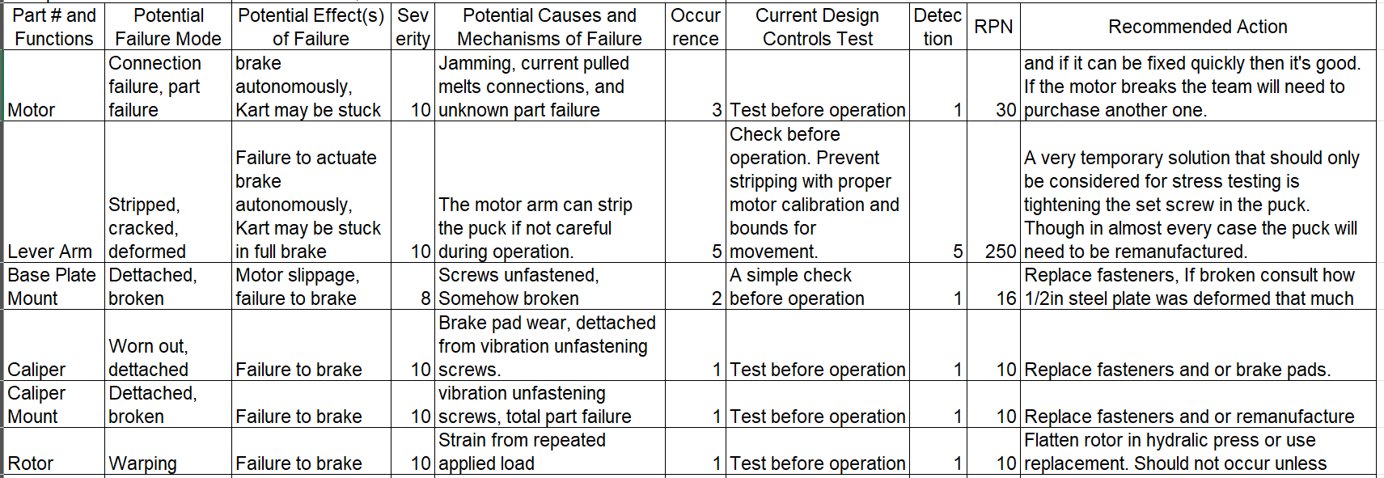

Steering
The steering FMEA analyzed each part mentioned in the subfunction’s BoM for the sub-team’s final design and used the FMEA to determine potential failures, potential effect(s) of failure, its severity based off these failures, potential causes and mechanisms of failure, a rating of occurrence for these causes, the current design controls test, a rating of detection based off of the current design controls test, the risk priority number calculated from the ratings of the severity, occurrence, and detection, and lastly a recommended action. The FMEA has prepared the steering sub-team by providing an opportunity to analyze important potential failures and issues that could arise during testing.

Table 29: Steering FMEA

Throttle
Our team performed an FMEA to identify the most critical risks in the autonomous throttle subsystem and determine how to mitigate them. The highest priority issues were associated with the stepper spool (RPN 324) and rotary potentiometer (RPN 320), both of which could cause loss of throttle control if the cable jammed or the pedal angle was read incorrectly. To address this, we can select a thicker, vibration-resistant cable, added retention features to prevent the spool slipping, and designed to custom rigid mount to secure the potentiometer.
Other components, such as the stepper motor, throttle linkage, and electrical wiring, had moderate RPN values due to risks like overheating, vibration-induced loosening, and wiring failures. These can be mitigated through the addition of a protective fuse, a more stable 3D printed linkage mount, and automotive-grade wire routing away from heat and moving parts.
Table 30: Throttle FMEA
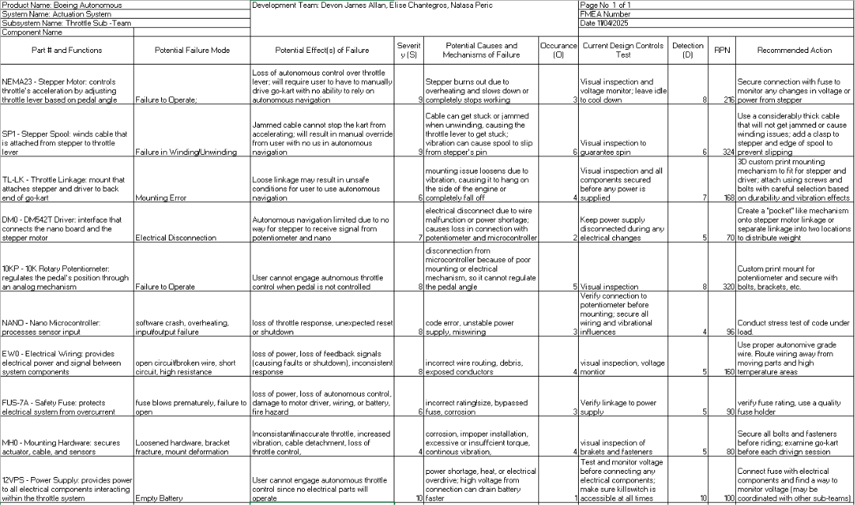
The team balanced safety, cost, manufacturability, and reliability when determining mitigation strategies. Some solutions such as custom mounts and upgrading wiring, which would increase material costs and assembly time, but significantly reduce the likelihood of unsafe throttle behavior. By prioritizing components with the highest RPN values, the team ensures that the subsystem remains reliable.

Initial Prototyping
The following section outlines the processes and methods by which each sub-team completed their initial prototypes. Each section describes the steps each sub-team took to determine what their prototypes would look like, as well as what iterations and changes followed into their second prototype and final design. Using these results, each sub system was optimized to work at its most efficient state, allowing the team to further define the parameters they needed to follow in order to have a strongly functioning system.

Brakes
Brake sub-teams’ goal for the first two prototypes was to find places to mount and control the brake with the spool drive by wire system. However, by the second semester the sub-team decided to pivot due to the increase of torque needed by the motor as well as production issues with the custom spool. This pivot lead us to prototype a new space for the motor which would be directly mounted to the brake lever arm. After manufacturing a new baseplate and modified lever arm the sub-team could fit the new lever arm directly into the motor shaft so it could actuate the autonomous brake caliper. From there the team first tested the motors speed, given the new position in a simple motor test. The purpose of this test is to find the time needed to move the motor once given a command, the speed needed to actuate across the needed range of motion, and the time needed to move back from the full state of motion. Results proved that the full actuation between engaged and disengaged was around 0.08s. Next the team performed a static brake test where the kart was placed on car jacks and the time needed to stop. The purpose of this test is to find the time once actuation begins needed to stop the brake given a starting speed equal to or larger than our maximum speed. From the test the team gathered that if the kart moves at its maximum speed of 5mph then the autonomous brake should be able to stop the kart moving within a second assuming integration is perfect. From all the prototype results the brake sub-system would be best off focusing on system integration and further iteration would primarily focus on this.

Steering
The steering sub team’s goal for prototype 2 was to answer the following question: How to mount the various parts of the prototype to the steering subsystems and go-kart? The team aimed to answer this question using 3-D printed models of the electrical box and motor casings. Issues that came about during prototyping include tolerance errors, warping and the angle needed to mount motor casing to frame of kart. From this round of prototyping the steering team was able to answer the type of clamps to use for mounting, increasing the ventilation for motor casing, mounting for gear system and other main components, finally allowing the team to move forward with material selection for future prototypes. These results will allow the team to move forward confidently with our mounting dimensions, 3-D printing processes, force analyses and remodeling within CAD. Moving forward the team will be triple checking calculation and measurement to ensure all future sizing will be correct before manufacturing. Along with our tolerances being corrected, extra material will be added to 3-D printed models to prevent wrapping within our designs. As the team develops prototype 2 FEA analysis will need to be used to ensure that we will choose a material for prototype 2 that standup to the applied forces within the system. Completing justification calculations for our future design will allow the team to continue improvements of the overall design.

Throttle
The prototype was created to determine how to mount the stepper motor to the go kart in a way that doesn’t interfere with existing components. Our team needed to identify the mounting location and hardware configuration that would allow the stepper, spool, cable, and encoder to function reliably without obstructing the pull-start mechanism or engine components.
We initially placed the stepper on the back bar parallel to the throttle lever, but this location lacked stability and would likely fall due to vibrations when the kart is running. We opted to hang the stepper upside down from the overhanging rack, parallel to the throttle lever on the opposite side. The wire connects the throttle lever to the spool on the stepper. We modified a corner bracket to allow for the spool and encoder to hang below. We used two L-brackets and the corner bracket for a stable base and bolted that to the steel sheet on the rack with Styrofoam to reduce vibrations. The encoder was mounted to the spool and held in place using a thin aluminum sheet secured to the corner bracket to ensure that the encoder doesn’t spin. This configuration provided significant clearance from the pull-start while maintaining stability.
Our prototype confirmed that the location is a major factor in the mounting design. In the future, we will be testing our prototype to ensure that our mount is stable enough to withstand vibration forces. Moving forward, we plan to refine the bracket geometry and improve the reinforcement of the steel mounting plate. Future iterations will also evaluate cable tension, bracket damping, and vibration resistance to finalize a robust mounting system for autonomous throttle control.

Other Engineering Calculations

Brakes
Motor Performance Validation
Clamp force: $F=\frac{τ}{0.00933}$
Brake torque at rotor: $T=F×0.35×0.092$
Deceleration: $a=\frac{T}{204×0.127}$
- Continuous torque (14.7 Nm): $F=1575$N, $T=50.7$Nm, $a=1.96$m/s² (0.20 g), stopping time = 1.14 s, stopping distance = 1.28 m (4.2 ft)
- Peak torque (34.3 Nm): $F=3676$N, $T=118$Nm, $a=4.55$m/s² (0.46 g), stopping time = 0.49 s, stopping distance = 0.53 m (1.75 ft)
Caliper Bracket Stress Analysis (worst-case tangential load $F=3000$N)
Bending moment: $M=F×d=3000×0.047625=142875$N·mm
Bending stress (two legs): $σ_{b}=\frac{M×c}{I_{\text{total}}}=78$MPa
FoS against yield: $\frac{σ_{y}}{σ_{b}}=\frac{250}{78}=3.2$
Heat Transfer Analysis
Brake sub-team experienced an issue with the motor pulling more current then the electronics could handle. This caused the sub-teams older motor to burst and thus the electrical engineers wished to have a thermal analysis on the new motor given how much wattage would be pulled to brake autonomously. For this the sub-team dug into their thermodynamics books and decided to run a nodal mesh analysis using SimScale due to the complexity of the geometry. This analysis would be for convection, and the team was determining if a fan and vents would be installed into the motor case. The results of the analysis can be seen in the appendix, but the team decided that the fan would be great for the motor overheating.

Steering
The steering sub-team has conducted additional analysis for the minimum thickness of the baseplate (aluminum) and u-clamp thickness (steel) for the motor mount assembly through MATLAB. The code can be found in the appendix. In summary, the baseplate needs to be a minimum thickness of 4mm, and the u clamp needs to have a minimum thickness of 0.841mm.

Throttle
The throttle sub-team conducted a Bowden cable analysis to determine how much force is required to pull the throttle lever using a Bowden cable.
Table 31: Assumptions
Assumptions | Values | Units
Horsepower of Go-Kart | 5.30 | Hp
Max Torque of Go-Kart at 2500rpm | 11.00 | Nm
Radius of Coupler (r_{Coupler}) | 32 | mm
Maximum Tensile Strength of Coupler Screws (σ_{ucs, max}) | 175 | ksi
Stepper Motor Holding Torque (T_{Motor, max}) | 2.4 | Nm

Table 32: Measurements and Variables
Measurements | Values | Units
Lever Force to 100% Throttle (F_{Throttle, min}) | 4.55 | N
Max turn of Stepper (θ_{Stepper}) | 90 | degrees
Angle of throttle lever turn (θ_{Lever}) | 22.7 | degrees
Cable Distance to Full Throttle (d_{Cable, min}) | 15 | mm
Diameter of Spool (d_{spool}) | 33.5 | mm
Friction Coefficient in Cable (μ) [94] | 0.16
Ultimate Cable Stress (σ_{ult}) [95] | 1800 | MPa

Equations
The following equations were used to determine the tension and factor of safety in the selected Bowden cable based on its distance from its mounting location. The capstan equation uses the friction coefficient and the bend angle of the cable when the stepper is in motion. Using this equation, the cable stress was found using the area from the cable wire’s diameter. Moreover, the factor of safety was calculated by dividing the ultimate tensile force over the maximum applied force to determine what stress the Bowden cable could endure.

$θ=\frac{d_{cable, min}}{r_{spool}}$ $A=\frac{πd^{2}}{4}$ $σ=\frac{F}{A}$ $F_{out}=F_{in}e^{-μθ}$ $η=\frac{F_{out}}{F_{in}}$ $FoS= \frac{σ_{ucs}}{σ_{act}}$ [96]

Conclusion
Using the equations and associated values, the Bowden cable was calculated to require a torque of range of 60-70 N to efficiently pull the cable so that it can pull the throttle lever. Because the stepper motor has a high motor holding torque of over 35 Nm, the torque relates to a linear force that is sufficient enough to overcome the force of the Bowden cable to pull and push the lever at different angles of its position.

Future Testing Potential
For testing all subsystems, safety is a large concern. No matter what mechanism is tested, there will be a driver always wearing a helmet in the vehicle and at least one other team member present. The vehicle will also operate on a closed course with fire extinguishers that are always accessible should an emergency arise. The team’s electrical engineers will further develop the system integration.

Brakes
Further integration between subsystems would be the key in perfecting the autonomous kart but other than that brakes still have several tests that need to be completed before the end of the project. Those tests being a stress test, emergency stop test, and a dynamic brake test. Starting with the emergency stop test, brake sub-team originally wanted to ensure the emergency release from the limit switch underneath the mainline brake pedal. This test would ensure that if the autonomous brake was stuck being engaged then the user could press the brake pedal and the autonomous system would disengage and power off. Next would be the brake stress test. This test would ensure that our system can meet the 20-minute requirement.

Steering
Potential testing of the steering system would be based on full system integration and system longevity. Current testing is geared to ensure the safety of the system, which is something that must constantly be improved and will be an aspect of all tests moving forward. For example, the steering system slowly loses accuracy. Inaccuracies between the true steering angle and expected angle from code can cause safety concerns. Testing to determine how long it takes for actuation to have a noticeable difference can inform system longevity. Because the steering sub team did not have enough dedicated time to perform a stress test, there is no quantitative insurance for longevity, which this test can provide. This directly correlates to CR7. The steering team has already tested to verify ER’s are met.

Throttle
Future testing of the throttle system should focus on improving response accuracy and reliability. The current system includes a Hall effect sensor to measure throttle position, providing feedback that could be further used to improve control performance. Additional testing is needed to better characterize system response, including delay and steady-state error under varying loads and battery conditions. Future work could involve implementing more advanced control strategies that actively use this position feedback to reduce error and improve responsiveness. Long-term testing would be beneficial to evaluate mechanical wear and actuator durability. Finally, additional safety testing could verify failsafe behavior, ensuring the system returns to idle in the event of power loss or signal failure.

Final Hardware
This portion of the document explains the final hardware and subcomponents used by the brakes, steering, and throttle sub-teams to define and create their designs using facilities such as the machine shop, local welding services, and local hardware stores for purchasing material. Throughout each section, all sub-teams have thoroughly defined what each component is used for in the completion of their final work, especially in terms of what was purchased and what was manufactured.

Final Physical Design
The following section defines the final physical design of each sub-team along with each corresponding explanation of all components and hardware that were used to complete their final iterations. Each description includes a top-level summary of their solution that applied to real world circumstances using materials and machinery to create specific parts based on the final CAD designs. Pictures are included to further highlight what aspects were worked on for each subsystem as well as how each CAD model supplemented the completion of each sub-team mechanism.

Brakes
The final physical design for the brakes subsystem is Concept 4: Direct Caliper Actuation System. At the top-level assembly, a Docyke 550 servo motor is mounted on a custom steel baseplate and actuates a standard mechanical brake caliper through a high-carbon steel caliper arm. This module is mounted independently on the go-kart frame, allowing autonomous braking without interfering with the existing hydraulic system. The figure below shows the first complete CAD assembly of the system, which includes the Docyke motor, steel baseplate, caliper bracket, caliper arm, and cooling fan.

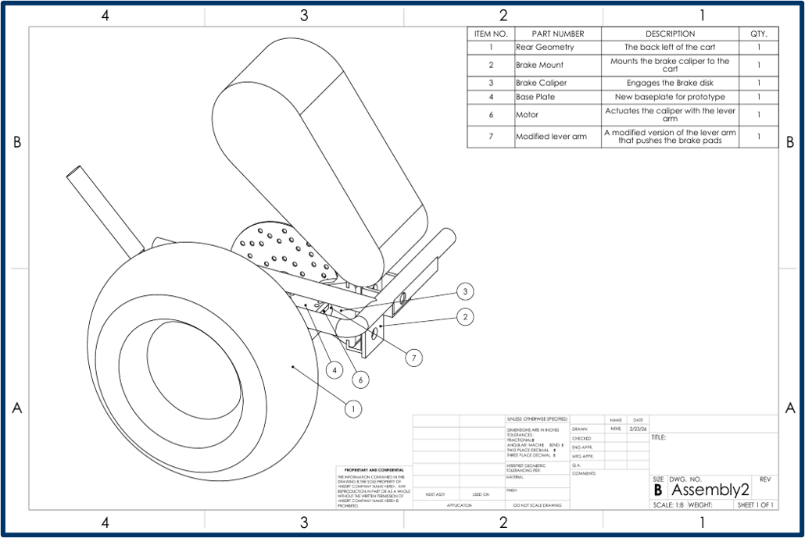
Figure 9: Brakes Full Assembly
After initial bench testing, several components were iterated for improved strength and alignment. The steel baseplate, caliper arm, and caliper bracket were redesigned and manufactured in the final version. The baseplate provides rigid motor mounting with slotted holes for precise adjustment, the caliper bracket securely attaches the caliper to the frame, and the high-carbon steel caliper arm efficiently transfers torque from the motor shaft to the brake pads. A cooling fan was also added to the motor to manage heat during prolonged operation. These design iterations significantly reduced flex, improved reliability, and minimized points of failure while maintaining the target 500 ms response time and dual-mode functionality.
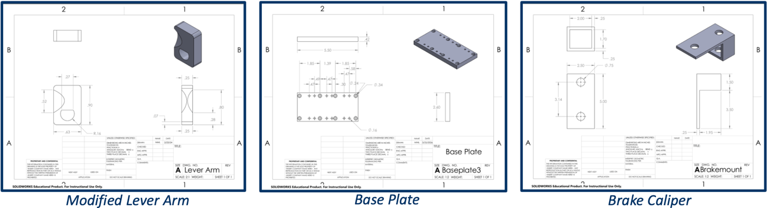
Figure 10: Brakes Manufactured Parts

Steering
The final design of the steering system includes a servo motor, a pair of gear and pinion, two encoders and, mounts and covers. Figure 11 displays the full steering with the BOM discussed in section 5.3. The cover shown in figure 12 protects the system from weather and debris. Figure 13 Shows the top encoder which allows manual mode without having to un-mesh the gear system and the bottom encoder shown in figure 15 tracks the error between the steering column and the wheel. Finally, the gear system is shown in figure 14 with the gear box half assembled and the gears un-meshed. The servo motor can also be seen in this figure and is controlled by an Arduino.
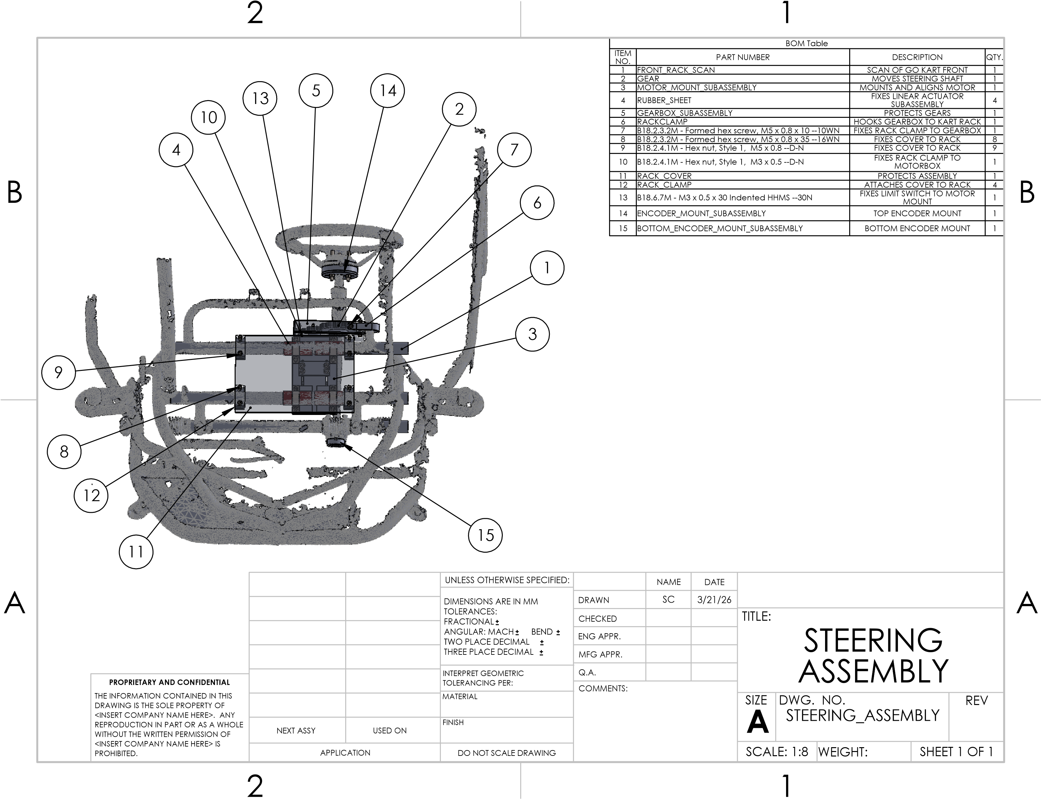
Figure 11: Steering Full CAD Assembly
Figure 12: Modified Steering Wheel
Figure 13: Steering Assembly Cover

Figure 14: Meshed Gears

Figure 15: Modified Steering Bar

Throttle
The final design of the throttle sub-team consists of a stepper motor, base plate, spool, Bowden cable, welded L-Bracket, and welded Bowden cable mount. Figure # displays the technical drawing of the throttle stepper assembly and all of the associated components and mounting material. Figure # displays the CAD model of the stepper assembly, and the remaining technical drawings demonstrate the custom design of each subcomponent.
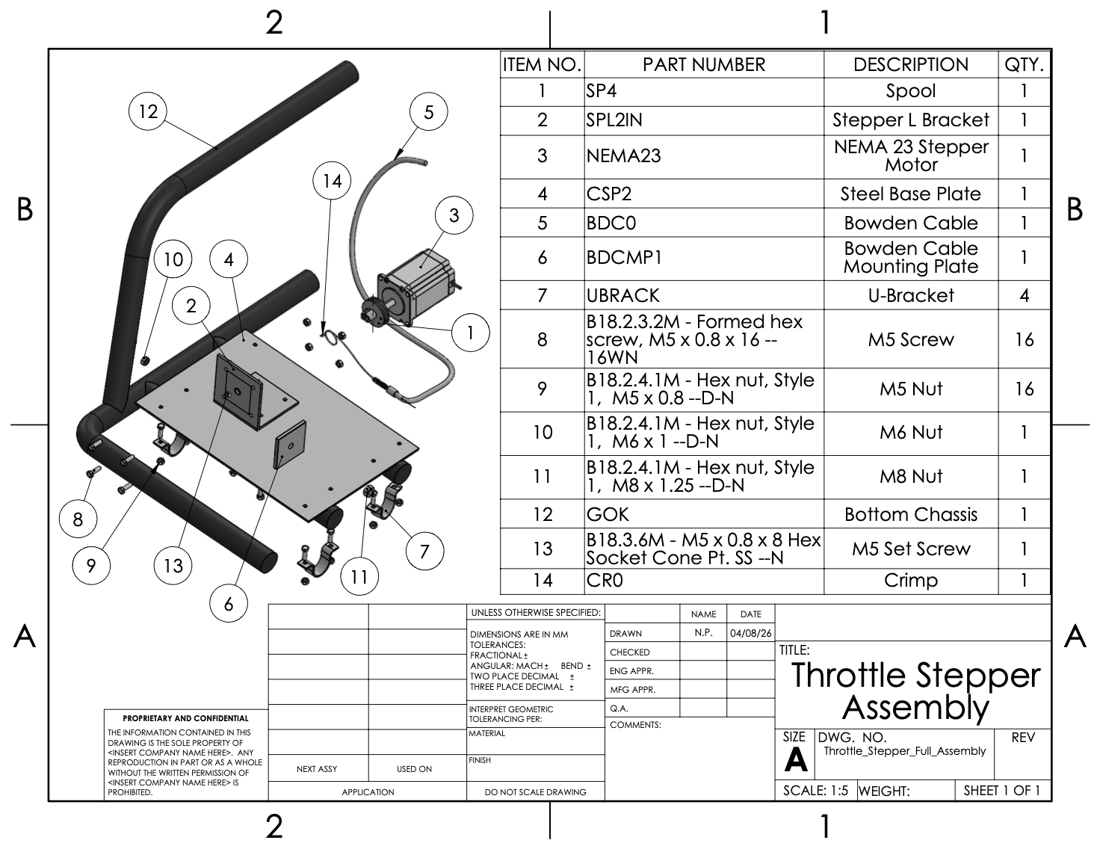
Figure 16: Throttle Stepper Assembly

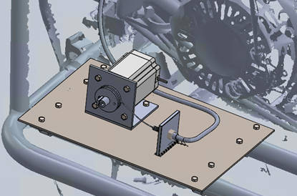
Figure 17: CAD Model of Throttle Assembly
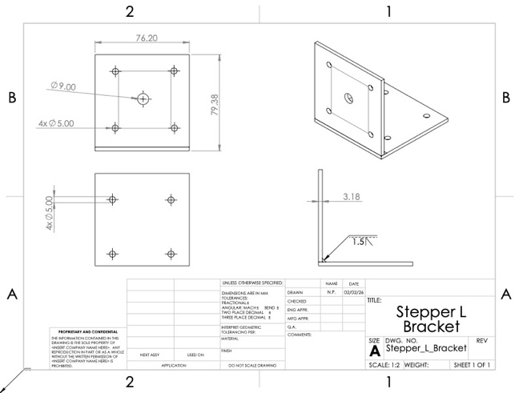
Figure 18: L-Bracket

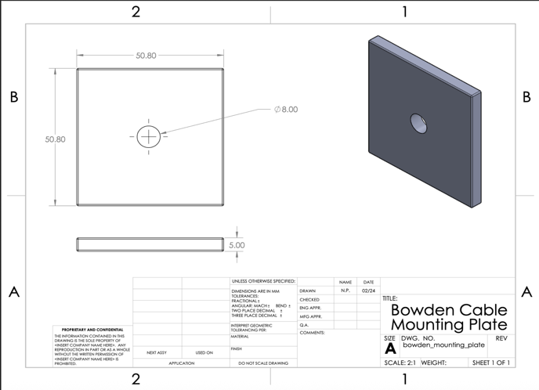
Figure 19: Bowden Cable Mounting Plate
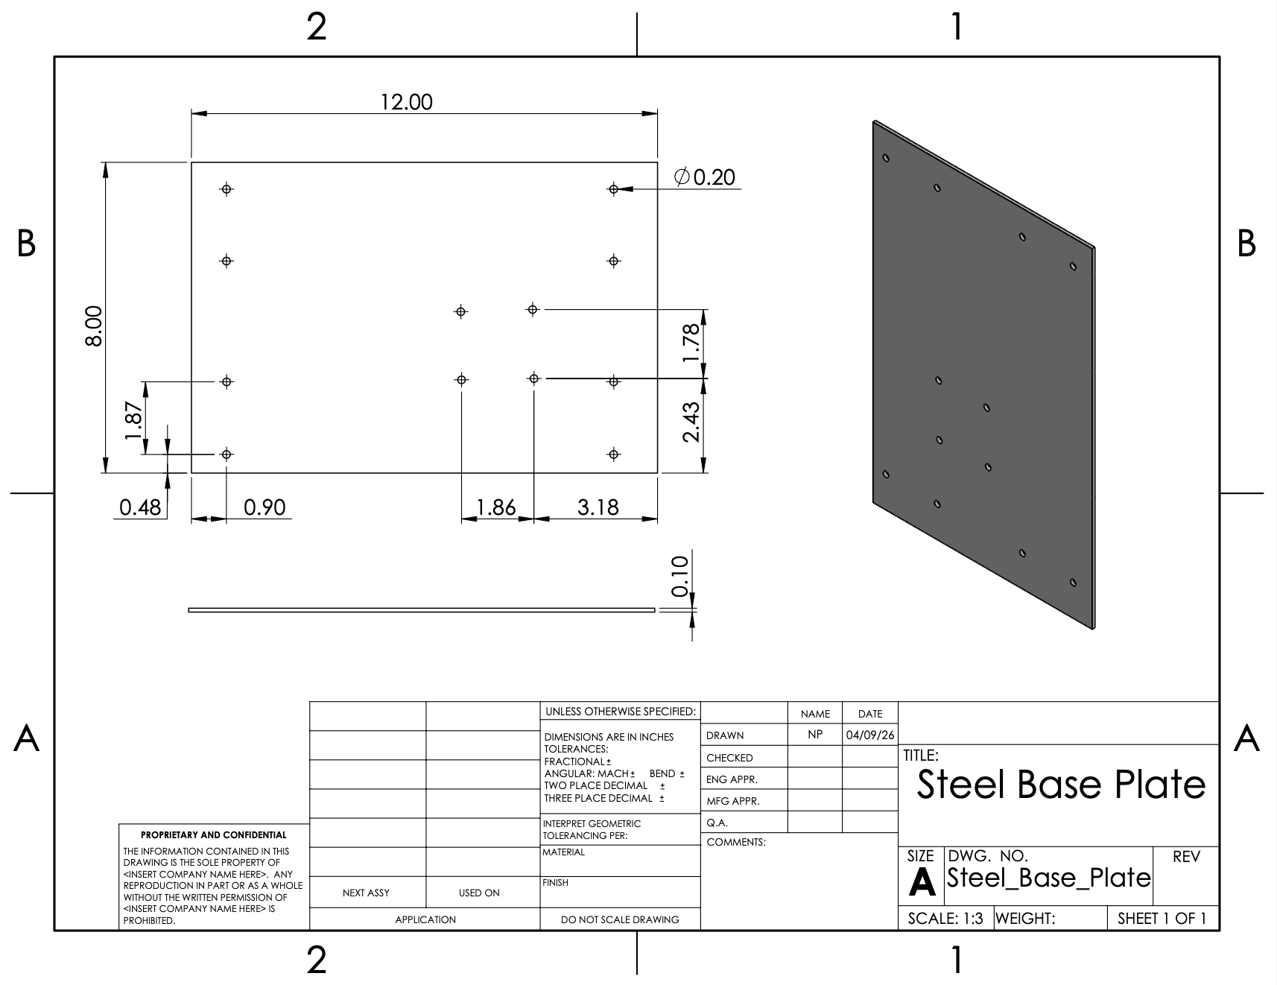
Figure 20: Steel Base Plate
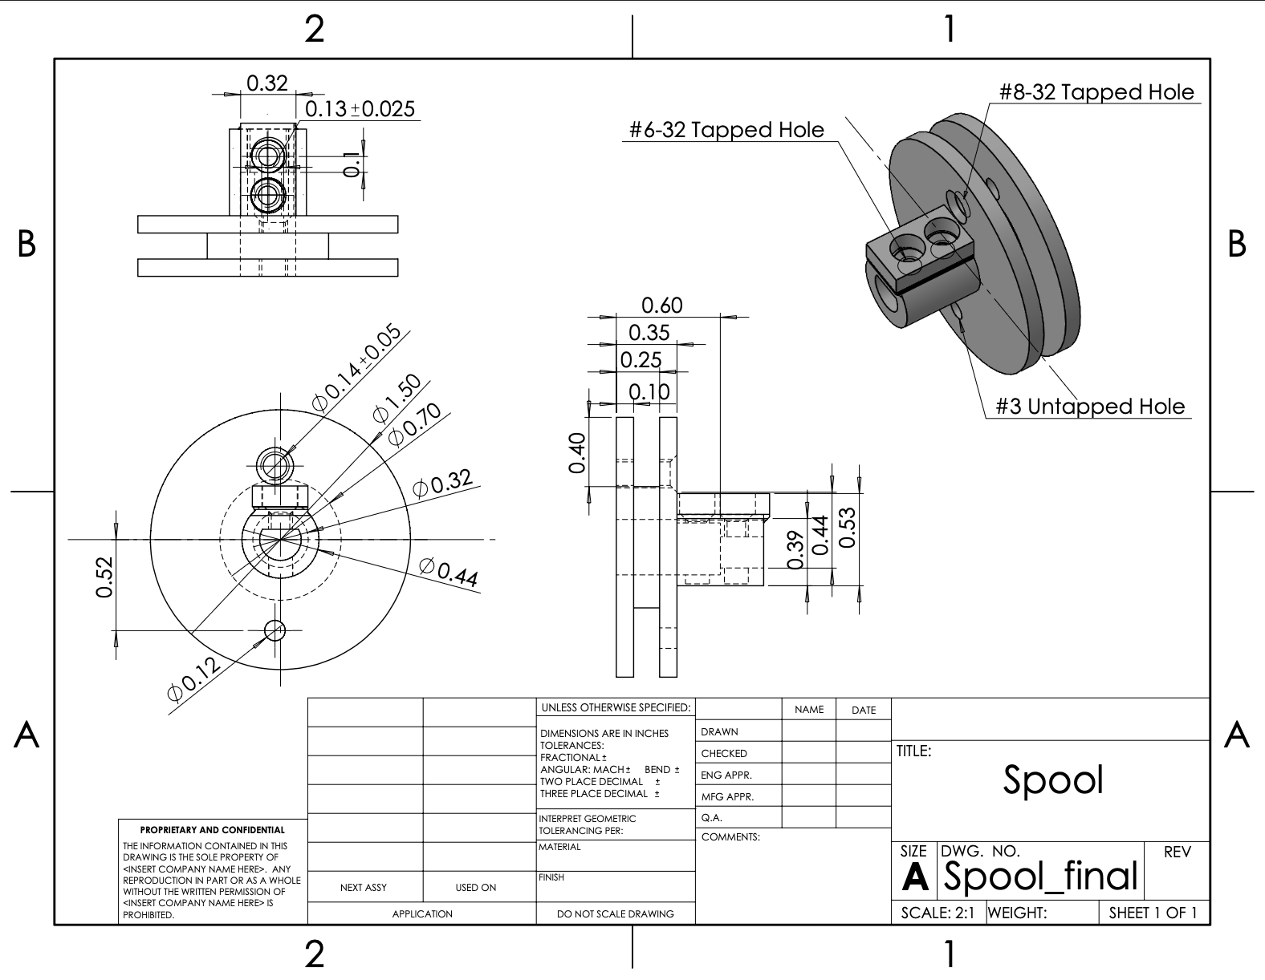
Figure 21: Spool

Top level testing summary table
The following section outlines the top-level testing summary for each sub-team based on their specific design requirements. Each sub-team has outlined the type of experiment and its relation to the design constraint, as well as what equipment and other materials are necessary to carry out an effective experiment.

Brakes
Table 33: Brakes Top Level Testing Summary
Experiment/Test | Relevant DRs | Testing Equipment Needed | Other Sources
Motor Test | ER 2 - Actuation Response Time  ER 3 - Brake Disengage Time  ER 6 - Speed of Actuation  of Components | • Camera Capable of Slow-Motion Recording  • Stopwatch  • Battery  • Motor  • PPE  • Brake Caliper | Personal protective equipment in addition to at least one EE and one EE are required.
Static Brakes Test | ER 4 - Time to Brake Kart from Maximum Speed  ER 13 - Maintainability | • Camera Capable of Slow-Motion Recording  • Stopwatch  • Battery  • Motor  • PPE  • Brake Caliper | Personal protective equipment in addition to at least one EE and one EE are required.
Brakes Stress Test | ER 1 - Manual Override Response Time  ER 7 - Maintaining User Control  ER 12 - Intuitive Brake Failsafe | • Go-kart  • Assembled subsystem  • PPE  • Battery  • Failsafe Mounted | Personal protective equipment in addition to at least one EE and one EE are required.
System Limit Test | ER 10 - Number of Brake Cycles from Full Battery  ER 11 - 20 Minute Operation Time | • Go-kart  • Assembled subsystem  • PPE  • Battery  • Failsafe Mounted | Personal protective equipment in addition to at least one EE and one EE are required.
Dynamic Brakes Test | ER 5 - Distance Traveled while Braking  ER 8 - Speed of brake in rainy conditions*  ER 9 - Speed of brake in snowy conditions* | • Go-kart  • Assembled subsystem  • PPE  • Battery  • Failsafe Mounted | To properly test ER 8 and 9 we would need the proper weather conditions.

Steering
Table 34: Steering Top Level Testing Summary
Experiment/Test | Relevant DRs | Testing Equipment Needed | Other Sources
Motor Controlled Steering Test | ER6- Left turn radius ER7- Right turn radius | Means to make a video Measuring Tape | A good weather day Empty parking lot Driver
Time Test 1 (Steering Dynamics) | ER3- Time to Achieve Angle  ER4- Time to Start Turn, ER5- Rate of Steering | Means to make a video Measuring Tape Phone Timer | A good weather day Empty parking lot
Time Test 2 (Override and Safety Response) | ER1- Manual Override Response  ER2- Actuation Response Time | Means to make a video Phone Timer | A good weather day Empty parking lot
Steering Rotation and Stress Test | ER8- Max Rotation Range  ER9 – Left Wheel Angle  ER10 – Right Wheel Angle  ER11- Cycles to failure | Means to make a video Means to track cycles Means to mark rotation | A good weather day, Empty parking lot  Lots of time

Throttle
Table 35: Throttle Top Level Testing Summary
Experiment/Test | Relevant DRs | Testing Equipment Needed | Other Sources
Force Test | - ER6 – Electric Pedal Force  - ER9 – Throttle Cable Force  - ER2 – Spring Force | - Fish Scale  - Electrical Setup – Computer, Arduino, Wires, Battery, Driver  - Calipers  - Go-Kart | - Jack Stands for Dry Test  - Outdoor Space  - Clear Weather  - Recording Sheet
Response Time Test | - ER3 – Manual Override Response Time  - ER4 – Actuation Response Time | - Electrical Setup – Computer, Arduino, Wires, Battery, Driver  - Timer  - Go-Kart | - Cones  - Jack Stands for Dry Test  - Outdoor Space  - Clear Weather  - Recording Sheet  - Driver with Proper PPE
Speed Test | - ER1 – Go-Kart Speed Range | - Go-Kart  - Gasoline  - Electrical Setup – Computer, Arduino, Wires, Battery, Driver | - Cones  - Jack Stands for Dry Test  - Outdoor Space  - Clear Weather  - Recording Sheet  - Driver with Proper PPE
Failsafe Test | - ER5 – Failsafe Response Time | - Killswitch  - Battery  - Timer  - Go-Kart | - Driver with Proper PPE  - Outdoor Space  - Clear Weather  - Recording Sheet
Overall Stress Test | - ER7 – Throttle Cable Velocity  - ER8 – Spool RPM to reach Maximum Throttle  - ER9 – Required Force to Pull Throttle Cable | - Electrical Setup – Computer, Arduino, Wires, Battery, Driver  - Fish Scale  - Go-Kart | - Jack Stands for Dry Test  - Outdoor Space  - Clear Weather  - Recording Sheet

Detailed Testing Plan

Brakes
Test 1 – Motor Test
Summary
The purpose of this test is to find the time needed to move the motor once given a command, the speed needed to actuate across the needed range of motion, and the time needed to move back from the full state of motion.
Procedure
- Complete safety checklist. Secure the cart
- Begin recording the system with camera
- Provide commands for motor to actuate both directions fully
- Measure time for each variable
- Repeat across three trials to gather an average
- Process data from the recording and analyze data for ER specifications
Results
${Average Actuation Time=t}_{1}=.08 s$
$${Actuation Response=t}_{R}=.01 s$$

$${Actuation Disengage Time=t}_{2}=.09 s$$
These were the average results from the test, and they are promising for future tests, specifically both the static and dynamic tests.

Brakes Test 2 – Static Brake Test
Summary
The purpose of this test is to find the time once actuation begins needed to stop the brake given a starting speed equal to or larger than our maximum speed.
Procedure
- Complete safety checklist. Secure the cart
- Mark a spot on the tire, begin recording and spinning the tire
- Provide commands for motor to actuate until at maximum range
- Measure speed of tire and time required to stop the tire from beginning of actuation
- Repeat across three trials to gather an average
- Process data from recording and analyzing data for ER specifications
Results
$$Average Tire Speed= V_{T}=3.46\frac{m}{s}$$
$$Average Brake Time= t_{T}=0.83s$$
$$Estimated Distance Traveled^{*}= D_{K}=2.6 m$$
From these results the team is projected to reliably brake the kart from the maximum speed of 5mph in under 0.83 seconds. In addition to that the stopping distance of 2.6m informs that we need a space of at least 26m to test for the dynamic brake test.

Brakes Test 3 – Stress Test
Summary
The purpose of this test is to find the number of cycles the system can run until failure while dual testing for our 20-minute operation time customer requirement. Unfortunately, due to delays from motor failure and integration testing the brake sub-team has been unable to complete tests 3-5. This report will introduce the purpose and procedure of the tests but will not show the results.
Procedure
- Complete safety checklist. Secure the cart
- Begin the program that repeats cycles and counts each cycle
- Finish the 20-minute test
- Check manufactured parts for failure
- Process data from recording and analyze data for ER/CR specifications
Results
From this test the sub-team is expecting to gather the number of cycles performed in 20 minutes and the total operation time with a projected time of over 20 minutes.

Brakes Test 4 – Failsafe Test
Summary
The purpose of this test is to find how effective the sensor-based failsafe the team installed is. In addition, this will allow the sub-team to test the durability of the manufactured parts.
Procedure
- Complete safety checklist. Secure the cart
- Engage the autonomous brake.
- Push the manual brake pedal, activating the limit switch.
- Record Results
- Process data from recording and analyze data for ER/CR specifications
Results
The projected results from the test are that the failsafe disengages the autonomous system in under 1 second.

Brakes Test 5 – Dynamic Brake Test
Summary
The purpose of this test is to find the time needed to stop from maximum throttle and the distance traveled from the start of actuation.
Procedure
- Complete safety checklist. Secure the cart
- Make chalk lines every 22 feet and place kart down perpendicular to the lines
- Reach maximum throttle speed and autonomously brake the kart.
- Record the test and distance once braking starts.
- Process data from recording and analyze data for ER/CR specifications
Results
Though this is the team’s most ambitious test and will define weather or not the system can autonomously brake the kart, the projected values from the test are a kart speed of 2.24m/s, a time to brake of less than 2 seconds, and a distance traveled of equal to or less than 3 meters.

Steering
Test 1: Motor Controlled Steering Test
Summary
This test will answer whether the turning radii match the targets listed in the specification sheet. These radii are the left turning radius (ER 6), and the right turning radius (ER 7). This test requires a go kart, a means to film a video and measuring tape. Variables that must be isolated include speed and steering wheel angle. The variables that must be measured are the minimum, left, and right turning radius.
Procedure
1. Complete safety checklist
2. Find a flat, open parking lot during a clear day with no obstacles or oil/water on the ground.
3. Set up kart to begin steering tests electrically.
4. Command the kart to perform a full left turn at a constant speed and record the motion using a video device.
5. Mark and measure the turning radius using a measuring tape.
6. Repeat steps 3 and 4 for a right turn.
7. Perform at least three trials for each direction.
8. Average the measured radii.
Results
This test has determined that the system has met ER6 and ER7 by measuring the radius of the vehicle. The system is considered to meet the requirement since the left and right turning radii are less than or equal to 6m with the allowed given tolerances of ±0.0254m.
- Left Turning Radius: 4.14m
- Right Turning Radius: 4.72m
- Meets requirement (≤ 6m with tolerances): Yes

Test 2: Time Test 1 (Steering Dynamics)
Summary
This test will answer how fast the steering system responds and moves to reach a commanded angle. The design requirements are the time to achieve the angle (ER3), time to start a turn (ER4), and rate of steering (ER5). This test will require the go kart, a means to make a video, measuring tape, a stopwatch, and an open parking lot. The variables that will be measured will be the time delay before steering begins, the time to reach the maximum full rotation angle, and the steering rate (angle change per second).
Procedure
1. Complete safety checklist
2. Set up the electronic parts of the steering subsystem and position the vehicle in a stationary starting position.
3. Begin recording a video and issue a steering command to turn fully left then right or vise versa.
4. Utilize the stopwatch and analyze the video to determine when the command is issued, when the steering begins, and when the desired angle is reached.
5. Repeat the test at least three times and average collected data.
Results
This test has determined whether the system meets E3, ER4, and ER5 by measuring the time it would take for the steering wheel to respond to its command. The system has met the requirement since the response times and rate of steering is within the allowed given tolerances.
- Time to Achieve Angle: 310ms
- Time to Start Turn: 250ms
- Rate of Steering: 75°/s
- Meets requirement: Yes
Test 3: Time Test 2 (Override and Safety Response)
Summary
This test will be assessing how quickly the system responds to manual override and failsafe conditions. The design requirements for this test will be the manual override response (ER1), and actuation response time (ER2). The equipment needed for this test will be the go kart, a means to record a video, a stopwatch, and an open parking lot. The variables measured for this test will be the time from override input to system response and the time it would take the system to convert from autonomous to manual mode.
Procedure
1. Complete safety checklist
2. Set up electrical components and operate the vehicle electrically.
3. Begin video recording and trigger the manual override input.
4. Record the time with the stopwatch until the steering subsystem responds.
5. Reset the system.
6. Trigger the system to achieve the actuation response.
7. Record the time until the system halts and responds.
8. Repeat tests at least three times and average recorded values.
Results
This test has determined that the system has met ER1 and ER2 by measuring the time it would take for the steering subsystem to respond to manual override and its actuation response. The recorded values fall within the allowed tolerances.
- Manual override response time: 150ms
- Actuation response time: 850ms
- Meets safety requirements: Yes

Test 4: Steering Rotation Range and Stress Test
Summary
This test will answer what the range of rotation is for the system and how many cycles the system will seamlessly perform. The design requirements for this test will be the maximum rotation range (ER8), the left wheel angle (ER9), the right wheel angle (ER10), and the cycles to failure (ER11). The equipment needed for this test will be a go kart, an open parking lot, time, measuring tape, a means to track the cycles and mark the rotation and record a video. The variables that will be measured will be the full range of rotation, the left and right wheel angles, and the number of cycles this rotation can be repeated.
Procedure
1. Complete safety checklist
2. Set up the electronic parts of the steering subsystem and position the vehicle in a stationary starting position.
3. Begin recording a video and issue a steering command to turn to the max angle.
4. Repeat for right and left side.
5. Utilize the chalk/marker to determine the max rotation, left and right angles.
6. Repeat the test at least three times and collect average data for both the right and left side.
7. Complete full range ration repeatedly for five minutes.
Results
This test determined whether the system meets ER8, ER9, ER10, and ER11 by measuring the rotation angles and the number of cycles until failure. The system has been considered to meet the requirement since the recorded values fall within the given tolerances.
- Max Rotation Range: 44.7 degrees
- Left Wheel Angle: 42.83 degrees
- Right Wheel Angle: 48.91 degrees
- Meets Requirements: Yes

Throttle
Test 1: Force Test

Summary

This test measures the forces required to operate the throttle system. The ERs being tested are the electric pedal force, throttle cable force, and spring force. This test will verify that these forces are within safe and operational limits. The equipment needed is a fish scale, throttle pedal, throttle cable, spool, stepper motor, and throttle lever. The forces being measured are maximum force required to fully press the throttle pedal, maximum force required to move the throttle via the cable, and maximum force exerted by the throttle return spring.
Procedure
- Secure the cart so it cannot move during testing.
- Attach a fish scale to the throttle pedal and pull the pedal down to measure the electric pedal force
- Attach the fish scale to the throttle cable near the spool or throttle lever and pull to measure throttle cable force.
- Measure the spring force of the throttle lever by attaching the fish scale and pulling.
- Repeat all measurements for accuracy.
Results
This test confirms that the pedal, throttle cable, and return spring forces are within expected ranges. The measurements ensure the throttle is safe, responsive, and compatible with the stepper motor and throttle cable setup.
Pedal Force: 44.4 N
Throttle Cable Force: 0.03 m/s
Spring Force: 11.1-17.3 N

Test 2: Response Time
Summary
This test measures how quickly the throttle system responds to input. The ERs being tested are manual override response time and the actuation response time. Manual override response time will measure how fast the throttle lever responds when the pedal is manually pressed. Actuation response time measures how fast the stepper motor moves the throttle lever in response to a command. The equipment needed to measure these are a timer, throttle pedal and control input, and throttle assembly. The variables that will be measured are the time from manual pedal actuation to throttle lever movement, time from stepper motor command to full throttle lever movement, and time for the throttle lever to return to neutral when power is cut or the failsafe is triggered.
Procedure
- Ensure the cart is stationary and the throttle system is powered
- Manual override response time: Press the throttle pedal manually and measure the time from pedal movement to throttle lever movement. Record the value.
- Actuation response time: Command the stepper motor to move the throttle lever fully and measure the time from command to full lever displacement. Record the value.
- Repeat each measurement three times to ensure accuracy
Results
This test verifies that the throttle system responds quickly and reliably to both manual and automated inputs.
Manual Override Response Time: 50 ms
Actuation Response Time: 100 ms

Test 3: Speed Test
Summary
This test answers how fast the go kart travels using its actuation mechanism when a passenger is riding on the road. This test relates to the design requirement that the go-kart can autonomously travel up to 14 kph. It is important to identify what the change in speed is between when the stepper actuates the speed to when a driver is manually controlling the speed using the electric pedal. The equipment needed to perform this test is the go-kart, a passenger, a helmet, cones, a timer, jack stands, a clear parking lot, and clear weather. The variables that will be isolated for measurement in this test is the friction coefficient of the pavement and the distance the go-kart will travel.
Procedure
- Roll the go-kart to an open parking lot clear of obstructions and other cars. Set up cones directly in front of the go-kart in a straight row. The cones should be spaced so that the track is 20 feet in length.
- Have the passenger sit in the go-kart with their foot on the brakes.
- Start the go-kart in neutral and then switch into drive. Have the driver slowly lift their foot from the brakes at 50% to see how fast the go-kart travels within 20 feet. Record all observations.
- For the second trial, have the driver fully lift their foot from the brakes and have a team member record how long it takes to reach the end of the 20 feet distance.
- For the third trial, have the driver use the electric acceleration pedal and measure how fast the go-kart reaches the end of the track at 50% force.
- For the fourth trial, have the driver use the acceleration pedal and measure how fast the go-kart reaches the end of the track at 100% force.
- Repeat any trial for better results and compare values between speeds using the stepper motor and the electric pedal
Results
This test defines the speeds the go-kart travels through the actuation of the stepper motor compared to the electric pedal. Using these results, the code for the stepper motor can be refined for more accurate reading of the go-kart's speed. More precise reading can be recorded once the speeds are established and integrated within the stepper motor and electric pedal.

Test 4: Failsafe Test
Summary
The failsafe test will answer how fast the failsafe will actuate the stepper motor to return to neutral and/or fully power it off. This test verifies the design requirement for the failsafe response time in terms of how fast and in what position the stepper will be actuated in case of an emergency. The equipment needed for this test will be the go-kart, an open parking lot, cones, a timer, a passenger, a helmet, and a computer to connect the battery, driver, stepper, and electrical pedal. Variables isolated for measurement in this test include the passenger, shape of the track, and the distance the go-kart will travel.
Procedure
- Have the driver put on a helmet and power on the go-kart.
- Input the autonomous throttle mode and ride the go-kart until 50% top speed at 20 feet is reached.
- Engage the failsafe and record results
- Repeat steps 1-3 for 100% speed. Keep the travel distance constant.
- Repeat trials for most accurate results.
Results
From this test, the results will identify the time that the failsafe takes to respond and return the throttle lever back to neutral. It will also demonstrate how long the entire system takes to disengage the throttle mechanism completely from further operation. This test will be utilized to ensure that the failsafe mechanism returns the throttle to a safe state within expected time limits. This complies with the safety standards required within the design to maintain system safety and performance. It will also help with defining which set of diagnostics can be used to determine if there are any errors.
Failsafe Response Time: 120 ms

Future work
The following section outlines the future work regarding the optimization in function and performance of an actuation system to be retrofitted onto an existing vehicle, such as a go-kart. Each sub-team has used the information and analyses from their prototypes and final design to thoroughly evaluate what changes would be most effective to improve each sub-team design. Moreover, each sub-team has detailed what changes they would make in material, placement, and modifications on the go-kart, as well as what better way to incorporate electrical components to their system

Brakes
If this brakes project were to continue, the next logical steps would be to refine the existing physical prototype of Concept 4 (Direct Caliper Actuation with the Docyke servo motor) by adding a mechanical disengagement mechanism to eliminate the risk of the system getting stuck engaged and improve fail-safe performance. Control would then be upgraded from simple on/off to closed-loop PWM feedback using the Arduino Nano or H-Board for smoother, modulated braking force. Comprehensive on-road testing would follow, including repeated stop-distance trials, 10-hour reliability runs, and full dual-mode (manual/autonomous) validation under real driving conditions. In parallel, a hybrid hydraulic pump system (iterating Concepts 2 and 3) would be explored for improved pressure modulation and seamless mainline brake integration. Finally, future iterations would schedule prototyping and testing much earlier to allow multiple design-build-test cycles well ahead of deadlines. These steps would advance the current bench-tested prototype into a robust, road-ready autonomous braking system.

Steering
For the steering sub team, if we were to proceed with this project or be given more time, we would continue to test until the testing success rate becomes higher. We would also continue to improve the encoder and motor mounts. The encoder mounts would be designed to become less bulky and machined with stronger material to ensure the encoders stay protected since currently the mounts are made from PLA. The motor mount would go through a redesign because it is very difficult to attach/detach the motor mount repeatedly due to the limited space and complex design. Additionally, the steering sub team would also improve the gearbox by designing the gearbox to make it easier to attach/detach and machine with a stronger material so the gearbox wouldn’t bend so easily.

Throttle
To further the improvements of the throttle sub-team, there would be a direct modification created onto the body of the throttle lever. This change would allow the Bowden cable to be mounted without a steel collar, decreasing added material. Moreover, the stepper motor mechanism would have an enclosure to better protect the spool, cable, and stepper motor from debris and damage. The location of the electrical pedal would also be adjusted so that it is more comfortable for the passenger. These alterations would further optimize the throttle mechanism and better protect it from being damaged during operation. With more time, the throttle sub-team could test their mechanism with these changes and see how each component would interact with the other.

CONCLUSION
The Boeing Autonomous capstone is a team-based project that has focused on designing an actuation and control system that can be retrofitted onto a go-kart, such as onto a go-kart. Mechanical and electrical engineering students collaborated throughout the past two semester to incorporate their components and mechanisms onto the go-kart through an autonomous fashion. Using motors, sensors, microcontrollers and having them paired with mounts, metals, and hardware, these components have been combined to give the go-kart both autonomous and manual modes. These components have been centered on the brakes, steering, and throttle subsystems to enable each component equal abilities.
The customer requirements for this project have remained consistent with the clients from Boeing. To meet these requirements for this project, the team researched and evaluated different existing mechanisms and components used for actuation systems so that the go-kart could navigate a predefine route by detecting and avoiding obstacles with 500 milliseconds. Moreover, the go-kart much reach a maximum of 14 kph and run on a single battery charge for a continuous 20 minutes. Within each subsystem, there must be a failsafe that works to keep the passenger safe at all times.
The engineering requirements within this capstone very based on each subsystem to ensure that each portion could work autonomously work in unison with the other. To achieve the proper iterations, Houses of Quality, concept generation, concept selection, and a variety of matrices were used to define the best system for each component needed on the go-kart. The changes each sub-team took on proved to be useful in the long run, as each modification has allowed them to optimize their systems to the best of their abilities and performance. With a maximum speed of 13.14kph of the throttle system, and reaction time below 500 ms for both the steering and brakes sub-teams, the decision process of each subcomponent proved to be effective within its respective system.
The iterations for the autonomous go-kart system became largely prevalent within the second half of the second semester as each sub-team manufactured and began testing their designs. For the brakes and steering sub-teams, they chose to use a servo motor to actuate their systems using different mechanisms. Steering relied on their motor to turn the gears that would acuate the steering wheel and regulate which position it was in at all times using the assistance of the electrical components. In contrast, the brakes used their motor to actuate the brake caliper design that they modified using a steel puck instead of a lever arm. This mechanism was analyzed to provide enough strength to bring the go-kart to a full stop when the brakes motor was actuated. Moreover, the throttle team used a stepper motor to regulate the angle of the throttle lever while pulling on it using the help of a Bowden cable. The Bowden cable was attached to a spool secured on the stepper motor’s shaft, pulling the cable to regulate the acceleration of the go-kart.
Each sub-team ran a series of tests with values and results that were significant to the evaluation and efficiency of their designs. The brakes sub-team completed push and actuation tests that allowed them to determine the stopping distance they needed to bring the go-kart to a complete halt. The steering sub-team conducted several turn tests to determine how far the steering wheel could turn and how the left and right turns varied in turning value. The throttle sub-team completed a set of acceleration tests to define how fast the go-kart could travel, comparing dry tests to road tests and accounting for frictional effects.
Challenges that all sub-teams faced included delays in part deliveries and struggles with testing. The brakes team had some challenges conducting tests at times due to mechanical and electrical issues, such as parts being broken due to over-actuation. The steering team had some troubles meshing their gears together when their system would switch from autonomous to manual mode. The throttle team struggled to regulate the location of the throttle lever, causing a delay and inconsistency in the go-kart’s acceleratory abilities. Additionally, challenges with the electrical sub-team included a lack of availability in team member schedules that disabled testing from happening more often than initially anticipated. There were also issues within the main code where all the systems needed to be integrated. Due to the complex nature of system integration, each sub-team code worked on its own but would come to a freeze when it was supposed to couple in the main code with the other subsystems. To move this project forward, more time to test and integrate the subsystems is a necessity to fully optimize the safety and performance of the actuation system and its capabilities.
The overall outcomes of this project include a secured go-kart with safety features stored on campus, three separate sub-teams with functioning designs, an electrical sub-team with significant results related to the success of each subsystem, over $3000 raised in donations through GoFundMe, and over $100 earned in restaurant-sponsored events. Remaining below their total budget, the team successfully used their funds to create a working actuation system while fulfilling their requirements.

REFERENCES
[1] TheRacingXpert, “ What Is The Role Of Steering Angle Sensor In Autonomous Driving?,”YouTube,https://youtu.be/bUD_fHQGjMk?si=sNnU_rH6ueBvyz2l (accessed Sep. 14, 2025).
[2] N. H. T. S. A. part of the U.S. Department of Transportation, “Automated vehicles for safety,” NHTSA, https://www.nhtsa.gov/vehicle-safety/automated-vehicles-safety (accessed Sep. 17, 2025).
[3] Math Modeling (MM) R. Budynas, Shigley’s Mechanical Engineering Design ISE. McGraw Hill, 2024.
[4] H. Luo, X. Hu, and L. Huang, "A Hybrid Model for Vehicle Acceleration Prediction," Sensors (Basel, Switzerland), vol. 23, no. 16, p. 7253, 2023
[5] A. Altby and D. Majdandzic, "Design and implementation of a fault-tolerant drive-by-wire system." Accessed: Nov. 26, 2025.
[6] H. Mauser, E. Thurner, and E. Hw, "Electronic Throttle Control -A Dependability Case Study." Accessed: Nov. 26, 2025.
[7] H. Guo, D. Cao, H. Chen, Z. Sun, and Y. Hu, "Model predictive path following control for autonomous cars considering a measurable disturbance: Implementation, testing, and verification," Mechanical Systems and Signal Processing, vol. 118, pp. 41-60, Mar. 2019
[8] S. Xu, H. Peng, Z. Song, K. Chen, and Y. Tang, "Accurate and Smooth Speed Control for an Autonomous Vehicle," IEEE Xplore, Jun. 01, 2018.
[9] N. Kolekar and S. Shelar, "Certified Organization) Website: www," International Journal of Innovative Research in Science, Engineering and Technology (An ISO, vol. 3297, 2007,
[10] R. Conatser, J. Wagner, S. Ganta, and I. Walker, "Diagnosis of automotive electronic throttle control systems," Control Engineering Practice, vol. 12, no. 1, pp. 23-30, Jan. 2004,
[11] "Drive-by-wire Conversion for Autonomous Vehicle," Robotics Knowledgebase, Dec. 07, 2022.
[12] "Digital Twin System for Automotive Safety with Integration of a Safety Controller," Research portal Eindhoven University of Technology, 2024.
[13] V. S. Dubey, Ruhshad Kasad, and K. Agrawal, "Autonomous Braking and Throttle System: A Deep Reinforcement Learning Approach for Naturalistic Driving," arXiv (Cornell University), Jan. 2021
[14] B. Mok, M. Johns, S. Yang, and W. Ju, “Reinventing the Wheel,” Oct. 2017, doi: https://doi.org/10.1145/3126594.3126655.
[15] W. Kim, C. Kang, Y.-S. Son, and C. Chung, “Nonlinear Steering Wheel Angle Control Using SelfAligning Torque with Torque and Angle Sensors for Electrical Power Steering of Lateral Control System in Autonomous Vehicles,” Sensors, vol. 18, no. 12, p. 4384, Dec. 2018, doi: https://doi.org/10.3390/s18124384.
[16] J. E. Naranjo, C. González, R. García, and T. de Pedro, “Electric Power Steering Automation for Autonomous Driving,” Lecture Notes in Computer Science, pp. 519–524, 2005, doi:https://doi.org/10.1007/11556985_67.
[17] P. Falcone, F. Borrelli, J. Asgari, H. E. Tseng, and D. Hrovat, “Predictive Active Steering Control for Autonomous Vehicle Systems,” IEEE Transactions on Control Systems Technology, vol. 15, no. 3, pp. 566–580, May 2007, doi: https://doi.org/10.1109/tcst.2007.894653.
[18] M. K. Mishra, A. Maurya, and R. R. Dev, “Automatic Steering System,” International Journal of Science and Research (IJSR), vol. 5, no. 5, pp. 105–107, May 2016, doi:10.21275/NOV163265
[19] Z. M. U. Din, W. Razzaq, U. Arif, W. Ahmad, and W. Muhammad, “Real Time Ackerman Steering Angle Control for Self-Driving Car Autonomous Navigation,” 2019 4th International Conference on Emerging Trends in Engineering, Sciences and Technology (ICEEST), pp. 1–4, Dec. 2019, doi: https://doi.org/10.1109/iceest48626.2019.8981710.
[20] D. A. Akhmedov, D. I. Xashimov, M. X. Rashidova, and D. B. Namozova, "Simulation of the Effect of Turning Steering Wheel Intensity on the Vehicle Stability," Int. J. Recent Technol. Eng., vol. 9, no. 2, pp. 129–134, Jul. 2020, doi: 10.35940/ijrte.B3464.079220.
[21] Z. Mehdiyev, C. Felh&#337;, and K. P. Zolt&aacute;n, “Investigation on 3D printing parameters of PLA polymers for gear applications,” SpringerLink, https://link.springer.com/chapter/10.1007/978- 3-031-15211-5_55#citeas (accessed Nov. 24, 2025).
[22] H.-J. Dennig, L. Zumofen, and A. Kirchheim, “Feasibility investigation of gears manufactured by fused filament fabrication,” SpringerLink, https://link.springer.com/chapter/10.1007/978-3-030- 54334-1_22 (accessed Nov. 24, 2025).
[23] R. Ciobanu, C. I. Rizescu, D. Rizescu, and B. Gramescu, “Surface durability of 3D-printed polymer gears,” MDPI, https://www.mdpi.com/2076-3417/14/6/2531 (accessed Nov. 24, 2025).
[24] J. Peng et al., “Electro-mechanical brake system architectural design and analysis based on functional safety of vehicles,” Actuators, vol. 13, no. 9, p. 346, 2024. [Online]. Available: https://www.mdpi.com/2076-0825/13/9/346
[25] M. Abusaima et al., “Simulation of screw size effect on performance of electro-mechanical brake system,” SN Applied Sciences, 2024. [Online]. Available: https://link.springer.com/article/10.1007/s42452-024-05706-7
[26] Z. Xu and C. Gerada, “Clamping-force control of a sensor-less electro-mechanical brake actuator in new-energy vehicles,” Energy Proceedings, 2021. [Online]. Available: https://www.energy-proceedings.org/wp-content/uploads/icae2021/1643123050.pdf
[27] J. Song, C. Zhu, and X. Ren, “A review on current status of electro-mechanical brake actuator for intelligent and electric vehicles,” Proceedings of SPIE, vol. 13645, 2025, doi: 10.1117/12.3059384.
[28] X. Wu et al., “Electronic mechanical braking system executive mechanism design, calculation, and modeling based on dynamic control,” Frontiers in Mechanical Engineering, 2024. [Online]. Available: https://www.frontiersin.org/journals/mechanical-engineering/articles/10.3389/fmech.2024.1368683/full
[29] L. Zhao, S. Yang, and J. Qu, “Research progress of EMB systems key technology,” Journal of Beijing University of Aeronautics and Astronautics, 2025. [Online]. Available: https://www.sciopen.com/article/10.13700/j.bh.1001-5965.2023.0210
[30] H. Koylu et al., “Experimental study on braking and stability performance during low speed braking with ABS under critical road conditions,” Journal of King Saud University - Engineering Sciences, 2021. [Online]. Available: https://www.sciencedirect.com/science/article/pii/S2215098621000306
[31] B. Zheng et al., “A comprehensive method to evaluate ride comfort of autonomous vehicles under typical braking scenarios: Testing, simulation, and analysis,” Mathematics, vol. 11, no. 2, p. 474, 2023. [Online]. Available: https://www.mdpi.com/2227-7390/11/2/474
[32] Q. Lin et al., “Electromechanical braking systems and control technology: A survey and practice,” Proceedings of the Institution of Mechanical Engineers, Part D: Journal of Automobile Engineering, 2025, doi: 10.1177/09544070241271826.
[33] B. Meng et al., “A survey of brake-by-wire systems for intelligent connected electric vehicles,” IEEE Access, vol. 8, pp. 210398–210412, 2020. [Online]. Available: https://ieeexplore.ieee.org/document/9268150
[34] S. G. Shadle, L. H. Emery, and H. K. Brewer, “Vehicle Braking, Stability and Control,” Login - CAS – central authentication service, https://www-jstor-org.libproxy.nau.edu/stable/44668097?seq=6 (accessed Sep. 14, 2025).
[35] K. D. Marshall, R. L. Phelps, M. G. Pottinger, and W. Pelz, “The effect of tire break-in on force and moment properties,” SAE Technical Paper Series, Feb. 1977. doi:10.4271/770870
[36] F. Talati and S. Jalalifar, “Analysis of heat conduction in a disk brake system,” Heat and Mass Transfer, vol. 45, no. 8, pp. 1047–1059, Jan. 2009. doi:10.1007/s00231-009-0476-y
[37] M. Haataja and T. Leinonen, “On the distribution of braking forces in road braking,” SAE Technical Paper Series, Dec. 2000. doi:10.4271/2000-01-3413
[38] P. S. Bokare and A. K. Maurya, “Acceleration-deceleration behaviour of various vehicle types,” Transportation Research Procedia, vol. 25, pp. 4733–4749, 2017. doi:10.1016/j.trpro.2017.05.486
[39] “Autonomous Vehicles Testing and operating in the state of Arizona,” Autonomous Vehicles Testing and Operating in the State of Arizona | Department of Transportation, https://azdot.gov/mvd/services/professional-services/autonomous-vehicles-testing-and-operating-state-arizona (accessed Sep. 17, 2025).
[40] Wikipedia Contributors, “Braking distance,” Wikipedia, Oct. 30, 2019. https://en.wikipedia.org/wiki/Braking_distance
[41] Wikipedia Contributors, “Acceleration,” Wikipedia, Oct. 05, 2025.
[42] P. Dewanji, “Design and Analysis of a Brake Caliper.” Available: https://theijes.com/papers/v5-i10/M0501093098.pdf
[43] S. Chauhan, “Motor Torque Calculations For Electric Vehicle.” Available: https://ijstr.org/final-print/aug2015/Motor-Torque-Calculations-For-Electric-Vehicle.pdf
[44] M. J. Lewis, “STEERING SYSTEM AND METHOD FOR AUTONOMUS VEHICLES,” Mar. 2022 STEERING SYSTEM AND METHOD FOR AUTONOMUS VEHICLES - EuropeanPatent Office - EP 3283349 B1
[45] “Intelligent Electric Power Steering: Artificial Intelligence Integration Enhances Vehicle Safety and Performance,” Intelligent Electric Power Steering: Artificial Intelligence IntegrationEnhances Vehicle Safety and performance, https://arxiv.org/html/2412.08133v1 (accessed Sep. 14, 2025). Intelligent Electric Power Steering: Artificial Intelligence Integration Enhances Vehicle Safety and Performance
[46] B. Németh, D. Fényes, P. Gáspár and A. Mihály, "Analysis and robust control design of a steering system forautonomous vehicles," 2017 IEEE International Conference on Advanced Intelligent Mechatronics (AIM), Munich,Germany, 2017, pp. 535-540, doi: 10.1109/AIM.2017.8014072. keywords: {Vehicle dynamics;Steeringsystems;Frequency-domain analysis;Tires;Autonomous vehicles;Control design}, Analysis and robust control design ofa steering system for autonomous vehicles | IEEE Conference Publication | IEEE Xplore
[47] H. Halin et al., "Simulation Studies - Path Tracking of an Autonomous Electric Vehicle (AEV) by Using FuzzyInformation of Speed and Steering Angle," 2018 International Conference on Computational Approach in SmartSystems Design and Applications (ICASSDA), Kuching, Malaysia, 2018, pp. 1-4, doi: 10.1109/ICASSDA.2018.8477593.keywords: {Autonomous vehicles;Navigation;Wheels;Mechatronics;Reliability;Automobiles;Inputvariables;fuzzy;simulation;lateral error;autonomous;steering control}, Simulation Studies - Path Tracking of anAutonomous Electric Vehicle (AEV) by Using Fuzzy Information of Speed and Steering Angle | IEEE ConferencePublication | IEEE Xplore
[48] Y. Jeong, D. H. Kim, M. H. Youn, S. Park, X. J. Li and T. Lee, "Model Predictive Control-Based Path Tracking withFour-Wheel Independent Steering, Driving, and Braking Autonomous Vehicles on Low Friction Road," 2023 23rdInternational Conference on Control, Automation and Systems (ICCAS), Yeosu, Korea, Republic of, 2023, pp. 1427-1432, doi: 10.23919/ICCAS59377.2023.10316779. keywords: {Transmission line matrixmethods;Friction;Roads;Wheels;Predictive models;Tires;Robustness;Autonomous vehicle;Four-wheel independentsteering;Four-wheel independent driving;Four-wheel independent braking;Low friction road. Model predictivecontrol;Control allocation}, Model Predictive Control-Based Path Tracking with Four-Wheel Independent Steering,Driving, and Braking Autonomous Vehicles on Low Friction Road | IEEE Conference Publication | IEEE Xplore
[49] A. Pushpakanth and M. N. Dhavalikar, Development of Steering Control System for Autonomous Vehicle,https://www.ijrte.org/wp-content/uploads/papers/v11i2/B71050711222.pdf (accessed Sep. 15, 2025). Development of Steering Control System for Autonomous Vehicle
[50] TheRacingXpert, “ What Is The Role Of Steering Angle Sensor In Autonomous Driving?,”YouTube,https://youtu.be/bUD_fHQGjMk?si=sNnU_rH6ueBvyz2l (accessed Sep. 14, 2025).
[51] R. Budynas, Shigley’s Mechanical Engineering Design ISE. McGraw Hill, 2024.
[52] E. Oberg and C. J. Mccauley, Machinery’s handbook : a reference book for the mechanical engineer, designer, manufacturing engineer, draftsman, toolmaker, and machinist. New York: Industrial Press, 2012.
[53] “spur gear in solidworks - Search Videos,” www.bing.com. https://www.bing.com/videos/riverview/relatedvideo?q=spur+gear+in+solidworks&mid=3CCBB7F95BBB8201C88E3CCBB7F95BBB8201C88E&churl=https://www.youtube.com/channel/UCjd_zIvYtQymk0dPx3vTJcA&FORM=VIRE (accessed Apr. 20, 2026).
[54] R. Nalbandian, T. Blais, and R. Horth, "A Recommended New Approach on Motorization Ratio Calculations of Stepper Motors." Accessed: Oct. 16, 2025. [Online]. Available: https://ntrs.nasa.gov/api/citations/20150004072/downloads/20150004072.pdf

[55] S. Thapa, "3D Printing of Automobile Power Transmission System Using Tough PLA," Urn.fi, 2020, doi: https://www.theseus.fi/handle/10024/343865

[56] M. Venczel, A. Veress, and Z. Peredy, "Past and Future Practical Solutions for Torsional Vibration Damping in Vehicle Industry," Periodica Polytechnica Transportation Engineering, vol. 50, no. 4, pp. 318-329, Aug. 2022, doi: https://doi.org/10.3311/PPtr.19194.

[57] Mattikalli, S., Rayar, V., Yallure, B., Akki, S., & Thane, S. (2024). AUTOSAR-enabled throttle position sensor testing and analysis using MATLAB. 2024 IEEE North Karnataka Subsection Flagship International Conference (NKCon), 1-5. https://do1.org/10.1109/nkcon62728.2024.10775293

[58] H. Niaz, Muhammad Abdullah Sheeraz, and M. A. Naeem, "Multi-Parametric Analysis of a Mimicked Accelerating Pedal (Via DC Motor) of an Electric Vehicle," DOAJ (DOAJ: Directory of Open Access Journals), pp. 48-48, Oct. 2023, doi: https://doi.org/10.3390/asec2023-15253.

[59] Oluwatobiloba Adejumo, "Safety of 3D Printing in Automotive Industries," SSRN Electronic Journal, Jan. 2025, doi: https://doi.org/10.2139/ssrn.5112375.

[60] J. Lee, K. Oh, and K. Yi, "DEVELOPMENT OF AN EMERGENCY CONTROL ALGORITHM FOR A FAIL-SAFE SYSTEM IN AUTOMATED DRIVING VEHICLES." Available: https://www-esv.nhtsa.dot.gov/Proceedings/26/26ESV-000101.pdf

[61] Arduino, "Power Consumption on Arduino Boards," Arduino.cc, 2024. https://docs.arduino.cc/learn/electronics/power-consumption/

[62] S. Lefevre, A. Carvalho, and F. Borrelli, “Autonomous car following: A learning-based approach,” 2022 IEEE Intelligent Vehicles Symposium (IV), pp. 920–926, Jun. 2015, doi: https://doi.org/10.1109/ivs.2015.7225802.

[63] T. Stolte, Gerrit Bagschik, and M. Maurer, “Safety goals and functional safety requirements for actuation systems of automated vehicles,” Nov. 2016, doi: https://doi.org/10.1109/itsc.2016.7795910.

[64] W. Zhang, “Exploiting over-actuation for improved active safety of autonomous electric vehicles,” DIVA, 2022. https://www.diva-portal.org/smash/record.jsf?pid=diva2%3A1658053&dswid=3624 (accessed Oct. 18, 2025).
[65] J. F. Arango et al., “Drive-By-Wire Development Process Based on ROS for an Autonomous Electric Vehicle,” Sensors, vol. 20, no. 21, p. 6121, Oct. 2020, doi: https://doi.org/10.3390/s20216121.
[66] W. Li, Z. Xie and P. He, "Research on the Application of Multi-Sensor Fusion in Autonomous Driving," 2025 5th International Conference on Sensors and Information Technology, Nanjing, China, 2025, pp. 389-392, doi: 10.1109/ICSI64877.2025.11010055.
[67] P. Y. Leong and N. S. Ahmad, "LiDAR-Based Obstacle Avoidance With Autonomous Vehicles: A Comprehensive Review," in IEEE Access, vol. 12, pp. 164248-164261, 2024, doi: 10.1109/ACCESS.2024.3493238.
[68] Y. W. Jeong, C. C. Chung and W. Kim, "Nonlinear Hybrid Impedance Control for Steering Control of Rack-Mounted Electric Power Steering in Autonomous Vehicles," in IEEE Transactions on Intelligent Transportation Systems, vol. 21, no. 7, pp. 2956-2965, July 2020, doi: 10.1109/TITS.2019.2921893.
[69] N. Kalkovaliev and G. Mirceva, "Autonomous Driving by Using Convolutional Neural Network," 2021 3rd International Congress on Human-Computer Interaction, Optimization and Robotic Applications (HORA), Ankara, Turkey, 2021, pp. 1-4, doi: 10.1109/HORA52670.2021.9461350.
[70] D. Meng, H. Chu, M. Tian, B. Gao and H. Chen, "Neural Network-Aided Fast Iterative Model Predictive Control for Autonomous Vehicle Motion Control," in IEEE Sensors Journal, vol. 25, no. 19, pp. 37181-37194, 1 Oct.1, 2025, doi: 10.1109/JSEN.2025.3598267.
[71] L. Anzalone, S. Barra and M. Nappi, "Reinforced Curriculum Learning For Autonomous Driving In Carla," 2021 IEEE International Conference on Image Processing (ICIP), Anchorage, AK, USA, 2021, pp. 3318-3322, doi: 10.1109/ICIP42928.2021.9506673.
[72] S. He, X. Xu, J. Xie, F. Wang and Z. Liu, "Fault Diagnosis Strategy of Autonomous Steering System for Intelligent Vehicle Based on State Estimation," 2022 6th CAA International Conference on Vehicular Control and Intelligence (CVCI), Nanjing, China, 2022, pp. 1-6, doi: 10.1109/CVCI56766.2022.9964723.
[73] D. Kyrychuk and A. Segin, "Training of a Convolutional Neural Network and Its Object Recognition Ability Depending on Illumination and Contrast of Images," 2021 11th International Conference on Advanced Computer Information Technologies (ACIT), Deggendorf, Germany, 2021, pp. 722-725, doi: 10.1109/ACIT52158.2021.9548493. keywords: {Training;Image recognition;Transfer learning;Neural networks;Lighting;Feature extraction;Object recognition;convolutional neural network;image classification;object detection},
[74] L. Bo, W. ShiWei, H. Qinghui, Q. Zan and Y. Jingyi, "An Improved Neural Network Algorithm for Intelligent Object Recognition," 2021 17th International Conference on Computational Intelligence and Security (CIS), Chengdu, China, 2021, pp. 26-29, doi: 10.1109/CIS54983.2021.00014.
[75] S. Tennekoon, N. Wedasingha, A. Welhenge, N. Abhayasinghe and I. Murray Am, "Advancing Object Detection: A Narrative Review of Evolving Techniques and Their Navigation Applications," in IEEE Access, vol. 13, pp. 50534-50555, 2025, doi: 10.1109/ACCESS.2025.3551686.
[76] D. Halliday and R. Resnick, Fundamentals of Physics, 10th ed. Hoboken, NJ: Wiley, 2013.
[77] J. D. Halderman, Automotive Brake Systems, 7th ed. Boston, MA: Pearson, 2019.
[78] M. Haataja and T. Leinonen, “On the distribution of braking forces in road braking,” SAE Technical Paper Series, Dec. 2000. doi:10.4271/2000-01-3413
[79] P. S. Bokare and A. K. Maurya, “Acceleration-deceleration behaviour of various vehicle types,” Transportation Research Procedia, vol. 25, pp. 4733–4749, 2017. doi:10.1016/j.trpro.2017.05.486
[80] S. G. Shadle, L. H. Emery, and H. K. Brewer, “Vehicle Braking, Stability and Control,” Login - CAS – central authentication service, https://www-jstor-org.libproxy.nau.edu/stable/44668097?seq=6 (accessed Sep. 14, 2025).
[81] K. D. Marshall, R. L. Phelps, M. G. Pottinger, and W. Pelz, “The effect of tire break-in on force and moment properties,” SAE Technical Paper Series, Feb. 1977. doi:10.4271/770870
[82] F. Talati and S. Jalalifar, “Analysis of heat conduction in a disk brake system,” Heat and Mass Transfer, vol. 45, no. 8, pp. 1047–1059, Jan. 2009. doi:10.1007/s00231-009-0476-y
[83] P. S. Bokare and A. K. Maurya, “Acceleration-deceleration behaviour of various vehicle types,” Transportation Research Procedia, vol. 25, pp. 4733–4749, 2017. doi:10.1016/j.trpro.2017.05.486
[84] “Autonomous Vehicles Testing and operating in the state of Arizona,” Autonomous Vehicles Testing and Operating in the State of Arizona | Department of Transportation, https://azdot.gov/mvd/services/professional-services/autonomous-vehicles-testing-and-operating-state-arizona (accessed Sep. 17, 2025).
[85] Wikipedia Contributors, “Braking distance,” Wikipedia, Oct. 30, 2019. https://en.wikipedia.org/wiki/Braking_distance
[86] Wikipedia Contributors, “Acceleration,” Wikipedia, Oct. 05, 2025.

[87] R. Nalbandian, T. Blais, and R. Horth, “A Recommended New Approach on Motorization Ratio Calculations of Stepper Motors.” Accessed: Oct. 16, 2025. [Online]. Available: https://ntrs.nasa.gov/api/citations/20150004072/downloads/20150004072.pdf
[88] E. Oberg and C. J. Mccauley, Machinery’s Handbook: a reference book for the mechanical engineer, designer, manufacturing engineer, draftsman, toolmaker, and machinist. New York: Industrial Press, 2012.
[89] H. Olsson, K. J. Åström, C. Canudas de Wit, M. Gäfvert, and P. Lischinsky, “Friction Models and Friction Compensation,” European Journal of Control, vol. 4, no. 3, pp. 176–195, Jan. 1998, doi: https://doi.org/10.1016/s0947-3580(98)70113-x.
[90] J. L. Meriam and L. G. Kraige, Engineering mechanics. Vol. 2, Dynamics. Hoboken, N.J.: Wiley; Chichester, 2012
[91] "NHTSA Rulemakings Related to Automated Driving System-Equipped Vehicles NHTSA Rulemakings Related to Automated Driving System- Equipped Vehicles," 2024. Available: https://www.nhtsa.gov/sites/nhtsa.gov/files/2024-05/Report-to-Congress-NHTSA-Rulemakings- Related-to-Automated-Driving-System-Equipped-Vehicles.pdf
[92] Krystian Radlak, M. Szczepankiewicz, T. Jones, and P. Serwa, "Organization of machine learning based product development as per ISO 26262 and ISO/PAS 21448," arXiv (Cornell University), pp. 110-119, Dec. 2020, doi: https://doi.org/10.1109/prdc50213.2020.00022.
[93] “ASME Codes and Standards - ProQuest,” Proquest.com, 2026. https://www.proquest.com/openview/add034c6460daa7ee9674b08c7ad27d6/1.pdf?pq-origsite=gscholar&cbl=40505 (accessed Apr. 20, 2026).
[94] E. Oberg and C. J. Mccauley, Machinery’s handbook : a reference book for the mechanical engineer, designer, manufacturing engineer, draftsman, toolmaker, and machinist. New York: Industrial Press, 2012.
[95] J. H. Jung, N. Pan, and T. J. Kang, “Capstan equation including bending rigidity and non-linear frictional behavior,” Mechanism and Machine Theory, vol. 43, no. 6, pp. 661–675, Jun. 2008, doi: https://doi.org/10.1016/j.mechmachtheory.2007.06.002.
[96] R. G. Budynas, J Keith Nisbett, and Joseph Edward Shigley, Shigley’s mechanical engineering design, 11th ed. New York, Ny: Mcgraw-Hill Education, 2020.
‌

APPENDICES

Appendix A: Figures
Figure 22:Selected Go-Kart
Figure 23: Brakes QFD

Figure 24: Steering QFD
Figure 25: Throttle QFD

Figure 26: Top Level Functional Decomposition

Figure 27: Brakes Functional Decomposition
Figure 28: Steering Functional Decomposition
Figure 29: Throttle Functional Decomposition
Figure 30: Brakes Full Assembly
Figure 31: Brakes Manufactured Parts
Figure 32: Steering Full CAD Assembly
Figure 33: Modified Steering Wheel
Figure 34: Steering Assembly Cover

Figure 35: Meshed Gears

Figure 36: Modified Steering Bar
Figure 37: Throttle Stepper Assembly

Figure 38: CAD Model of Throttle Assembly
Figure 39: L-Bracket

Figure 40: Bowden Cable Mounting Plate
Figure 41: Steel Base Plate
Figure 42: Spool

Appendix B: Tables
Table 36: Brakes Morphological Matrix

Table 237: Steering Morphological Matrix

Table 3: Throttle Morphological Matrix
Table 438: Brakes Specifications Chart
Table 539: Brakes Option Comparison

Table 6: Brakes Pugh Chart

Table 740: Brakes Decision Matrix
Table 841: Steering Specifications Chart

Table 942: Steering Option Comparison

Table 10: Steering Pugh Chart
Table 11: Steering Decision Matrix

Table 12: Throttle Option Comparison

Table 13: Throttle Specification Sheet

Table 14: Throttle Decision Matrix

Table 15: Throttle Pugh Chart

Table 16: Semester 1 Gantt Chart Brakes

Table 17: Semester 2 Gantt Chart Brakes
Table 18: Semester 1 Gantt Chart Steering

Table 19: Semester 2 Gantt Chart Steering

Table 20: Semester 1 Gantt Chart Throttle

Table 21: Semester 2 Gantt Chart Throttle
Table 22: Budget Expenses Table
Table 2343: Brakes Bill of Materials

Table 24: Steering Bill of Materials

Table 25: Throttle Bill of Materials

Table 26: Electrical Bill of Materials

Table 27: Electrical Bill of Materials Continued
Table 28: Brakes FMEA

Table 29: Steering FMEA
Table 30: Throttle FMEA
Table 44: Assumptions
Assumptions | Values | Units
Horsepower of Go-Kart | 5.30 | Hp
Max Torque of Go-Kart at 2500rpm | 11.00 | Nm
Radius of Coupler (r_{Coupler}) | 32 | mm
Maximum Tensile Strength of Coupler Screws (σ_{ucs, max}) | 175 | ksi
Stepper Motor Holding Torque (T_{Motor, max}) | 2.4 | Nm

Table 45: Measurements and Variables
Measurements | Values | Units
Lever Force to 100% Throttle (F_{Throttle, min}) | 4.55 | N
Max turn of Stepper (θ_{Stepper}) | 90 | degrees
Angle of throttle lever turn (θ_{Lever}) | 22.7 | degrees
Cable Distance to Full Throttle (d_{Cable, min}) | 15 | mm
Diameter of Spool (d_{spool}) | 33.5 | mm
Friction Coefficient in Cable (μ) [1] | 0.16
Ultimate Cable Stress (σ_{ult}) [3] | 1800 | MPa

Table 46: Brakes Top Level Testing Summary
Experiment/Test | Relevant DRs | Testing Equipment Needed | Other Sources
Motor Test | ER 2 - Actuation Response Time  ER 3 - Brake Disengage Time  ER 6 - Speed of Actuation  of Components | • Camera Capable of Slow-Motion Recording  • Stopwatch  • Battery  • Motor  • PPE  • Brake Caliper | Personal protective equipment in addition to at least one EE and one EE are required.
Static Brakes Test | ER 4 - Time to Brake Kart from Maximum Speed  ER 13 - Maintainability | • Camera Capable of Slow-Motion Recording  • Stopwatch  • Battery  • Motor  • PPE  • Brake Caliper | Personal protective equipment in addition to at least one EE and one EE are required.
Brakes Stress Test | ER 1 - Manual Override Response Time  ER 7 - Maintaining User Control  ER 12 - Intuitive Brake Failsafe | • Go-kart  • Assembled subsystem  • PPE  • Battery  • Failsafe Mounted | Personal protective equipment in addition to at least one EE and one EE are required.
System Limit Test | ER 10 - Number of Brake Cycles from Full Battery  ER 11 - 20 Minute Operation Time | • Go-kart  • Assembled subsystem  • PPE  • Battery  • Failsafe Mounted | Personal protective equipment in addition to at least one EE and one EE are required.
Dynamic Brakes Test | ER 5 - Distance Traveled while Braking  ER 8 - Speed of brake in rainy conditions*  ER 9 - Speed of brake in snowy conditions* | • Go-kart  • Assembled subsystem  • PPE  • Battery  • Failsafe Mounted | To properly test ER 8 and 9 we would need the proper weather conditions.

Table 47: Steering Top Level Testing Summary
Experiment/Test | Relevant DRs | Testing Equipment Needed | Other Sources
Motor Controlled Steering Test | ER6- Left turn radius ER7- Right turn radius | Means to make a video Measuring Tape | A good weather day Empty parking lot Driver
Time Test 1 (Steering Dynamics) | ER3- Time to Achieve Angle  ER4- Time to Start Turn, ER5- Rate of Steering | Means to make a video Measuring Tape Phone Timer | A good weather day Empty parking lot
Time Test 2 (Override and Safety Response) | ER1- Manual Override Response  ER2- Actuation Response Time | Means to make a video Phone Timer | A good weather day Empty parking lot
Steering Rotation and Stress Test | ER8- Max Rotation Range  ER9 – Left Wheel Angle  ER10 – Right Wheel Angle  ER11- Cycles to failure | Means to make a video Means to track cycles Means to mark rotation | A good weather day, Empty parking lot  Lots of time

Throttle
Table 48: Throttle Top Level Testing Summary
Experiment/Test | Relevant DRs | Testing Equipment Needed | Other Sources
Force Test | - ER6 – Electric Pedal Force  - ER9 – Throttle Cable Force  - ER2 – Spring Force | - Fish Scale  - Electrical Setup – Computer, Arduino, Wires, Battery, Driver  - Calipers  - Go-Kart | - Jack Stands for Dry Test  - Outdoor Space  - Clear Weather  - Recording Sheet
Response Time Test | - ER3 – Manual Override Response Time  - ER4 – Actuation Response Time | - Electrical Setup – Computer, Arduino, Wires, Battery, Driver  - Timer  - Go-Kart | - Cones  - Jack Stands for Dry Test  - Outdoor Space  - Clear Weather  - Recording Sheet  - Driver with Proper PPE
Speed Test | - ER1 – Go-Kart Speed Range | - Go-Kart  - Gasoline  - Electrical Setup – Computer, Arduino, Wires, Battery, Driver | - Cones  - Jack Stands for Dry Test  - Outdoor Space  - Clear Weather  - Recording Sheet  - Driver with Proper PPE
Failsafe Test | - ER5 – Failsafe Response Time | - Killswitch  - Battery  - Timer  - Go-Kart | - Driver with Proper PPE  - Outdoor Space  - Clear Weather  - Recording Sheet
Overall Stress Test | - ER7 – Throttle Cable Velocity  - ER8 – Spool RPM to reach Maximum Throttle  - ER9 – Required Force to Pull Throttle Cable | - Electrical Setup – Computer, Arduino, Wires, Battery, Driver  - Fish Scale  - Go-Kart | - Jack Stands for Dry Test  - Outdoor Space  - Clear Weather  - Recording Sheet

Appendix C: Additional Resources

Steering Additional Calcs (referenced in paragraph)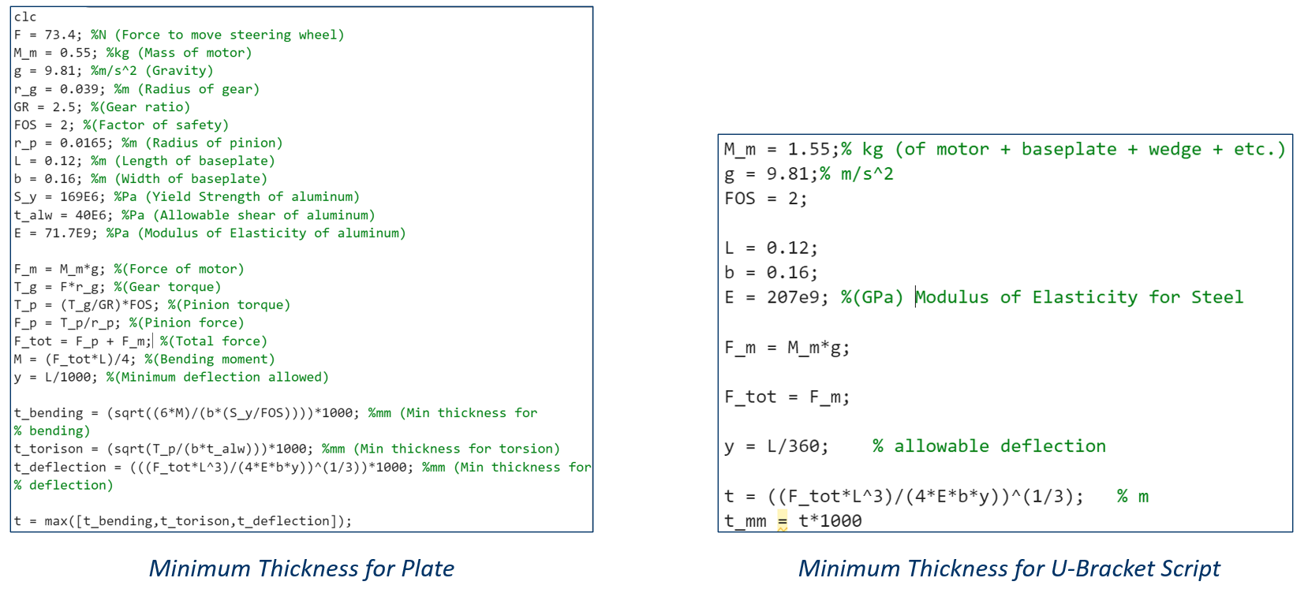

Brakes Motor Case Convective Heat Transfer Analysis

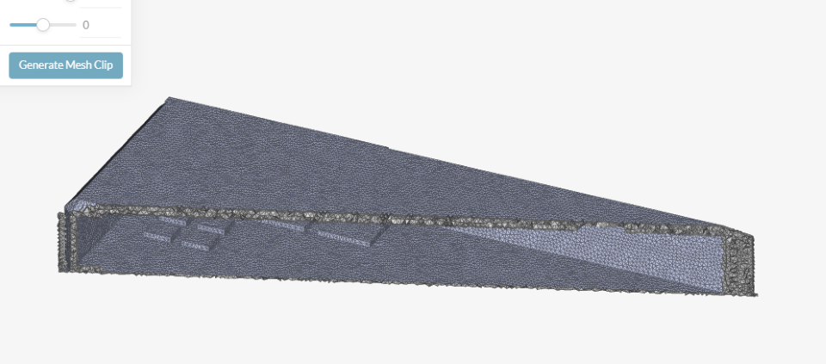
Nodal Mesh Cross-Section of Motor Case with Heated Electrical Surfaces

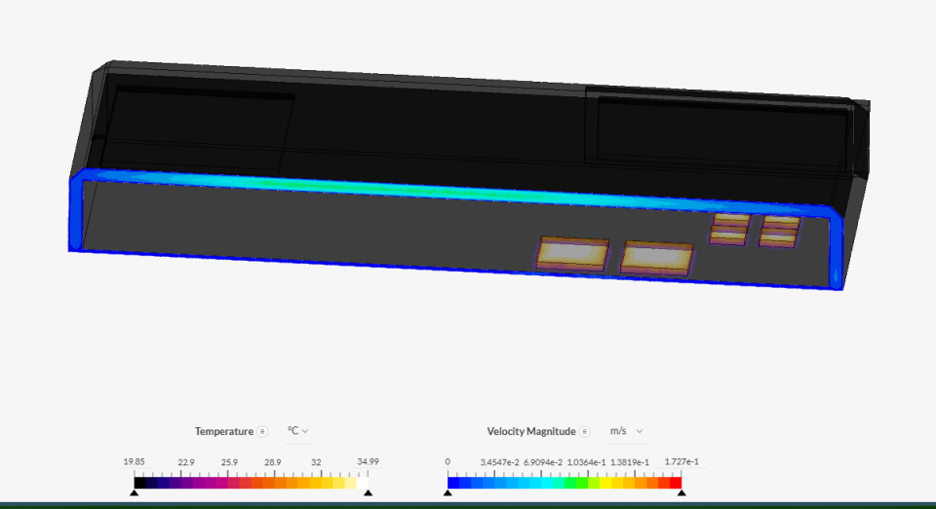
Convective Heat Transfer Analysis
Throttle:
Mathematical Computation of the Bowden Cable Analysis
F_throttle_min = 4.55;
theta_stepper = 90;
theta_lever = 22.7;
d_cable_min = 15;
d_wire = 1.5;
d_spool = 33.5;
friction_coeff = 0.16;
sigma_ult = 1800;

r_spool = d_spool/2;
rad_stepper = deg2rad(theta_stepper);
rad_lever = deg2rad(theta_lever);

% Spool Rotation Angle
theta_cable_bend = d_cable_min/r_spool;
Area_inner_wire = (pi*(d_wire)^2)/4;

% Calculate the output force
F_in = F_throttle_min * exp(friction_coeff*theta_cable_bend);

% Cable stress using the area of the inner wire
cable_stress = F_in / Area_inner_wire;

% Calculate the actual tensile force
F_ult = sigma_ult * Area_inner_wire;

% Calculate the Factor of Safety
FoS = F_ult / F_in; % Factor of Safety calculation

% Calculate Efficiency
n = F_throttle_min/F_in;

